Common Note-taking Methods

The Cornell Method
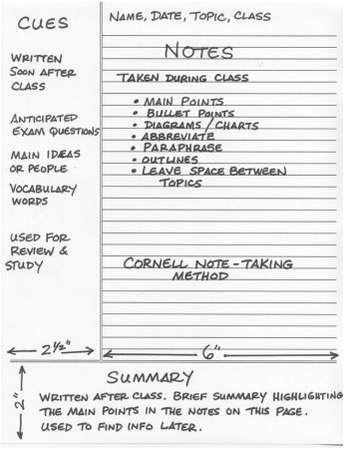
The Cornell Method provides a systematic format for condensing and organizing notes without laborious recopying. After writing the notes in the main space, use the left-hand space to label each idea and detail with a key word or “cue”.

Method: Rule your paper with a 2 inch margin on the left leaving a six-inch area on the right in which to make notes. During class, take down information in the six-inch area. When the instructor moves to a new point, skip a few lines. After class, complete phrases and sentences as much as possible. For every significant bit of information, write a cue in the left margin. To review, cover your notes with a card, leaving the cues exposed. Say the cue out loud, then say as much as you can of the material underneath the card. When you have said as much as you can, move the card and see if what you said matches what is written.

Advantages: Organized and systematic for recording and reviewing notes. Easy format for pulling out major concept and ideas. Simple and efficient. Saves time and effort. “Do-it-right-in-the-first-place system”.

Disadvantages: None

When to Use: In any lecture situation

The Outlining Method
Dash outlining is usually best except for some science classes such as physics or math. The information which is most general begins at the left with each more specific group of facts indented with spaces to the right. The relationships between the different parts are carried out through indenting. No numbers, letters, or Roman numerals are needed.

Method: Listen and then write in points in an organized pattern based on space indention. Place major points farthest to the left. Indent each more specific point to the right. Levels of importance will be indicated by distance away from the major point. Indentation can be as simple as or as complex as labeling the indentations with Roman numerals or decimals. Markings are not necessary as space relationships will indicate the major/minor points.
Advantages: Well-organized system if done right. Outlining records content as well as relationships. It also reduces editing and is easy to review by turning main points into questions.
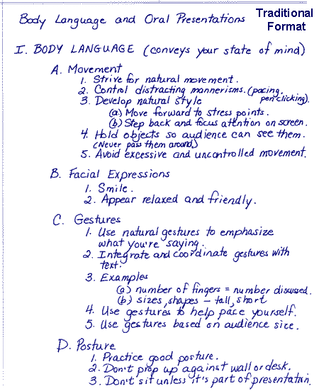
Disadvantages: Requries more thought in class for accurate organization. This system may not show relationships by sequence when needed. It doesn’t lend to diversity of a reivew attach for maximum learning and question application. This system cannot be used if the lecture is too fast.
When to Use: The outline format can be used if the lecture is presented in outline organization. This may be either deductive (regular outline) or inductive (reverse outline where minor points start building to a major point). Use this format when there is enough time in the lecture to think about and make organization decisions when they are needed. This format can be most effective when your note-taking skills are super and sharp, and you can handle the outlining regardless of the note-taking situation.

The Mapping Method
Mapping is the method that uses comprehension/concentration skills and evolves in a note-taking form which relates each fact or idea to every other fact or idea. Mapping is a graphic representation of the content of a lecture. It is a method that maximizes active participation, affords immediate knowledge as to its understanding, and emphasizes critical thinking.

Advantages: This format helps you to visually track your lecture regardless of conditions. Little thinking is needed, and relationships can be easily seen. It is also easy to edit your notes by adding numbers, marks, and color coding. Review will call for you to restructure thought processes which will force you to check understanding. Review by covering lines for memory drill and relationships. Main points can be written on flash or notecards and pieced together into a table or larger structure at a later date.
Disadvantages: You may not hear changes in content from major points to facts.
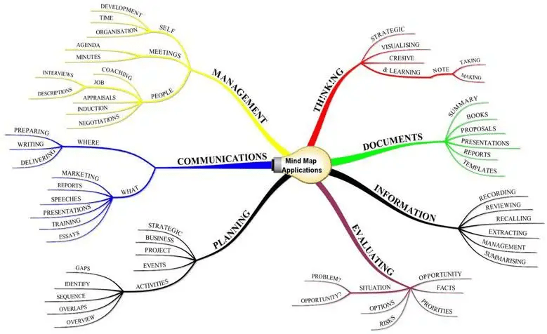
When to use: Use when the lecture content is heavy and well-organized. May also be used effectively when you have a guest lecturer and have no idea how the lecture is going to be presented.

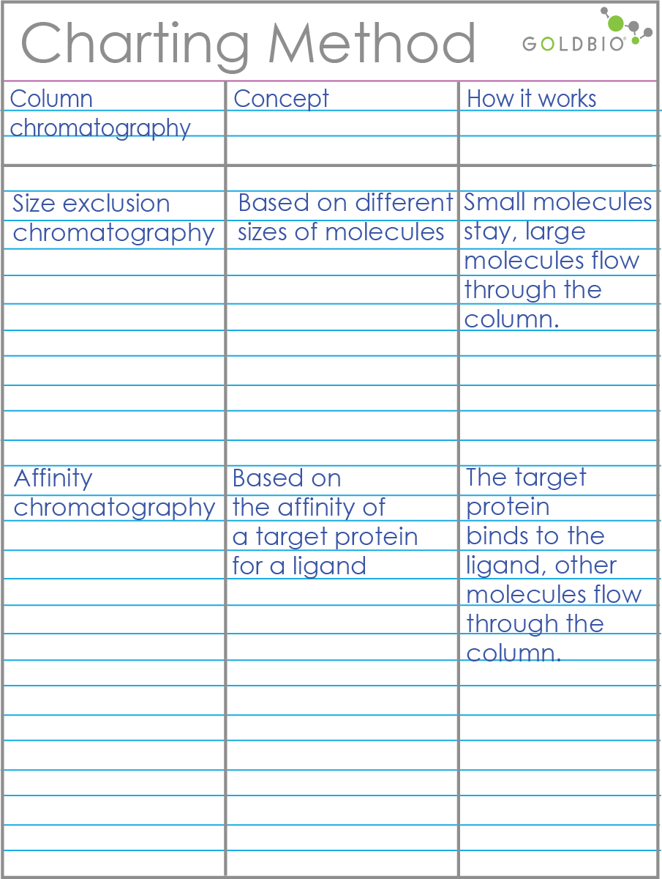
The Charting Method
If the lecture format is distinct (such as chronological), you may set up your paper by drawing columns and labeling appropriate headings to label.

Method: Determine the categories to be covered in the lecture. Set up your paper in advance by columns headed by these categories. As you listen to the lecture, record information (words, phrases, main ideas, etc.) into the appropriate category.
Advantages: Helps you track conversation and dialogues where you would normally be confused and lose out on relevant content. Reduces amount of wriitng necessary. Provides easy review mechanism for both memorization of facts and study of comparions and relationships.
When to use: Test will focus on both facts and relationships. Contents is heavy and presented fast. You want to reduce the amount of time you spend editing and reviwineg at test time. Yiou want to get an overview of the whole course on one big paper sequence.

The Sentence Method
Method: Write every new thought, fact or topic on a separate line, numbering as you progress.
Advantages: Slightly more organized than the paragraph. Gets more or all of the information. Thinking to tract content is still limited.
Disadvantages: Can’t determine major/minor pints from the numbered sequence. Difficult to edit without having to rewrite by clustering points which are related. Difficult to review unless editing cleans up relationship.
When to use: Use when the lecture is somewhat organized, but heavy with content which comes fast. You can hear the different points, but you don’t know how they fit together. The professor tends to present in point fashion, but not in grouping such as “three related points”.
Example 1: A revolution is any occurrence that affects other aspects of life, such as economic life, social life, and so forth. Therefore, revolutions cause change.
Example 2: At first, Freud tried conventional, physical methods of treatment, such as giving baths, massages, rest cures, and similar aids. But when these failed, he tried techniques of hypnosis that he had seem used by Jean-Martin Charcot. Finally, he borrowed an idea from Jean Breuer and used direct verbal communication to get an un-hypnotized patient to reveal unconscious thoughts.

