How to Schedule Exams with Testing Services

- Log into your MyCWU page;

- Under Applications, select Disability Services Portal;
- This will take you to the Disability Services website, scroll down and click the underlined Disability Services Portal link;
- Once in the portal, read any messages on your home screen;
- Scroll down to My Accommodations on the left side of your screen;
- Click Alternative Testing;
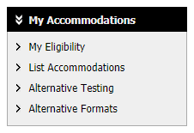
- Under Alternative Testing Agreement(s), select the course for which you would like to schedule your exam and click Schedule an Exam.
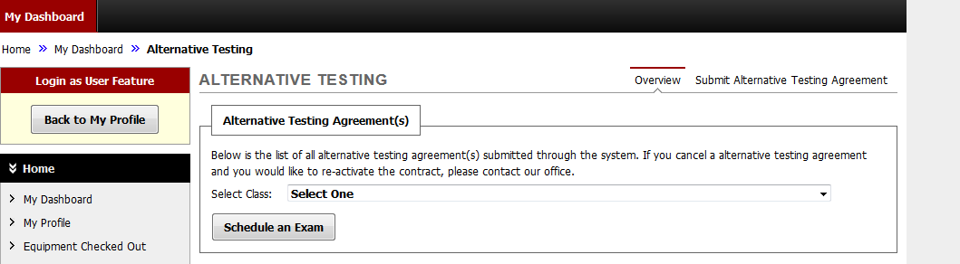
- Click Request Type to select quiz, exam, mid-term, or final.
  - Enter date
  - Enter time (your usual class time, unless you and the instructor have agreed on an alternate start time)
  - Exams may not be scheduled to start after 3:00PM
  - Testing Services is open Monday-Friday, 8:00AM-5:00PM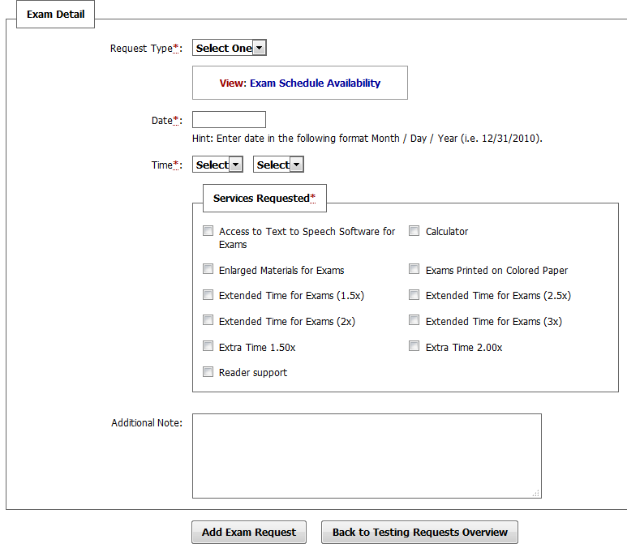
- In Services Requested box, choose the accommodations you want to use.
- Click Add Exam Request.
- When your request goes through, you will see System Update Successful and receive a confirmation e-mail.

NOTE: If a class is not showing up under Alternative Testing Agreement, or you cannot choose the kind of exam under Request Type, there is most likely an issue with your testing agreement. Please call or e-mail Disability Services at 509-963-2214 to resolve the problem.

