Equity & Services Council
Agenda
October 2, 2026
Friday at 2:00 p.m.
Call to Order: 2:00 pm
- CWU ASA: Absent
- ASU: Present
- AUAP: Present
- BSU: Present
- EQuAL: Present
- FASA: Present
- FGSO: Present
- LSO: Present
- MECHA: Present

Other Attendees/ Non-Voting Members:
ALPFA: Present
NASU: Present

Approval of Meeting Minutes:
Motion to approve: MECHA
Seconded by: FASA
Motion passes: 7-0-2

Additions or Corrections to Agenda:

Approval of Agenda:
Motion to approve: FASA
Seconded by: ASU
Motion Passes: 7-0-2

Org Report:
ASA - [NAME OF ESC REP] Not Present
Total Attendance: 0
ASU- [NAME OF ESC REP] Moved meeting time to 6 pm to 7pm Mondays
Total Attendance: 0
AUAP - [NAME OF ESC REP] General meeting went well!
Total Attendance: 26
BSU - [NAME OF ESC REP] Good first meeting
Total Attendance: 20
EQuAl - [NAME OF ESC REP] Meeting times TBD, Possible new officer position available
Total Attendance: 0
FASA - John Mathew Espina – first meeting went well!
Total Attendance: 46 attendees
FGSO - [NAME OF ESC REP] first meeting went well, next meeting on Wednesday
Total Attendance:0
LSO – Mario
Total Attendance: 55
- We had our first meeting of the year this Tuesday: Maruchan x Lotería
- We now have a representative for Folklorico
- Folklorico is a branch of LSO
- We will be looking for volunteers for Día de los Muertos during our kickoff on the 20th
MECHA - [NAME OF ESC REP] First meeting went well!
Total Attendance: 22
- History of MEChA
  - Cock fighting
  - This or that
  - Dominos Pizza
  - Announced NACCS conference in Nov. 6-7th
ALPFA - [NAME OF ESC REP] Hoping to host first meeting October 15th, rest of the information is TBD
Total Attendance: 0
NASU - [NAME OF ESC REP] First meeting TBD
Total Attendance: 0

ESC Executive Board Report
ESC Chair: Jose Manuel Milanes Gomez, email, ASCWU.Equity@cwu.edu
- BOD meeting was cancelled due to lack of quorum
  - Next meeting is Monday at 3 in the SURC Pit
- Great job to all the orgs that had their first meetings this week!!
- EVP applications still open, if interested applications close October 9th
- ESC training right after this from 3-5PM and tomorrow from 1-4PM!
- Volunteer hour opportunity for Wellingtons Wildfire!
- Preview Day October 10th
- 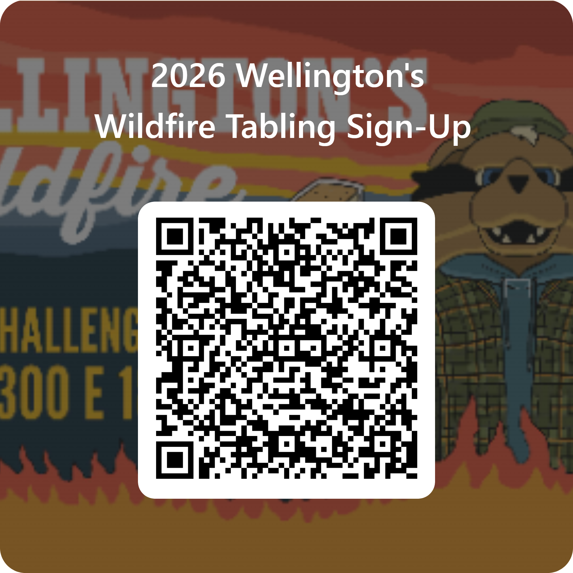
  - You can only receive hours only if you help setup tables
  - You cannot receive hours just for tabling
Executive Assistant: Loralai Norris, email: ASCWUCommunityAsst@cwu.edu
- A newsletter was sent out to everyone on Monday!
- Events Calendar, please update it!
Community Programmer: Isabella Furuc, email: ASCWUProgrammer@cwu.edu
- Lip Sync Theme Ideas
  - Any Suggestions
- Send 3 photos via teams sabella furuc or by email for promotion reasons
  - If you haven’t got back to me
  - Best represents the org as a whole 😊
    - Ex) highlights of last year, tabling and first meeting if it has occurred
- ESC Spotify Playlist
  - Spotify Link
  - Add songs you would like to hear in ESC public events
  - Has to be appropriate
ESC Advisor: Justin Santoli, he/him/his, email: Justin.Santoli@cwu.edu
- Year End Info Session today at 5 pm after training
- ESC Closet Cleanout tomorrow – if you would like to arrive earlier to clean up before training, let me know, otherwise we will arrive at 12:30
- 2LGBTQ+ Welcome – Monday, 4-6 pm, SURC 137
ESC Senator: Alexandra Lake, email: ascwusenateesc@cwu.edu
- No senate meeting last week, the next meeting will be Monday October 5th
Old Business:

New Business:
Funding requests
- LSO – Dia: Motioned to approve by FGSO, seconded by MECHA, passes 6-0-3
General meeting supplies: Motioned to approve by MECHA, seconded by EQuAL, passes 6-0-3
- FGSO – General meeting supplies: Motioned to approve by FASA, seconded by LSO, passes 6-0-3
- AUAP – Boo Baskets: Motioned to approve by MECHA, seconded by LSO, passes 6-0-3

Issues/ Concerns/ Announcements:
Equity Clubs and clubs in bad standing do not have voting power; please don’t vote

Public Comments:
- First Peoples Market volunteer search, QR code provided, mostly needing help with setup, will have free food, and orgs can get community service hours
- Please fill out the event calendar

Adjournment: 2:37 pm

Next meeting is ... October 9^{th,} 2026

