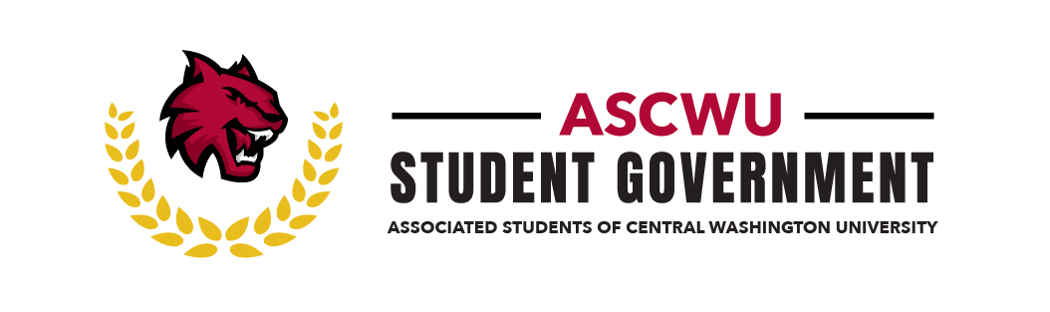
ASCWU Board of Directors Public Meeting

31 October 2022 | Microsoft Teams

CALL TO ORDER

President Reyes calls the meeting to order at 2:32 PM at the SURC Pit.

ROLL CALL

ASCWU Luis Reyes-Ascencio, Executive Vice President

Brayden Smith, Senate Speaker

Briana Silva, Director of Student Life & Facilities

Mariah Minjarez, Director of Equity & Multicultural Affairs

Joseph Gabriel Burke, Director of Governmental Affairs

APPROVAL OF MINUTES

The previous meeting minutes are approved by President Reyes as there are no objections.

ADOPTION AND APPROVAL OF AGENDA

President Reyes-Ascencio moves to amend the agenda by inserting the item” Extend Executive Assistant Hours” under New Business.” Speaker Smith seconds the motion.
President Reyes-Ascencio moves to amend the agenda by inserting the item” Approval of Training and Training Budget” under New Business.” Speaker Smith seconds the motion.

The amendment to the agenda is approved.

President Reyes considers the agenda approved as board has no objections.

PRESENTATIONS
No new presentations.

UNFINISHED BUSINESS

Senator Smith presents a report on the “Title IX and Misconduct.”. Senator Smith reports that the BOD has taken steps to connect with students who have reported the misconduct and other on campus facility to address the reports. Director Minjarez adds that the BOD is meeting with these individuals to ensure that they are aiming for accountability for the institution. Peaceful Protests to be held on Tuesday November 1st, Director Minjarez highly recommends that students help spread the word on the event and support fellow students. Information and services will be provided at the protest as well.
President Reyes emphasizes that safety is top priority and that they have connected with the CWU PD as police will be present but as way to ensure the safety of protesters.

NEW BUSINESS

Senator Smith reporting “Office Space Reorganization,” states that the Space is underutilized and should be created as a hub for student involvement; this also helps with the functionality of the BOD. President Reyes and Director Silva adds that this is a need of the office, there’s 40 staff and not enough room for everyone at once. Formal vote was not taken but the board agrees to further discuss this in the future.

President Reyes motion for the extended one of the Executive Assistants hours to 20 weeks and was passed with a roll call vote with 5 votes in the affirmative.

Roll Call

“To extend ASCWU Executive Assistant hours from 15 to 20 hours a week”

Yes: 5 No: 0 Abstain: 0 Absent: 0

Board Member | Yes | No | Abstain | Absent
Reyes, Luis | ✓
Smith, Brady | ✓
Silva, Briana | ✓
Minjarez, Mariah | ✓
Burke, Joseph Gabriel | ✓

President Reyes motions to the approval of training and training budget for $1100 on November 19th, 2022. Board had scheduling concerns for the training, the date for this event was put off until scheduling conflicts are resolved. Budget for location, meals, and moterpool was passed with a roll call vote of 5 votes in the affirmative.

Roll Call

“Budget for $1100 for ASCWU Training”

Yes: 5 No: 0 Abstain: 0 Absent: 0

Board Member | Yes | No | Abstain | Absent
Reyes, Luis | ✓
Smith, Brady | ✓
Silva, Briana | ✓
Minjarez, Mariah | ✓
Burke, Joseph Gabriel | ✓

REPORT OF ADVISORS

Advisor Amber Hoefer updated that the Election Commission is still hiring! Contact Amber Hoefer for more information and involvement opportunities regarding this. There is also 38 days left in the quarter, Amber encourages students to focus on self-care and reach out to Wildcat 365 for student assistant.

ANNOUNCEMENTS

The State of the University Address will be held on November 4th at 9 am. Tickets will be available at Wildcat Tickets.

Executive session with CAA will be held on October 31st, 2022, this is a private meeting due to the state of the situation.

PUBLIC COMMENT

No comments to report

ADJOURNMENT

The meeting was adjourned at 3:17 PM.

