ASCWU Spring Meeting Minutes
April 18th, 2022
- Call to Order: 1:02 pm
- Approval of the previous meeting minutes
  - Approved by: Edgar
  - Seconded by: Mariah
  - Vote: 4:0:1
- Approval of the agenda (same as above)
  - Approved by:
  - Seconded by:
  - Vote: 0:0:0
- Communications-
  - The BOD voted to strike our previous vote to allow late filing candidates in the ballot
    - Vote passed 3:0:2
  - Elections are happening this week!
    - Please find our tabling stations in front of the SURC Pit and C-Store to vote
    - The link to vote is found on our ASCWU website main page, where you will need to sign into Presence using your CWU log in. Especially important, it will not let you vote if you use your Gmail, yahoo, or other personal email account.
- New Business:

- Committee Updates.
  - The Services and Activities Fee Committee (S&A) meets weekly and virtually via Zoom on Wednesday evenings starting at 5:30 p.m. Meetings are now bi-weekly.
  - The S&A Committee is heavily involved in more of Programs Reviews. Please attend the meeting to learn more about how the base fund areas have used the S&A Fees you paid in the past academic year.
  - If you have questions or need assistance, please contact me at ascwuevp@cwu.edu
  - Office hours are entirely by appointments only this Spring Quarter 2022. Email me at ascwuevp@cwu.edu to schedule a meeting with me.
- Exec Board Updates:
- Rachael-
  - Senate meeting tonight in Shaw Meisner 115
    - Any student is welcome to attend.
  - Senate elections are coming up, they will directly follow the BOD general elections, I am available if anyone has questions about the positions or would like tips on how to run.
    - Senators currently make $15 an hour, 5 hours a week
    - Responsibilities of a senator include meeting with students, holding office hours, speaking with administration, coming to senate meetings, and more.
    - Email ascwu.senate@cwu.edu or william.stryker@cwu.edu with questions about senate elections.
  - My office hours this quarter are Mondays and Tuesdays from 3-3:50 pm.
- Alejandra –
  - Wildcat Wednesdays every Wednesday in the SURC corridor from 1 PM – 3 PM. Stop by to win free CWU swag & get the inside tea on what's happening around campus.
  - CWU Mariners Night is on Friday April 22^{nd.} . ASCWU is giving away 10 free pairs of tickets to current CWU students. Follow @Wellington_Wildcat on Instagram to you can find the link for the giveaway. 10 lucky Students will be selected at random.
  - Wildfest (Student Appreciation Day) will take place on Thursday May 26th at Barto Lawn. Free food, inflatables, yard games, booths, and a killer lineup. An event you won't want to miss!
  - Family Weekend on campus May 6-8. Follow @cwucampusactivites on Instagram for more info.
  - Office Hours: Tuesday & Thursday 12-2, Wednesday & Friday 3-5, or by appointment. Contact us: @Wellington_Wildcat & ASCWU.StudentLife@cwu.edu
- Mariah –
  - ESC Weekly Meetings are held on Fridays from 1-3 pm via zoom
  - CCI Taskforce Updates
    - CCI Taskforce meeting dates
      - Tue, May 10th @5 PM (location TBD)
      - Wed, June 1st @5 PM (location TBD)
    - The final CCI Open Forum will be held on Tuesday, May 31st at 5 PM in the SURC Pit
  - THRIVE is meeting on Tuesday, April 19th at 5:30 PM in Black Hall 105!
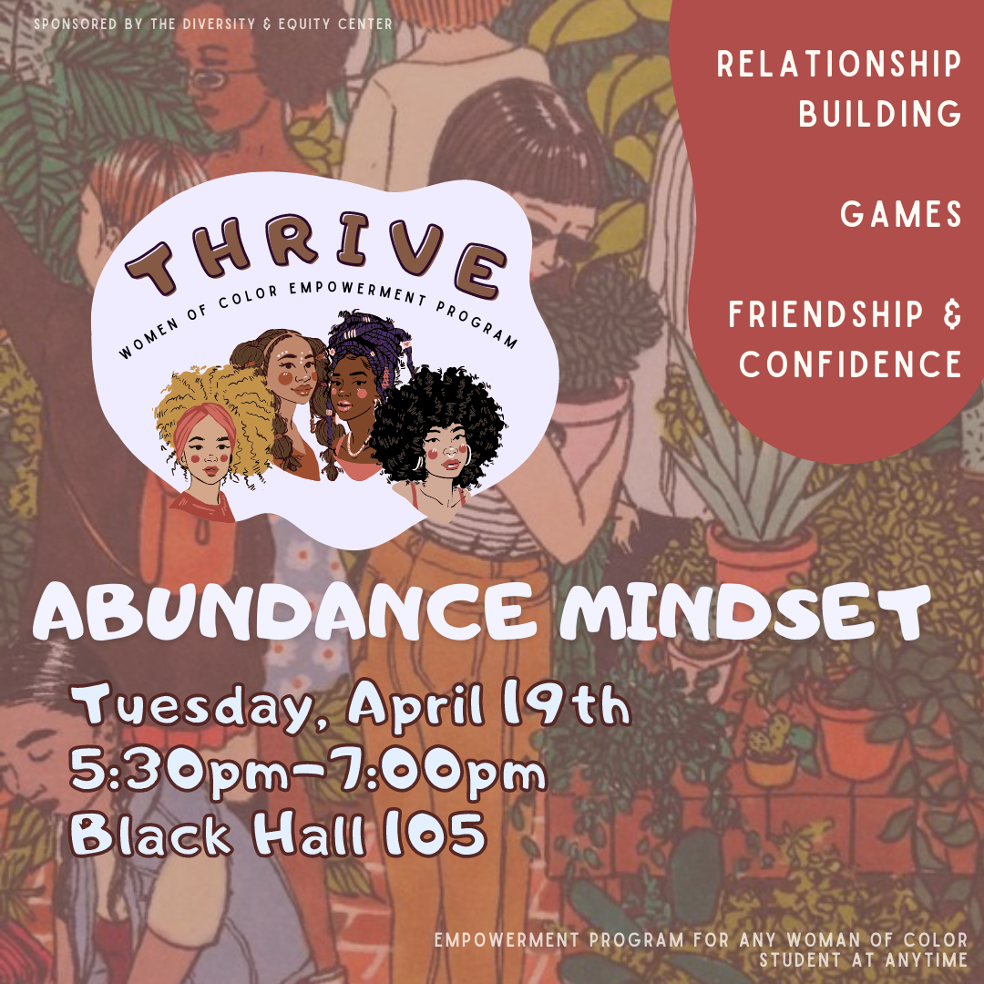
  - Culture Corner at the DEC is in full swing! Please stop by for thoughtful chats and snacks!

- Be sure to follow our Instagram for more updates!
  - @escatcwu
- My office hours are Tuesday and Thursday from 1-2 PM or by appointment.
  - Location: ASCWU Student Government Office, SURC 236
- Edgar –
  - Student Trustee Application open until May 2nd!
    - Link to apply: https://cwu.presence.io/form/2022-2023-student-trustee-application, QR code to link below
    - 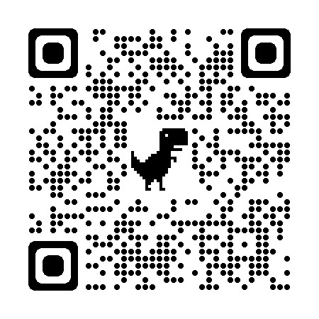
  - SLAC Meeting this Thursday via Zoom
    - Zoom Link: https://cwu.zoom.us/j/8462790436
  - Movie Night with ASCWU Gov Affairs: May 5th (Day of Rage), May 12th (Plot to Overturn the Election) and May 24th (Al-Nakba: The Palestinian Catastrophe 1948), 6-8pm each day in the SURC Theater (SURC 210)
    - Will be hosting a drawing a well each night for the Movie Night, come on by and learn more about contemporary political issues and win some cool prizes
  - Office hours M-F 1-4pm
  - Question? Reach out to me at ascwugovernmental@cwu.edu
- Maddy –
  - We are gaining access to the student body email in May!
  - Council of Probity and Election Commission for 2022-2023
  - Office Hours
    - M/W/F from 9-10:50 am
    - T/Th from 11-2 pm
    - F from 9-9:50 am and 12-3:00pm
  - My email: ascwupresident@cwu.edu
  - Social media handles:
    - Instagram: ascwu_sg
    - Twitter: ascwu_sg
    - Facebook: ascwusg
- Co-advisor updates:
- Amber Hoeffer
- Emails: hoeffera@cwu.edu
- Public Questions, Comments, Concerns, Announcements:
- Adjournment:

