ASCWU Winter Public Executive Board Meeting Minutes
March 7th, 2022
- Call to Order: 1:00 pm
- Approval of the previous meeting minutes
  - Approved by: Rachael
  - Seconded by: Mariah
  - Vote: 5:0:0
- Approval of the agenda
  - Approved by: Rachael
  - Seconded by: Mariah
  - Vote: 5:0:0
- Communications-
  - Utilize your resources! Access resources at the Student Health Services, Wildcatcare365, the Wellness Center, and the DEC.
- New Business:
  - Election commission appointments:
- Committee Updates:
  - Met on 2/15 with Joel-University CFA Concerning the CCI and Potential funding sources for ASCWU-Funding from Alumni Foundation.
  - S&A-Resolution Update
    - Over the last week, student government voted to shift voting power from faculty members entirely into the hands of the students!
    - Students pay, so they should have a say where the money gets spent
  - The Services and Activities Fee Committee (S&A) meets virtually via Zoom on Wednesday evenings starting at 5:30 p.m.
- Exec Board Updates:
- Rachael-
  - Senate update:
    - Very last meeting tonight! Guest speaker from Dining Services
      - 5 pm in Samuelson 102
- Alejandra –
  - PUSH X ASCWU Food Drive from February
    - Raised over $6,000 that will help keep the pantry stocked!
    - Also gathered enough physical donations to keep the pantry stocked for 2 weeks.
    - We wanted to thank everyone who was involved and made the effort to donate!
  - CCI Open Fourm from March 3rd
    - A significant amount of participants
      - To update student population on the meeting ASCWU had with Executive Leadership Team and Jim Wohlpart
    - Discussion about funding the CCI through the Student Fee was a prominent point
      - Location, funding methods available, feedback from students about the Student Fee
    - Followed up with Andreas Bohman about student feedback
      - Follow-up meeting to discuss secure locations with funding methods, more information in the first public meeting of Spring quarter
  - We have 1 Spot available for Housing Dinning Advisory Board Spring quarter for a student at large. We are also looking for Students to sit on the Wildcat Shop Advisory Board.
- Mariah –
  - The last ESC Meeting of the quarter will be held this Friday (March 11th) at 1 PM via Zoom!
  - Womens Herstory Month Display
    - March 8th, 12-3pm in SURC 137
  - Donut Stress Study Session with THRIVE and Q*Fam.
    - March 9th, 1-5 pm, Black 105
  - THRIVE Guest Speaker: Beatrice Kamau
    - March 10th, 5 pm (Zoom)
  - DEC Spirit Week!
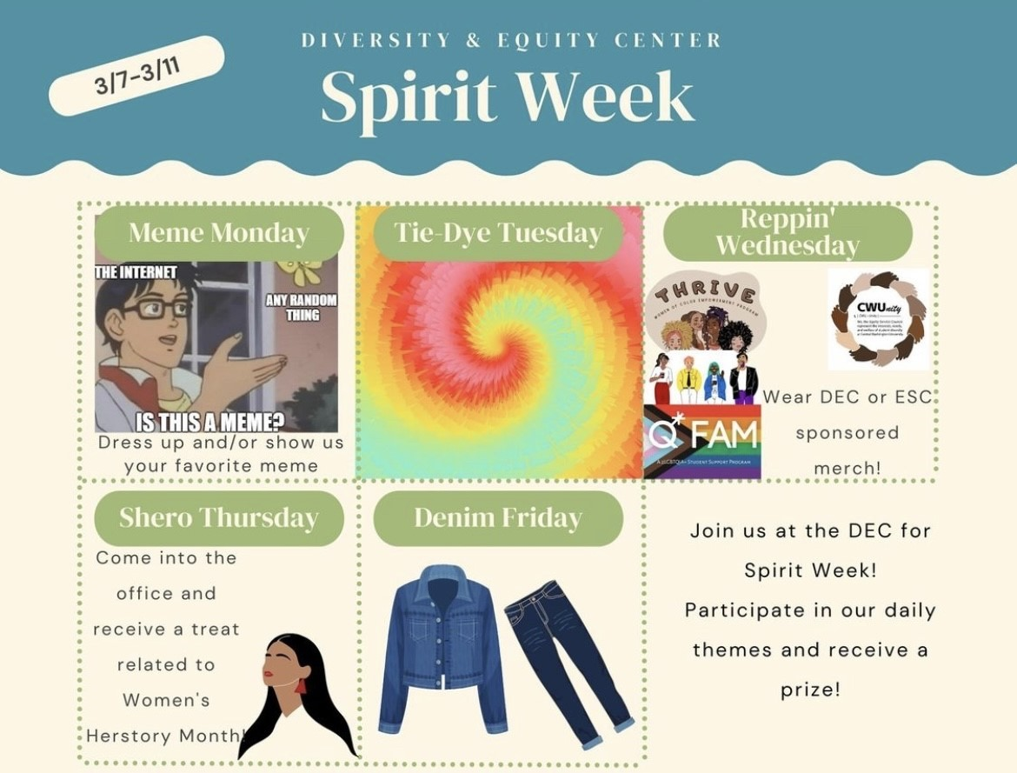

- Edgar –
  - SLAC this Thursday at 4 pm via Zoom
    - CANCELLED
  - Global Politics discussion/livestream event
    - March 8th – 10th from 5-7 pm
  - Legislative updates:
    - HB 1659 (increases Washington college grant) passed the Senate and will go to the governor's office to be signed into law
    - 2SHB 1835 (increasing FASFA/WASFA completion rate) has passed the senate will go to the governor's office to be signed into law
- Maddy –
  - Election update and upcoming events:
    - There are no primary elections, only general elections
    - ASCWU Public Debate #1: April 4th at 6 pm
    - ASCWU Public Debate #2: April 11th at 6 pm
    - General elections begin April 18th at 8 am and end April 22nd at 5 pm
  - Constitution updates:
    - We are working on creating an amendment to our current constitution that will lower the number of senators within the senate due to budgetary constraints and more details will be shared at the beginning of spring quarter
      - Just to ensure we aren't going over budget and into debt at all
      - Updates for you next quarter
      - In order to pass must be voted on by the student body
  - Mask updates for spring quarter:
    - The Executive Leadership Team is still working on their decision about the mask update
    - A survey went around from administration asking opinions about the mask mandate – we have not seen the results of that survey
    - I conducted a survey myself on Instagram:
      - 401 students replied to the survey
      - 61% said that they believe masks should be optional
      - 39% said they think we should keep the mask mandate for spring quarter
    - Update from Jim Wohlpart is forthcoming
  - Office Hours
    - M/W from 9-10:50 am
    - T/Th from 11-2 pm
    - F from 9-9:50 am and 12-3:00pm
  - My email: ascwupresident@cwu.edu
  - Social media handles:
    - Instagram: ascwu_sg
    - Twitter: ascwu_sg
    - Facebook: ascwusg
- Advisor updates:
- Amber Hoeffer (Director of SLICE and Advisor for ASCWU)
- Emails: hoeffera@cwu.edu
- Orientation Session on Monday, March 14th
  - Hosting new students starting in the Spring quarter
- Elections Commission is meeting every Monday
  - Student-run process
  - Reach out to Election commissioner or Amber to be connected to the election process
- Cwu.edu/events-caldendar to see all of the events this upcoming finals week
- Library extended hours for finals week (starting March 14th)
  - Open until 2 am
- Public Questions, Comments, Concerns, Announcements:
- Adjournment: 1:18 pm

