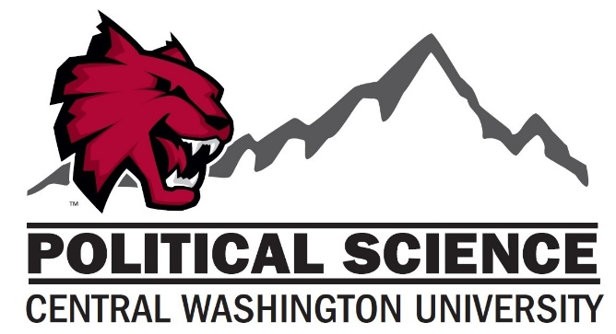

Political Science Courses
(Numerical order)
First Year Experience Course
POSC 184 Freedom and Authority

Core Courses
POSC 101 Introduction to Politics
POSC 210 American Politics
POSC 260 Comparative Politics
POSC 270 International Politics
POSC 280 Introduction to Western Political Thought
POSC 489 Senior Assessment

Elective Courses
POSC 230 State and Local Government
POSC 250 Language and Power
POSC 298 Special Topics
POSC 311 Women and Politics
POSC 312 Public Opinion and Political Communication
POSC 313 The Legislative Process
POSC 314 The American Presidency

Electives Continued
POSC 315 Political Campaigns and Elections
POSC 316 Latinos and the US Political System
POSC 318 Political Parties and Interest Groups
POSC 320 Public Administration
POSC 325 Intro to Public Policy
POSC 340 Politics and American Capitalism
POSC 341 Politics and Religion
POSC 343 Politics of the U.S
POSC 344 Environmental Politics
POSC 342 U.S. Foreign Policy
POSC 350 Introduction to Public Law
POSC 361 Latin American Politics
POSC 362 Western European Politics
POSC 363 Russian and Soviet Politics
POSC 365 African Politics
POSC 366 Government and Politics of East Asia
POSC 367 Japanese Politics
POSC 368 Chinese Politics
POSC 369 Korean Politics
POSC 372 Politics of Globalization
POSC 373 International Politics of the Pacific Rim

POSC 375 The Middle East and International Politics
POSC 376 International Organization
POSC 378 International Political Economy
POSC 398 Special Topics
POSC 401 Nobel Prize Winning Political Scientists
POSC 410 Contemporary Issues in American Politics
POSC 411 American Indian Politics and Sovereignty
POSC 429 Research Seminar in Public Policy
POSC 441 Politics and Film
POSC 451 Introduction to Constitutional Law
POSC 452 The Constitution and Human Rights
POSC 453 Constitution and War
POSC 460 Contemporary Issues in Comparative Politics
POSC 470 Contemporary Issues in International Relations
POSC 475 International Human Rights Political Thought and Philosophy
POSC 481 Early Political Thought
POSC 482Early Modem Political Thought
POSC 483 Recent Political Thought
POSC 485 American Political Thought and Culture
POSC 488 Intro to Political Science Methods and Research
POSC490 Cooperative Education

