Educational & Career Benefits
Skills gained are directly applicable to research
and technical work in Biology:
- field equipment maintenance
- Electrofishing to capture fish in small streams
- Handling, measuring, and tagging live fish
- Processing and identifying aquatic
invertebrates

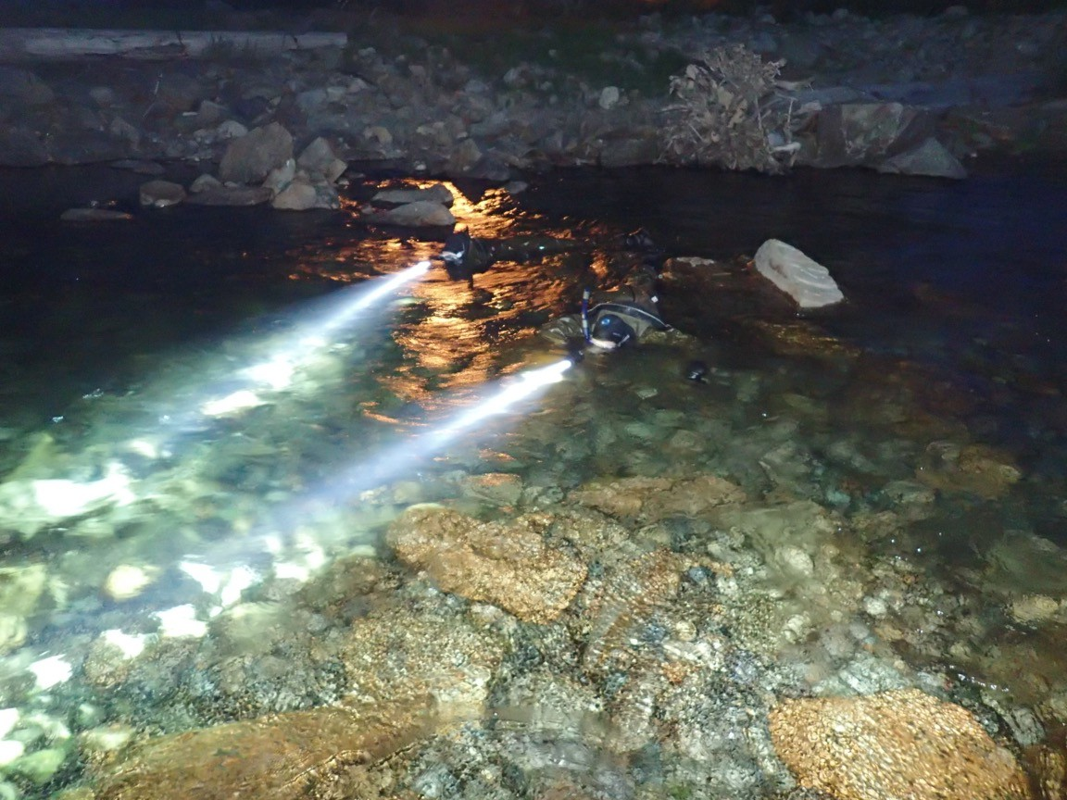
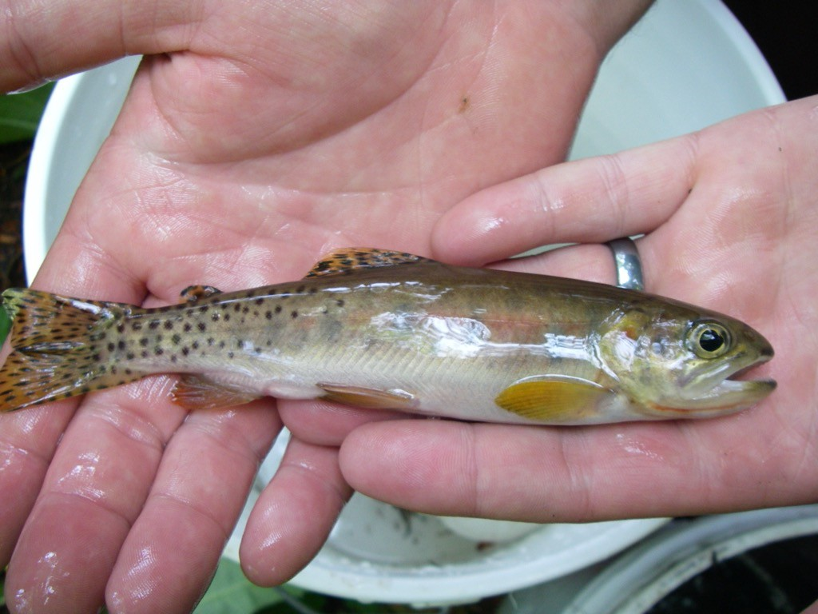
CWU Summer 2026 Field Biology Job Stream Research Field Assistant
Job summary
- Survey fish and aquatic insect populations in
structures on I-90 for ecological connectivity.
- Process (sort and identify) benthic macroinvertebrate samples in the lab.
small streams near Snoqualmie Pass to assess the effectiveness of wildlife crossing
Qualifications:
Required:
•
•
•
•
•
•
•
•
Ability to swim and be comfortable wading in running water;
one quarter of college biology for majors (BIOL 181); career interest in biology or environmental sciences; excellent team-work skills;
ability to carefully follow protocols and instructions; ability to carry field gear (up to 30 pounds) across rough terrain through forests and in rocky streams;
adaptable to varying environmental conditions (weather,
biting insects, etc.);
valid driver’s license and clear driving record.
Preferred: Junior standing at CWU with at least one year of undergraduate work in Biology or ENST-Biology; experience in ecological field work (may be during courses) or related research or job experience; experience handling live animals

Pay and Schedule: $22-25 per hour, depending on experience. Total 200-400 hours during the summer (approx. Jul. 1- Aug. 31), depending on availability and research needs. Some flexibility, but not compatible with 6-week or 8-week summer courses or with weekday jobs.
Info & Application Process
- For more information, contact Dr. Paul James via email: jamesp@cwu.edu
- To apply: submit (1) cover letter that addresses your qualifications for the position and your research and career interests; and (2) resume or CV with names and phone numbers of 2 references who can speak to your qualifications.
- Review of applications will begin May 4, 2026 and continue until suitable candidates are hired.

