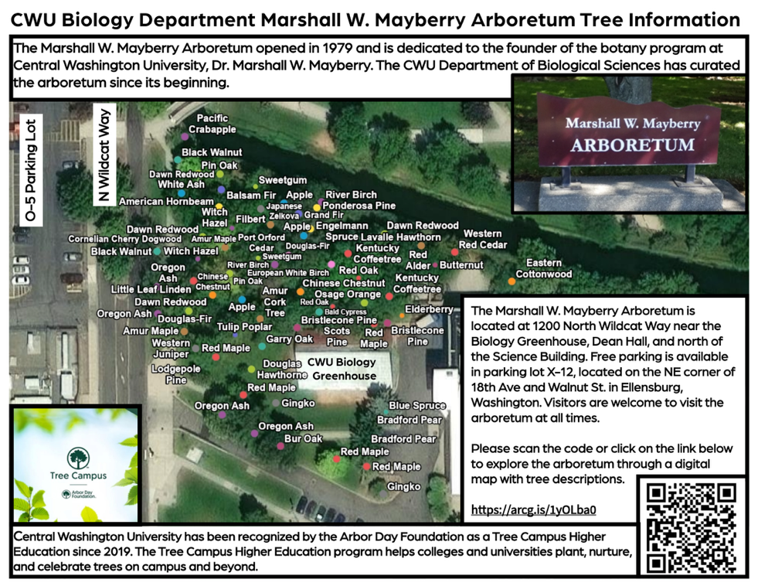
CWU Biology Department Marshall W. Mayberry Arboretum Tree Information
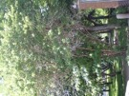  American Black Elderberry, (Sambucus canadensis). This North American shrub is common in Washington but not native to the area. Although leaves and roots of the plant are toxic, the berries are edible and are enjoyed by wildlife and can be used in jams, pies, and for wine. | 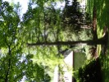  Bald Cypress, (Taxodium distichum). This tree is named for the fact that it loses its leaves in the winter and becomes a "bald" conifer. It is native from southern swamps in the United States to the East Coast as far north as Maryland. This tree is the Class Tree for the CWU Class of 1950. | 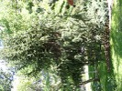  Bristlecone Pine, (Pinus aristata). This species is native to the southwestern United States and is best known for its longevity. Bristlecone pine trees can live for thousands of years. Needles of these trees are often frosted with tiny white pitch droplets.
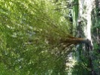  American Hornbeam, (Carpinus caroliniana). Also known as ironwood, this tree is native to the eastern United States where it often grows near the banks of streams and rivers. | 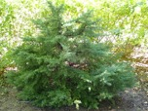  Balsam Fir, (Abies balsamea). This aromatic and symmetrical fir is native to the northeastern United States and is an important component of forests across eastern Canada. Cones are purple when they are young. | 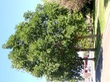  Bur Oak, (Quercus macrocarpa). Named for its large acorns with bristled husks, this oak species is one of the most cold and drought tolerant oaks native to the eastern and midwestern United States. A long-lived tree that provides food to birds and many mammals.
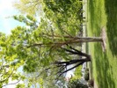  Amur Cork Tree, (Phellodendron amurense). Named for its cork-like bark and native to Asia, this tree is often planted as an ornamental due to its large, spreading crown. This tree is the Class Tree for the CWU Class of 1934. | 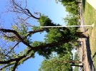  Black Walnut, (Juglans nigra). The walnuts from this species have a zestier flavor than English walnuts. The wood is supreme in its hard grain and lovely deep brown color and workability. This species is native to the central and eastern portions of the United States. | 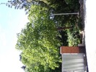  Butternut, (Juglans cinerea). This species is native to the eastern United States. Nuts from the tree are edible and can be made into a butter, hence the common name, butternut. The wood of the tree is softer than black walnut but is rot resistant and often used for making furniture.
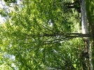  Amur Maple, (Acer ginnala). This small maple is often grown in gardens or along boulevards. It is native to Asia and tolerant of cold winters. | 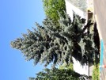  Blue Spruce, (Picea pungens). This Rocky Mountain tree is a popular ornamental due it the attractive blue-green to silver-colored needles. | 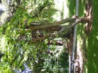  Chinese Chestnut, (Castanea mollissima). Chinese chestnut trees are resistant to the chestnut blight that decimated American Chestnut trees in the 1900s. These are, therefore, the most popular chestnut trees in the US and are often grown for their edible nuts.
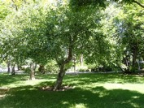  Apple, (Malus domestica). Apples originated in central Asia but are now cultivated worldwide, including in Washington, the "Apple State". | 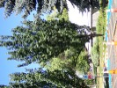  Bradford Pear, (Pyrus calleryana). Native to China and Taiwan, this species, also known as Callery pear, is planted for the showy white flowers it produces in the spring and glossy foliage. The fruits are woody but soften after the fall frost and are enjoyed by birds. | 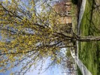  Cornelian Cherry Dogwood, (Cornus mas). The common name of this tree refers to bright red fruits that resemble the gemstone, Carnelian. Native to Europe and Asia, this tree has bright yellow flowers that appear in the early in the spring, before the leaves emerge

CWU Biology Department Marshall W. Mayberry Arboretum Tree Information

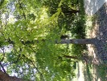  Dawn Redwood, (Metasequoia glyptostroboides). This tree was first discovered from a fossil. In the 1940s, living specimens were found in China. The needle-like green leaves turn orange in the fall before falling from the tree. | 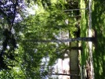  European White Birch, (Betula pendula). This birch has been introduced to the US from Europe. It is planted as a decorative tree and casts light shade that allows other plants to grow underneath. | 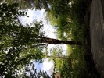  Japanese Zelkova, (Zelkova serrata). Native to Japan and eastern China, this elm tree is often planted in urban areas as a substitute for American elm as it is not susceptible to Dutch elm's disease. This tree was one of the first to be planted in the Marshall W. Mayberry Arboretum.
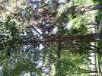  Douglas-Fir, (Pseudotsuga menziesii). This tree species is common in Washington, covers more area than any other tree in the Pacific Northwest and is the most important lumber species in the United States. | 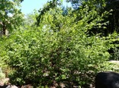  Filbert, (Corylus maxima). This European tree is grown commercially to produce filberts, which are similar to hazelnuts. The nuts produced by this tree are small but eaten by wildlife. | 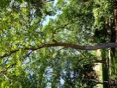  Kentucky Coffeetree, (Gymnocladus dioicus). Native to the midwestern United States seeds of this species can be used to brew a coffee-like beverage. As with many trees in the pea family, leaves of this tree move to a sleeping position at night. This is the Class Tree for the CWU Class of 1970.
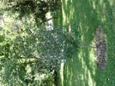  Douglas Hawthorne, (Crataegus douglasii). This tree is native to Washington and named after David Douglas, a Scottish botanist who collected plants in the Pacific Northwest. The fruits are an important food source for birds. | 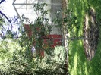  Garry Oak, (Quercus garryana). Also called Oregon white oak, this is the only oak native to Washington state. Historically common in the state, the Washington Garry oak population diminished greatly. Mature Garry oak have a gnarled appearance and can live up to 500 years. | 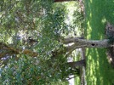  Lavalle Hawthorn, (Crataegus x lavallei). This tree type originated in France as a hybrid between two cultivated trees. White flowers in the spring give rise to showy orange fruits or “haws” that stay on the tree into winter. The tree produces tough thorns when grown on poor soils
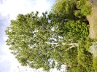  Eastern Cottonwood, (Populus deltoides). This large, fast-growing tree is native to the eastern United States and grows especially well along streams and rivers. Seeds have hairs that give the appearance of cotton as they float in the air. | 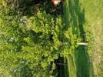  Gingko, (Gingko biloba). The lineage of this tree is one of the oldest of any tree species on the planet. A relative of the conifer family, its leaves turn a striking yellow-gold in the fall before they are dropped from the tree. These characteristics give the tree the common name of "golden fossil tree." | 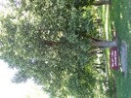  Little Leaf Linden, (Tilia cordata). Little leaf linden is native to Europe. It is frequently planted in the United States along paths and as a shade tree. Butterflies are attracted by the fragrant spring flowers. The specific epithet, cordata, refers to the heart-shaped leaves.
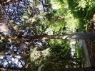  Engelmann Spruce, (Picea engelmannii). This spruce is a slow-growing shallowed-rooted species native to Washington State. At timberline, you might see it in a shrub form. This tree is the Class Tree for the CWU Class of 1970. | 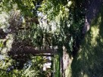  Grand Fir, (Abies grandis). Also known as white fir this tree is found throughout forested areas of Washington State mixed with Douglas-fir and Ponderosa pine. The wood is used for lumber and pulpwood. | 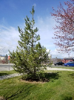  Lodgepole Pine, (Pinus contorta). This pine is native to the western United States and named for the custom of native people using the tall, straight stems to construct lodges.

CWU Biology Department Marshall W. Mayberry Arboretum Tree Information

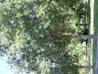  Oregon Ash, (Fraxinus latifolia). Native to the western United States, this ash tree grows rapidly, and forms stands along water courses and in swampy areas. | 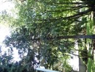  Port Orford Cedar, (Chamaecyparis lawsoniana). Despite the name, this species belongs to the cypress family. It is native to coastal California and Oregon. The wood is strong and has a straight grain. Pea-sized cones may be green, yellow, or blue. This tree is the Class Tree for the CWU Class of 1977. | 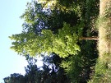  Sweetgum, (Liquidambar styraciflua). This tree is one of the most valuable forest trees in the southeastern United States. It has star-shaped leaves that smell sweetly resinous if scratched and recognizable hard, spiked fruits.
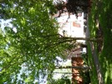  Osage Orange, (Maclura pomifera). Also called "hedge apple" because the apple-sized fruits and because in these trees were historically planted as hedges in the southwestern United States. Spines on this tree inspired the invention of barbed wire. This is the Class Tree for the CWU Class of 1958. | 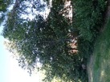  Red Alder, (Alnus rubra). This alder is native to the Pacific Coast from southern Alaska to central California where it grows along watercourses and wetlands. It is commonly associated with Douglas-fir, western hemlock, grand fir and western redcedar in Washington forests. | 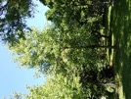  Tulip Poplar, (Liriodendron tulipifera). This species, also known as American Tulip Tree, is named for its large spring flowers that resemble tulips and its wood that resembles poplar wood. It is native to the eastern United States and a member of the magnolia family.
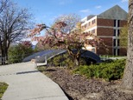  Pacific Crabapple, (Malus fusca). This crabapple is native to western North America and is common in Cascade and Pacific Coast temperate forests. The fruits are edible but very sour. | 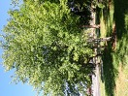  Red Maple, (Acer rubrum). This maple is one of the most common deciduous trees of the eastern and central United States. In the west it is often planted as a shade tree and as an ornamental. In the fall the leaves turn a scarlet red giving some strains of the species the name "October Glory Maple". | 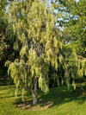  Western Juniper, (Juniperus occidentalis). This tree is native from British Columbia to southern California where it typically grows in rocky sites at high elevations where there is less competition from Ponderosa pine. The cones are berry-like and become blue-brown as they mature.
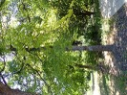  Pin Oak, (Quercus palustris). Also called swamp oak this fast-growing tree is native to the Eastern and Midwestern portions of the United States where is an important food source for migrating waterfowl. The name "pin" refers to slender twigs that form pin-like knots in the wood. | 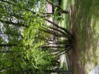  River Birch, (Betula nigra). Also called black birch this species, native to the eastern United States commonly occurs in floodplains or along streams. It can be trained to be a single tree, but naturally occurs as a multi-trunked tree. The bark is a reddish brown and the leaves are leathery. | 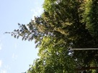  Western Red Cedar, (Thuja plicata). This Pacific Northwest native tree is one of the most important trees in Washington State. It has been used by native peoples for many practical uses from medicine to canoes and almost all wooden shakes in the United States are made from this species.
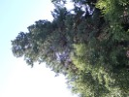  Ponderosa Pine, (Pinus ponderosa). Ponderosa pine is the dominant pine tree of the western United States. It often grows in pure stands and is an important timber tree. Ponderosa pines can grow to be 1000 years old and may be over 200 feet tall and 8 feet in diameter. | 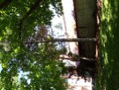  Scots Pine, (Pinus sylvestris). The only pine tree native to northern Europe where it is an important timber tree. In the United States, this tree is often planted as an ornamental. | 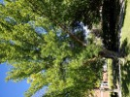  White Ash, (Fraxinus americana). White ash is native to the eastern and central United States where it is a common tree but threatened by the Emerald Ash borer, a common pest throughout the United States. This tree is the Class Tree for the CWU Class of 1942.

CWU Biology Department Marshall W. Mayberry Arboretum Tree Information
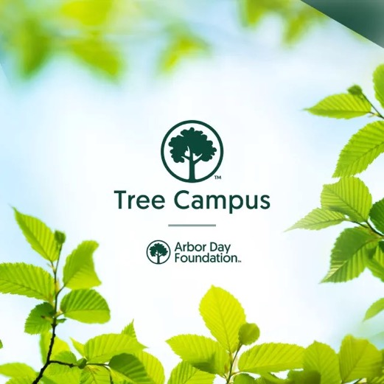
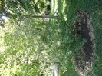
Witch Hazel, (Hamamelis virginiana). This shrub is native to eastern North America and has bright yellow flowers that appear in the fall. The stems, bark, and leaves can be used to make an extract that is an astringent and has been used traditionally to treat swelling and inflammation.
In recognition of its efforts to plant, nurture, and celebrate trees, the Arbor Day Foundation has honored Central Washington University as a Tree Campus USA.
The Tree Campus Higher Education program helps colleges and universities establish and sustain healthy community forests

