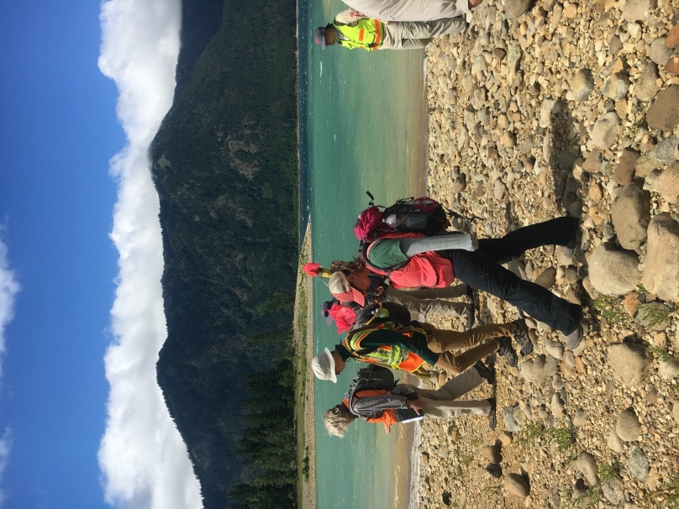
ADDITIONAL INFORMATION 2026
on CRM Archaeology Field School
Central Washington University

Updated February, 2026

Eligibility
The field school is open to anyone eligible to register for college credits (whether college students or not), and may be audited by those not wanting college credit. There are no pre-requisites, but some background in archaeology is strongly encouraged.

Schedule
The field school will meet weekdays from June 22 through July 10, 2026.
Pedestrian Survey at Lake Cle Elum

Our first meeting will be Monday June 22 at 9 AM in Dean Hall Rm 209.

Registration
Your first step is to submit a field school application to the instructor by May 15, 2026 (or later as space allows).
Here’s more information on Summer Session including registration, housing, and tuition https://www.cwu.edu/admissions-aid/summer-session/index.php/tuition-and-fees

Once you are accepted, you will need to register for CWU Summer Session. You will need to get a permission number from the instructor to register, and take these additional steps:

Current CWU students who will not graduate before the field school need only to enroll using their permission numbers. This can be done online by sending me your student id so that I can add you to the permissions list for the course.

All non-CWU students and CWU graduating students will need to submit a “Summer Session Non-matriculated Student Application” form before registering. The form may be obtained online under Registrar Forms at https://www.cwu.edu/about/offices/registrar/academic-information/forms.php.
You will receive an acceptance notification within 72 hours of applying. Once you are accepted, you will log into MyCWU using the information in your acceptance email.

The $40.00 application fee is not due up front; it will be due together with tuition and fees on the payment due date listed in the Academic Calendar for the applicable term. Please also review the “open enrollment” date on the Academic Calendar, which will indicate when classes can be added. The link to the calendars can be found here for each term: https://www.cwu.edu/about/offices/registrar/academic-information/index.php.

Rates for tuition and fees can be reviewed at the Financial Aid website at: https://www.cwu.edu/admissions-aid/financial-aid-scholarships/additional-resources/summer-cost-of-attendance.php#accordion-d353dd39-d8a8-48d4-8675-f01574c7c61f-0 Further questions about rates should be directed to their office at FinancialAid@cwu.edu or at 509.963.1611.

Steps for adding and dropping classes can be found at: https://www.cwu.edu/about/offices/registrar/academic-information/how-adddrop-classes.php.

All students will earn credits in ANTH 493 "Anthropological Field Experience" (6 credits). These credits are on the quarter system; 6 quarter credits are equivalent to 4 credits on the semester system.

See the CWU website for more information on tuition, fees, and deadlines https://www.cwu.edu/admissions-aid/financial-aid-scholarships/financial-aid/about/Summer%202024%20COA.php
. When a student registers for classes a financial obligation to the University is incurred and adjustments will be made according to the current refund policy. Payment by VISA or MASTERCARD is accepted for all tuition and fee expenses for summer quarter. The field school cost of approximately $1927 (6 credits for undergrads) will be used to pay for tuition, student fees, instructor salaries, and part of our transportation costs. Graduate credits and out-of-state tuition is more expensive so check the tables on the webpage listed above.

Housing
For out-of-town students, campus housing and dining facilities may be available through the CWU Housing Program https://www.cwu.edu/student-life/housing/resources/summer-housing.php Please check the website for details about cost and availability. You can contact Dr. Terry for suggestions, but you must make your own housing reservations.

There are also several local commercial campgrounds. The best options for the length of our project are the Ellensburg KOA about three miles west of campus (509-925-9319; www.koa.com), or the Yakima River RV Park about six miles south of campus (509-925-4734, www.YakimaRV.com ). Other campsites are available in the Yakima Canyon and near Cle Elum, but these are a bit further away from town. You might find something that suites you!

Finally, you could rent from AirBNB or Vrbo, a motel, or sublet an apartment for the summer. Since we are a college town, there are often sublets available in the summer. Several students have done this in past years. We are asking current CWU students about their plans and possible rooms that may open.

Getting Here
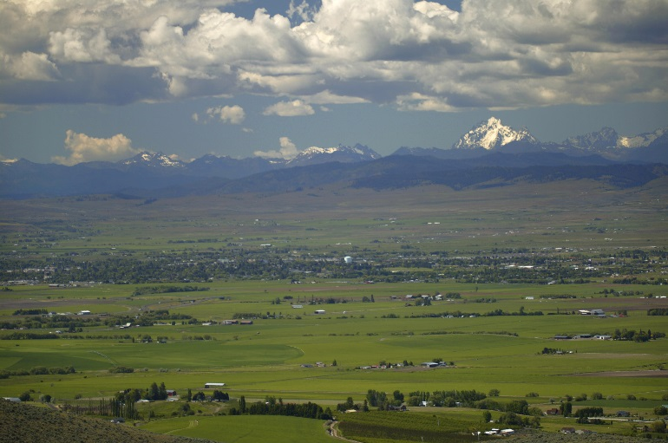
Ellensburg is in the middle of Washington State, along Interstate Highway 90 just few miles west of its intersection with Interstate Highway 82, which makes it very accessible by car. If you are flying to Ellensburg, you can fly into Seattle (Sea-Tac Airport; ~hour drive west of Ellensburg) or Yakima (~45 minute drive south of Ellensburg). It might be simplest to fly to Sea-Tac and take the Bellair Airporter shuttle from the airport directly to the Starbucks at the edge of CWU campus in Ellensburg. The shuttle bus web site with the schedule is at
Ellensburg and surrounding mountains.

http://www.airporter.com/schedules/schedules-rates-cwa

Field Setting
The field school meets daily at the CWU campus, and will travel from campus to field sites. The CWU campus is in Ellensburg, a town of about 18,000 people at about 1,500 feet elevation in central Washington. The town is surrounded by agricultural fields, particularly timothy hay, and basalt ridges rising up to 6,000 feet elevation. The Stuart Range (Mt. Stuart 9,415 feet) and Alpine Lakes Wilderness lie northwest of town. The ridges around town and most of eastern Washington are covered by plants of the sagebrush/bunchgrass community, primarily big sagebrush and wheatgrass.

In the summer, this area is typically hot and dry. The daily high temperatures during the field season may range from about 75 to 105 degrees (F), with most days hot and sunny and about 90 degrees. We have experienced over 100 degree-temperatures the past few years, so be ready for some very hot conditions. The early mornings can be quite cool and breezy, down to 55-65 degrees, but it will quickly warm up. A few days may be cloudy, with widely scattered showers. Some days could be breezy, blowing around a lot of dust, but most are likely to be nearly still. It may sometimes be very hot, with no trees. On most field days, it will be important to wear sunscreen and a hat, and drink lots of water. The ability to handle these conditions is important; people who are highly sensitive to heat or sunshine may not be good candidates for the project.

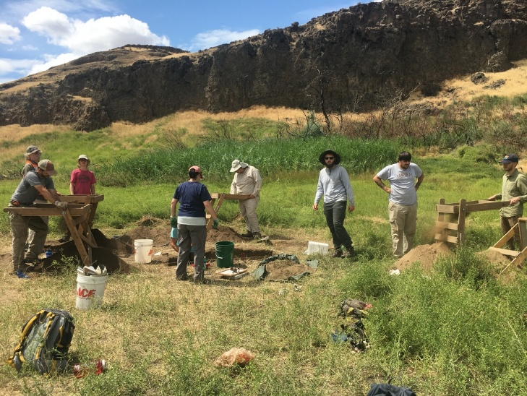
Because of the dry conditions, insect pests like mosquitoes are quite rare. There could be other pesky creatures in the area (e.g., rattlesnakes, scorpions, wasps, Black Widow spiders, and/or ticks), but these are rarely seen. While we have not had problems with any of these creatures in the past, you should be aware of these possible dangers.
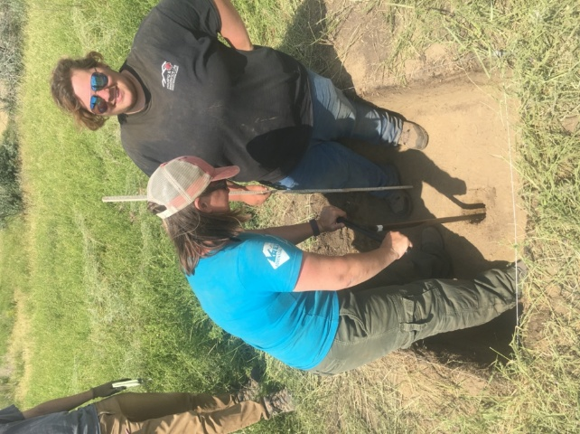

Test excavations Yakima Training Center
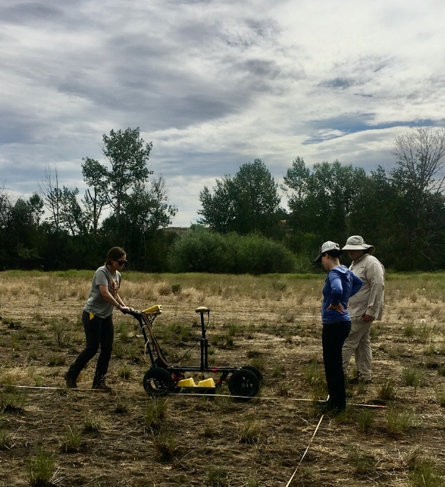 Ground Penetrating Radar (GPR)

Projects and Activities
The field school will include a mix of activities. Most of our field projects are in Kittitas and Yakima counties (reservoirs, fish passage on steams, fire, timber and grazing, spring developments, forest and shrub-steppe). We teach using our 25-year history of case studies and program development at undergraduate and graduate levels. CRM sessions and guest presentations take place in CWU labs and online, and some field training will involve campus project sites. Our project collaborations involve state and federal agency and tribal partners. We accommodate varying levels of engagement to ensure safety and comfort, with acclamation, in our arid and warm climate.

Most of our field sites are located less than an hour drive from our CWU campus. Some opportunities have involved 2-3 hour drives and shorter workdays (Snake River, Upper Columbia, Lower Columbia, Puget Sound). If overnight trips become an option we will prepare participants for field camping, or more “glamping.”

Our orientation is cultural (aka heritage) resource management and we involve students to a full range of tasks: planning, budgeting, GIS applications, survey, site mapping, geophysical prospecting, testing, evaluation, site recordation and artifact analysis. We focus on inventorying pre-contact and historic archaeological resources. Our field sessions include transect survey, total station and GPS mapping, ground penetrating radar, and shovel probing. Where appropriate we include excavating test units or contribute to block excavations on ongoing projects. Our projects support community participation and interpretation, and serve transdisciplinary geoarchaeological and landscape studies.

You may need to arrive prepared for a day in the field as early as the second day of class. Our fieldwork will be in collaboration with government agencies that manage public land in Washington and/or tribal cultural resource management programs. We will be doing CRM (cultural resource management) archaeology for them just as you might do in a future job for an agency or private archaeology contracting company. We will be assisting agency efforts by surveying for archaeological sites on their land, recording sites, helping to determine the significance of sites for listing on the National Register of Historic Places (NRHP), doing test excavations, and/or evaluating damage to sites. The possibility that a site could be listed on the NRHP is a common means for agencies to decide what sort of protection or further work a site will get. Finding sites and evaluating their significance, usually through test excavation, are the most common tasks in CRM archaeology, and we will be sure to provide students with the opportunity to gain familiarity and experience with these tasks.

Further Information:
Karisa Terry, PhD (Instructor)
Department of Anthropology
Central Washington University
400 E. University Way
Ellensburg, WA 98926-7544
Karisa.Terry@cwu.edu

Steven Hackenberger, PhD (project manager)
Department of Anthropology Central Washington University
400 E. University Way
Ellensburg, WA 98926-7544
hakenbe@cwu.edu

See Field Clothing & Equipment and Suggested Readings on following pages.

Field Clothing & Equipment
Except for the days we are in the laboratory or online, you should bring a pack lunch, drinking water, and field clothes every day. Although we will provide all of the larger and more expensive equipment, you will need to provide your own personal gear. The following items are required:

Shoes: Rugged, durable shoes or hiking boots are a must. We may be walking cross-country on hilly slopes and across basalt, so good, comfortable boots are critical. We will be in the desert, so comfort and ruggedness are more important than the ability to repel water. Some people may prefer heavy leather hiking boots for their stiff support and water repelling ability, while others may be fine with light nylon and leather trail boots. Flip-flops and low tennis shoes are never acceptable at work… but you may carry a pair for changing. If you get new footwear for this project, be sure to wear it well before you start the field school or else you will get sore, blistered feet.

Socks: When we do pedestrian survey, we will be hiking, so you should think about having adequate padding while keeping your feet cool. Some people like a thin liner sock plus a thick padding sock to prevent blistering. Experience suggests you should have three or four pairs of socks (cleaned each week). We recommend a thick hiking sock designed to wick moisture from the foot, like Thorlo, Fox Valley, or Wick's Dry, but think polypropylene and wool are too hot, and straight cotton provides too little padding. Be aware that cheat grass is common in some parts of the region, and this stuff sticks horribly in socks. You will want to be sure your pants cover your socks and/or use some lightweight gaiters if we are in a cheatgrass area.

Daypack: For survey days, you will need a comfortable pack for carrying your lunch, water, notebook, extra clothes, and your share of group field equipment (camera, reel tape, etc.). The sort of pack many people use for school is often fine, although some instructors find they need a larger pack to fit it all in. A padded hip belt on the pack that can be tightened to relieve pressure on the shoulders is often appreciated. In rough country, this can be especially useful.

Clothing: Be sure to bring adequate clothes for hot and sunny weather, plus extra clothes for wet and/or cold days. Instructors typically wear lightweight long pants (to protect from sun and vegetation), a T-shirt, and a lightweight long-sleeved shirt (to protect from sun or cool weather). Shorts will not be an option except in very rare circumstances. If you swim you will want a swim suit for the local pool, streams or lakes. We may organize a one day river raft trip. Summer field clothes could be cotton, cotton/polyester, or special sun-blocking work shirts, work pants, painter's pants, or even worn-out dress shirts and slacks like those at the Goodwill store. Low-hip pants are discouraged and belts are strongly recommended.

Hat: A hat with a brim to protect you from the sun is an absolute must, and we strongly recommend sunglasses as well.

Other Personal Gear: Bring sunscreen and water bottles (at least 2 liters worth-- even used 1-1.5 liter plastic pop bottles work well). Leather work gloves may be helpful for the occasional heavy labor we will be doing. If you are allergic to pollen, bee stings, etc., you should make sure to have your necessary medicines. You might also bring along a swimsuit in case we have the chance to take a dip in a swimming hole (optional).

Lunchbox (optional): You may wish to bring a small personal-size cooler for your lunch. On some days we may be able to return to the van for lunch, but if we are surveying we are often far from the van mid-day. So you might consider a small insulated lunch bag instead.

Camping Gear (optional): We may arrange an overnight trip or two as an optional activity. If you’d like to go, it would be helpful to bring along a sleeping bag. If you have a tent to use or share, you might consider bringing that along also.

Archaeology Field Gear: You are required to bring pencils/erasers (We recommend mechanical pencils with large built-in erasers), and a clipboard. You will be provided with everything else you need, but you could consider this additional optional equipment if you would like your own personal equipment:
*an orienteering compass with adjustment for declination. The Silva Ranger (like Forestry Suppliers 37136 ~$40) is recommended. We will introduce you to the Brunton pocket transit, but we think it is too expensive to purchase for personal use (see Forestry Suppliers 37226 ~$300).
*a trowel. We recommend a concrete finishing trowel; Marshalltown 5" pointing trowel or equivalent -- NOT a garden trowel.
*a hand lens. We recommend some sort of folding pocket magnifier such as is typically used by geologists to examine dirt or rocks. Model 61493 from Forestry Suppliers (~$20) is a good choice, but others prefer higher magnification.
*a small ruler. We recommend a 4-8" ruler for use as a straight edge when drawing on your clipboard, and to use with graph paper, preferably marked in English and metric.
* a cheap calculator.
* a clipboard.

Since we will be out in the public, it is important that students act and dress in a responsible and professional manner. No alcohol or controlled substances are permitted.

Suggested Readings
If you wish, you may do some reading in preparation of the summer field school. The following sources provide some background about regional archaeology, cultural resource management, regional geology, and archaeological methods.

Alt, David D., and Donald W. Hyndman
1984 Roadside Geology of Washington. Mountain Press, Missoula, Montana.

King, Thomas F.
2012 Cultural Resource Laws and Practice. 4th ed. AltaMira Press, Lanham, Maryland.

Kirk, Ruth, and Richard D. Daugherty
2007 Archaeology in Washington. University of Washington Press, Seattle.

Stewart, R. Michael
2002 Archaeology Basic Field Methods. Kendall/Hunt, Dubuque, Iowa.

Stilson, M. Leland, Dan Meatte, and Robert Whitlam
2003 A Field Guide to Washington State Archaeology. Electronic document, http://www.dahp.wa.gov/programs/archaeology

Walker, Deward E., Jr. (editor)
1998 Plateau. Handbook of North American Indians, Vol. 12. Smithsonian Institution, Washington, D.C.

Waters, Michael R.
1992 Principles of Geoarchaeology: A North American Perspective. University of Arizona Press, Tucson.

