CWU Forensic Anthropology Field School
July 13 – July 31, 2026

Record and excavate a mock crime scene.
Analyze skeletal remains in a laboratory setting.

Dates and Times:
July 13 - July 31, 2026
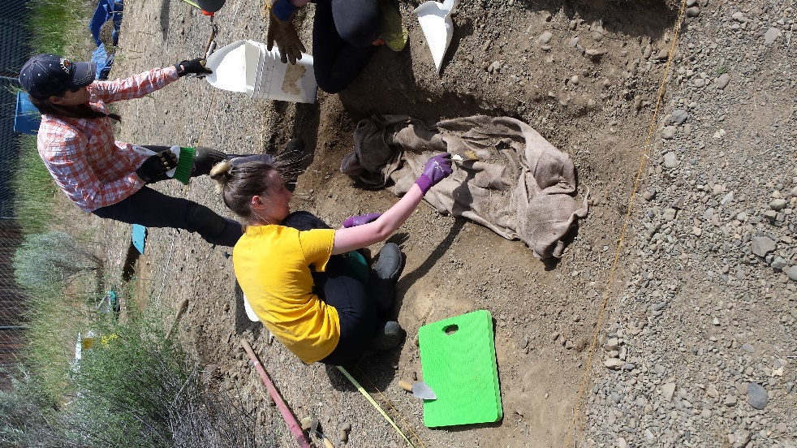
M-F, 9 AM – 5:00 PM
Ellensburg Campus

Course:
Anth 414: Osteobiographical Analysis
6 credits.

Pre-requisites:
Anth 315 and 315L OR approved Human Osteology Course, AND permission of instructor.

To Apply:
Download application form at website or acquire from Dr. Jastremski. Submit all documents to Dr. Jastremski by May 22, 2026. Enrollment is limited. If accepted, registration information will be sent.

Instructor:
Nicole A. Jastremski, PhD
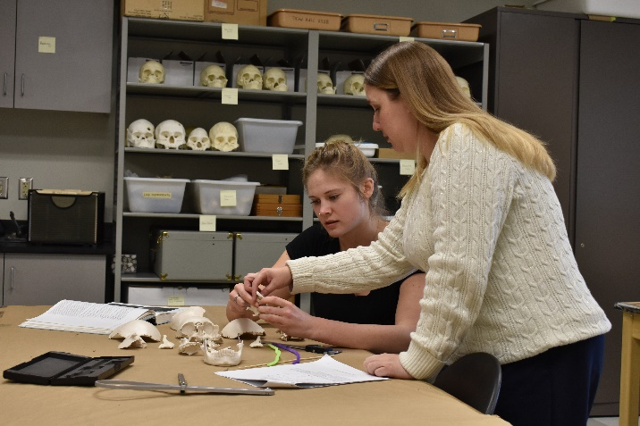
Nicole.Jastremski@cwu.edu, 509.963.2215



