Forensic Anthropology Field School

Central Washington University

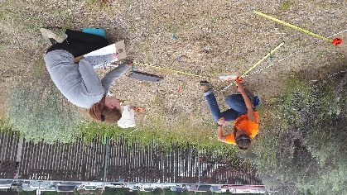
July 13 – 31, 2026

The CWU Forensic Anthropology Field School provides practical experience in recovery and handling of human remains by excavating a mock crime scene and laboratory methods of forensic anthropology through analysis of skeletal projects. Students must enroll in Anthropology 414 Osteobiographical Analysis. The 6 credit field school starts July 13 and ends July 31, 2026. Class meets from 9:00 AM – 5:00 PM each day at the Ellensburg Campus. Space is limited, but is open to anyone eligible to register for college credits (whether college students or not).

Pre-requisites:
Anthropology 315/L Forensic Skeletal Analysis and Laboratory (or other comparable human osteology and forensic anthropology course) AND permission of instructor. An advanced human osteology course substitution may be permitted; please contact instructor. Acceptance or denial will be sent by email. Once accepted you will be given directions on how to register for the courses.
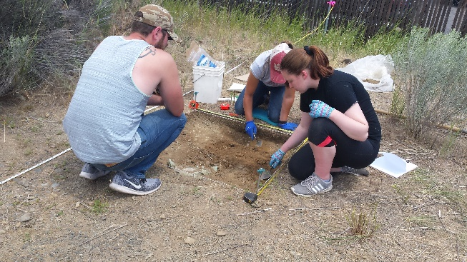
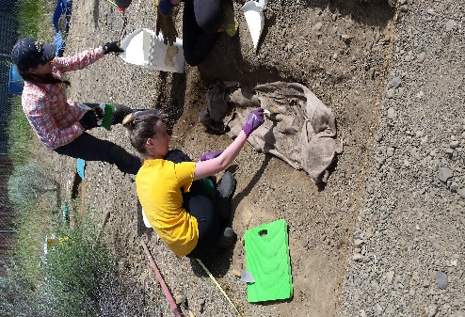
Registration:
You must first submit a forensic field school application to Dr. Nicole Jastremski by May 22, 2026 (or as space allows). Once you are accepted, you will need to register for CWU Summer Session for Anth 414. Dr. Jastremski will have electronically given you permission to register for the class, however it is your responsibility to go into the registration system and actually register. Current CWU students that will not graduate before the field school need only to register the same way they would for any academic year course. This is done online.
All non-CWU students and CWU students who have graduated (not walked) will need to submit a “Summer Session Non-matriculated Student Application” form before registering. The form may be obtained online at
https://cwucsprd.peoplesoft.cwu.edu/psc/cwucsprd/EMPLOYEE/SA/c/CW_OLA_MENU.CW_NM_APPL_CMP.GBL?

If you have any questions regarding this process, please contact the registrar’s office at reg@cwu.edu . When you have received a student number, immediately contact Dr. Jastremski so that she can put the permission in the system.
Tuition is the only cost for this field school.
Housing
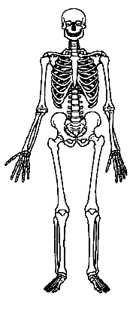
For out-of-town students, campus housing and dining facilities are available through the CWU Conference Program. You can contact Dr. Jastremski for suggestions, but you must make your own housing reservations. Please contact the Conference Program for more information at https://www.cwu.edu/academics/conference/resources/summer-short-term-lodging.php or at 1-509-963-1141 or via email at Conference.Program@cwu.edu . Or you may find more information at CWU Housing at https://www.cwu.edu/student-life/housing/resources/summer-housing.php or by contacting them at 509-963-1831 or via email at housing@cwu.edu .
Another possibility is camping. There are several local commercial campgrounds. The best bet is the Ellensburg KOA about three miles west of campus (509-925-9319; ellensburgkoa@gmail.com; www.koa.com ).
Finally, you could rent from a motel or sublet an apartment for the summer. Since we are a college town, there are often sublets available in the summer.
Getting Here
Ellensburg is in the middle of Washington State, along Interstate Highway 90 just a few miles west of its intersection with Interstate Highway 82, so it is very accessible by car. If you are flying to Ellensburg, you can fly into Seattle (Sea-Tac Airport; approximately a 2 hour drive west of Ellensburg) or Yakima (approximately a 45 minute drive south of Ellensburg). It might be simplest to fly to Sea-Tac and take the Bellair Airporter shuttle from the airport directly to the CWU Starbucks in Ellensburg. The shuttle website is http://www.airporter.com/schedules/schedules-rates
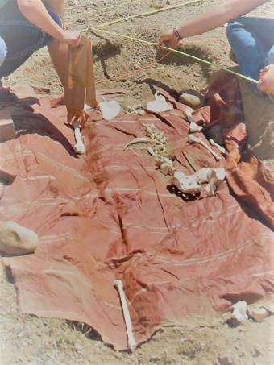
What to Wear
Shoes: Rugged, durable shoes or hiking boots. Flip-flops are not acceptable.
Clothes: Be sure to bring adequate clothes for hot and sunny weather, plus extra clothes for wet and/or cold days. The crime scene does not close due to weather. I recommend lightweight long pants to protect from sun, a T-shirt, a lightweight long-sleeved shirt to protect from sun. Summer field clothes could be cotton, cotton/polyester, or special sun-blocking work shirts, work pants, khakis, etc. A hat, sunglasses, sunscreen, water bottle, and bug repellant are recommended.
We will be out in the public eye so it is important that students act and dress in a responsible and professional manner. No alcohol or controlled substances are permitted. Attire should be modest, meaning students will not be topless or wear revealing clothing.
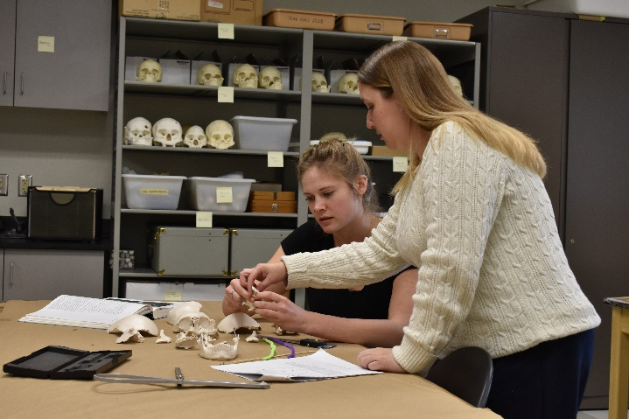
Further Information
Dr. Nicole Jastremski
Department of Anthropology
Central Washington University
400 E. University Way
Ellensburg, WA 98926-7544
Office: 342 Dean Hall
Phone: 509.963.2215
Nicole.Jastremski@cwu.edu

