Charles Glassick, et al. 1997

1. Clear Goals

Does the scholar state the basic purposes of his or her work clearly? Does the scholar define objectives that are realistic and achievable? Does the scholar identify important questions in the field?

1. Adequate preparation

Does the scholar show an understanding of existing scholarship in the field? Does the scholar bring the necessary skills to his or her work? Does the scholar bring together the resources necessary to move the project forward?

1. Appropriate methods

Does the scholar use methods appropriate to the goals? Does the scholar apply effectively the methods selected? Does the scholar modify the procedures in response to changing circumstances?

1. Significant Results

Does the scholar achieve the goals? Does the scholar’s work add consequentially to the field? Does the scholar’s work open additional areas for further exploration?

1. Effective Presentation

Does the scholar use a suitable style and effective organization to present his or her work? Does the scholar use appropriate forums for communicating work to its intended audiences? Does the scholar present his or her message with clarity and integrity?

1. Reflective Critique

Does the scholar critically evaluate his or her own work? Does the scholar bring an appropriate breadth of evidence to his or her critique? Does the scholar use evaluation to improve the quality of future work?

Ernest Lynton, 1995

1. The scholar and community learn something (discovery/originality/absence of standard operating procedure)

2. Knowledge advances base of discipline

3. Scholarly activity is responsive and adaptive (with community input)

4. Reasoned choice of goals reflecting agreement with community partner

5. Methods chosen appropriate to scope of work and context (with community input)

6. Scholar undertakes reflection (observing, assessing, making adjustments, community input)

7. Reflection generates outcomes (results, inferences, new insights that can be generalized)

8. Outcomes can be shared with colleagues formally or informally (community)

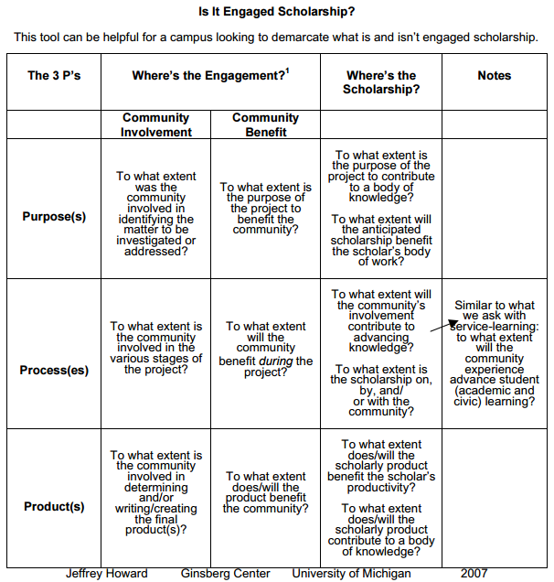

**National Review Board on the Scholarship of Engagement, 2005**

**Goals/Questions**

* Does the scholar state the basic purpose of the work and its value ***for public good***?
* Is there an "academic fit" with the scholar's role, departmental and university mission?
* Does the scholar define objectives that are realistic and achievable?
* Does the scholar identify intellectual and significant questions in the discipline ***and in the community***?  
    
  **Context of theory, literature, "best practices”**
* Does the scholar show an understanding of relevant existing scholarship?
* ***Does the scholar bring the necessary skills to the collaboration***?
* Does the scholar make significant contributions to the work?
* Is the work intellectually compelling?  
    
  **Methods**
* Does the scholar use methods appropriate to the goals, questions and context of the work?
* Does the scholar describe rationale for election of methods in relation to context and issue?
* Does the scholar apply effectively the methods selected?
* Does the scholar modify procedures in response to changing circumstances?

**Results**

* Does the scholar achieve the goals?
* Does the scholar's work add consequentially to the discipline ***and to the community***?
* Does the scholar's work open additional areas for further exploration and collaboration?
* Does the scholar's work achieve impact or change? Are those outcomes evaluated and by whom?
* Does the scholar's work make a contribution consistent with the purpose and target of the work over a period of time?  
    
  **Communication/Dissemination**
* Does the scholar use a suitable styles and effective organization to present the work?
* Does the scholar communicate/disseminate to appropriate academic ***and public audiences*** consistent with the mission of the institution?
* Does the scholar use appropriate forums for communicating work to the intended audience?
* Does the scholar present information with clarity and integrity?  
    
  **Reflective Critique**
* Does the scholar critically evaluate the work?
* What are the sources of evidence informing the critique?
* Does the scholar bring an appropriate breadth of evidence to the critique?
* ***In what way has the community perspective informed the critique?***
* Does the scholar use evaluation to learn from the work and to direct future work?
* Is the scholar involved in a local, state and national dialogue related to the work?