Collaborating with Students in Teams

Step 1: Set up a Class Team
Start at https://portal.office.com (Links to an external site.) then create following the steps in this video:
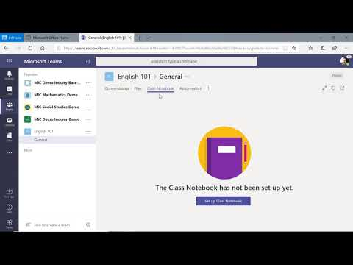

Step 2: Work in Channels
Now that your team has got structure let's see how we can make real-time collaboration easy.
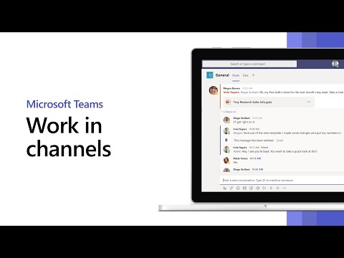
- Tip: You can easily add lots students using:
  - Join by code
- 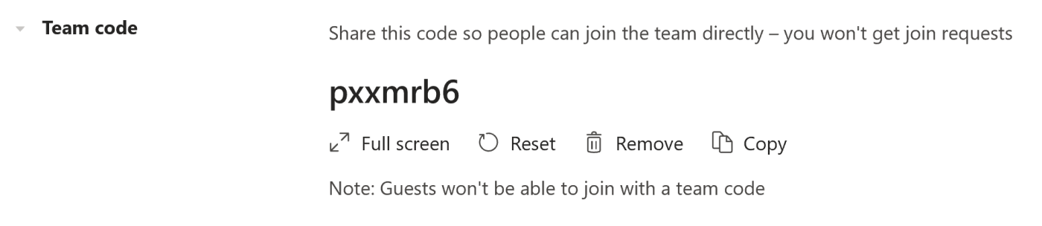
  - You can create a short code people type into Teams to immediately join the team you've created - how to details (Links to an external site.).
- Tip: Don't want students to edit files in certain channels or folders? Check-out how you can make some areas read-only (Links to an external site.).

Step 3: Customize your Class Team with apps

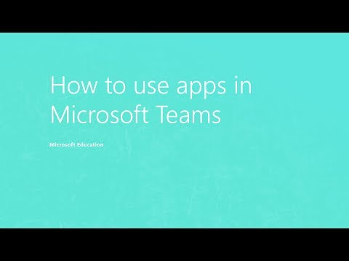
You can find all the apps available for Microsoft Teams here (Links to an external site.)

Bonus: Sync notebook grading
Create assignments and sync grades back to your LMS using the Class Notebook created within your Class Team. Many popular solutions are supported.
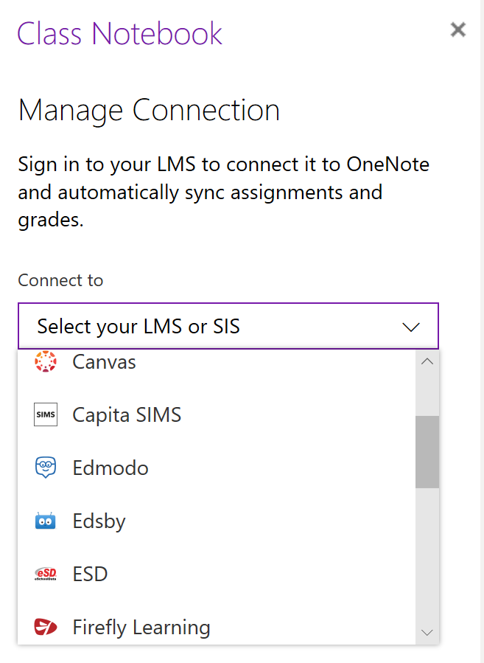
Streamline the course and marking workflow with the ability to assign grades directly from the Class Notebook which sync back to your selected LMS or SIS.
