Summer 2026 Start of Quarter Procedures for

Canvas Course Management

Summer 2026 courses Now in Canvas

Updates
If you have already overridden the populated syllabus content you can restore it by following this video guide: How do I Restore Syllabus Policies?
Accessibility Checker - The Canvas Course Accessibility Checker is a course-level tool that enables instructors to identify, remediate, and validate accessibility issues across Canvas-created content. It streamlines accessibility compliance with live, on-demand reports, built-in remediation guidance, and content previews. This is a Canvas feature and is a separate tool from the blackboard Ally accessibility tool.

DesignPLUS Summer School - Cidilabs is hosting a 5-day DesignPLUS webinar series from June 22nd to June 26th which will go through a step-by-step process of using the DesignPLUS tool and creating engaging content for your canvas courses. Each webinar will be an hour a day. Register here if interested.

See the last page for Course Checklist.

Requests for Independent Study, Practicum or Research Courses
If you need a Canvas course for a class that ends in 90, 92, 96, 96 or 700 please submit the Independent study, Practicum or Research Canvas Course Request Form.

Faculty are responsible for publishing their Canvas course. Students cannot view or participate in the course until it is published. Canvas courses should be published by the first day of instruction, June 22nd, by 8am.

Combined Course sections in Canvas
Course sections that share the following criteria will again automatically be combined in Canvas:
- A Course ID (Ex: ENG101)
- Instructor of record
- Teaching modality (online / face-to-face)
Within a combined Canvas course, faculty can still:
- Set differentiated due dates by section
- Filter the gradebook by section
- Send out announcements by section
What if I do not want my course sections combined?
If you do not want your course sections combined, complete the Separate Combined Course Sections Request form. Course sections cannot be separated after the term has started or assignment submissions have been made.

Cross-listing Canvas Course Sections: If your course sections are not automatically combined in Canvas but meet the criteria for cross-listing, complete the Canvas Cross-listing Request form.

AI Tools in Canvas
All current AI tools in Canvas are “Feature Options” that can be turned on in the course settings area. Click the “Feature Options” tab at the top.

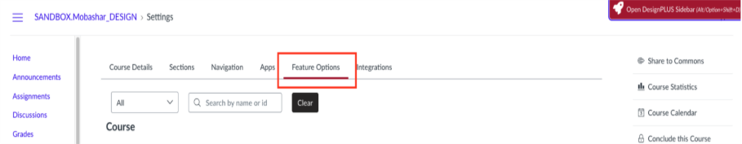

Smart Search - Smart search is an AI tool that allows instructors to search for content within their Canvas course. Once enabled, you will see the “Smart Search” option in your course navigation menu (Blue links on the left). This is available for both instructors and students. Students can only search for content they have access to.

Discussion Summary - Discussion summary allows users to get an overall summation of the responses using AI. It analyzes the responses and then creates a summary of what participants are saying. It creates a consensus or themes within the responses.

IgniteAI Question Authoring for Quizzes - In New Quizzes, you can use IgniteAI Question Authoring for Quizzes to create questions based on course content.

Accessibility Checker - The Canvas Course Accessibility Checker is a course-level tool that enables instructors to identify, remediate, and validate accessibility issues across Canvas-created content. It streamlines accessibility compliance with live, on-demand reports, built-in remediation guidance, and content previews. This is a Canvas feature and is a separate tool from the blackboard Ally accessibility tool.

See last page for Course Checklist.

Canvas Course Checklist
To learn more about how to complete the task in the checklist below, follow the link to the Canvas guide. For 24/7 Premium Faculty Canvas Support call: 1-833-209-6110.

- Set course homepage
- Create a banner for Canvas front page
- Upload syllabus
- Create welcome announcement
- Set-up course navigation
- Import content from another Canvas course (Choose ‘Select specific content’)
- Import shared resources from Canvas Commons, when applicable
- Create assignments, discussions, quizzes
- Use modules to organize course content
- If using LockDown Browser, click on the LockDown Browser link to verify settings
- Check the My Textbooks link to view confirm course materials are accurate
  - Questions or concerns message Elliott.Reid@cwu.edu
- Review course using the student view
- Important: Publish course by 8am on the first day of the quarter

Faculty One-On-One Instructional Design Consultation
Faculty can book 30-minutes instructional design consultations with one of the Multimodal Learning Team Members. Choose from the following categories: Instructional Design, Canvas Technologies, Digital Accessibility, Panopto or other instructional video questions.

Faculty Canvas Support and Help
- CWU Instructor Resource Course: Requires CWU login. This course provides guides and instructions on all CWU Instructional Technologies.

