Wildcat Career Network
Creating an Employer Account
- Login to WCN by going to this link, https://cwu-csm.symplicity.com/employers, which will take you to the screen below:
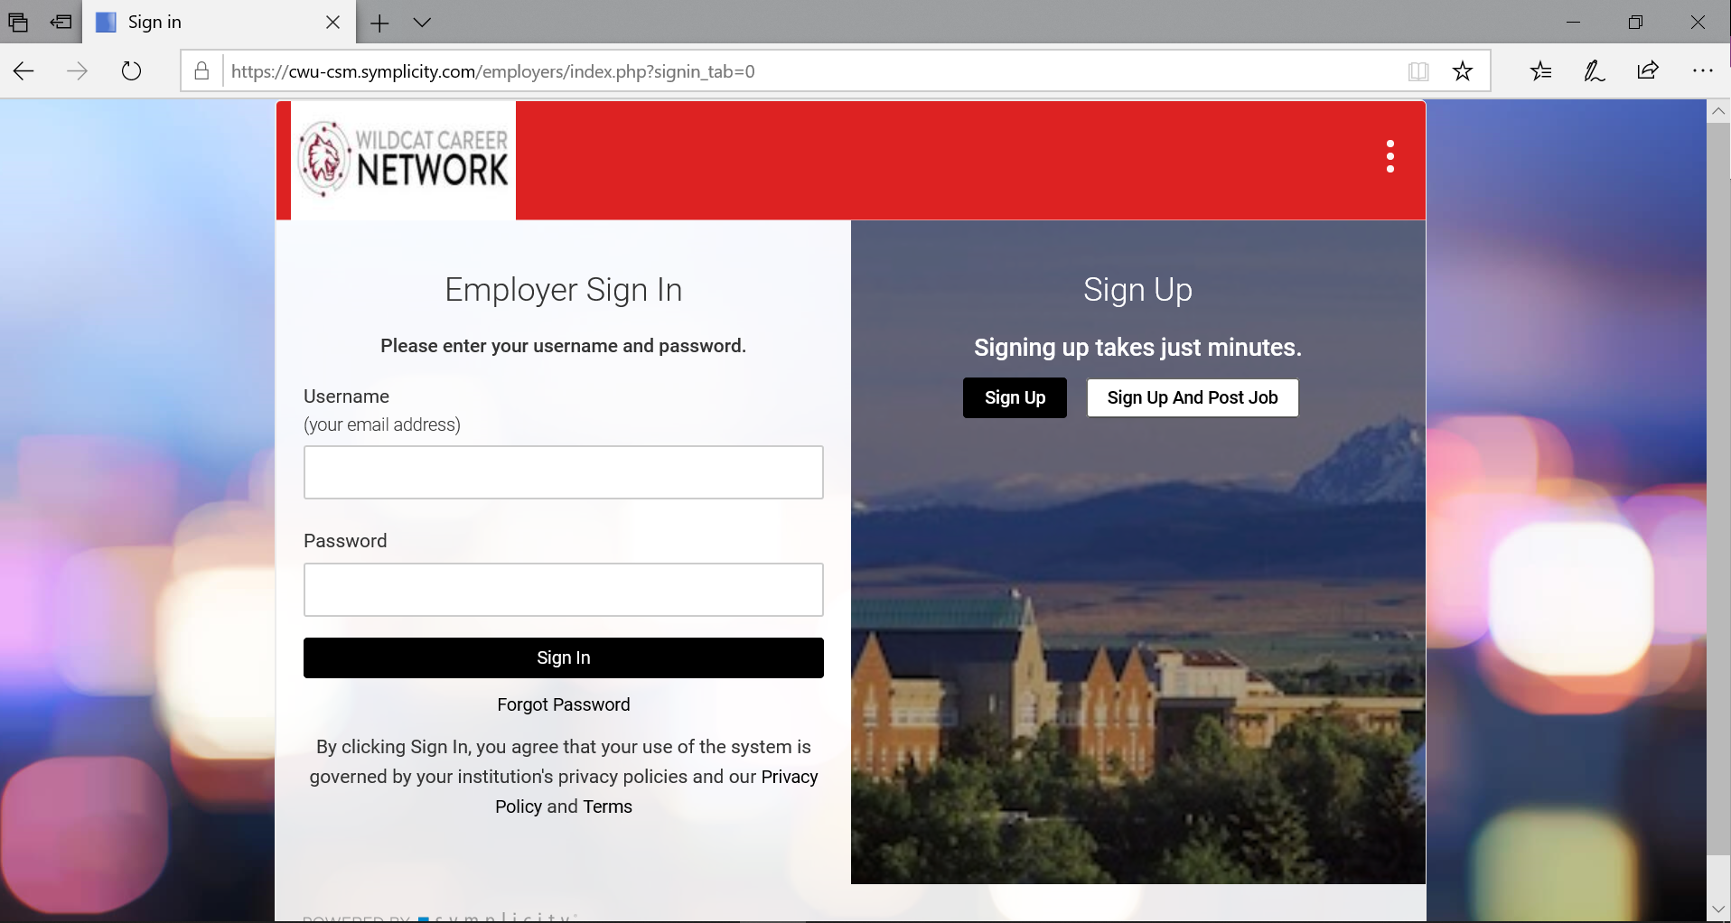

- To create a new employer account, select either “Sign Up” or “Sign Up and Post Job”. For this example, “Sign Up” was selected which takes the user to the screen below. If you are uncertain if you have already created an account, you can try the “Forgot Password” button to reset your password.
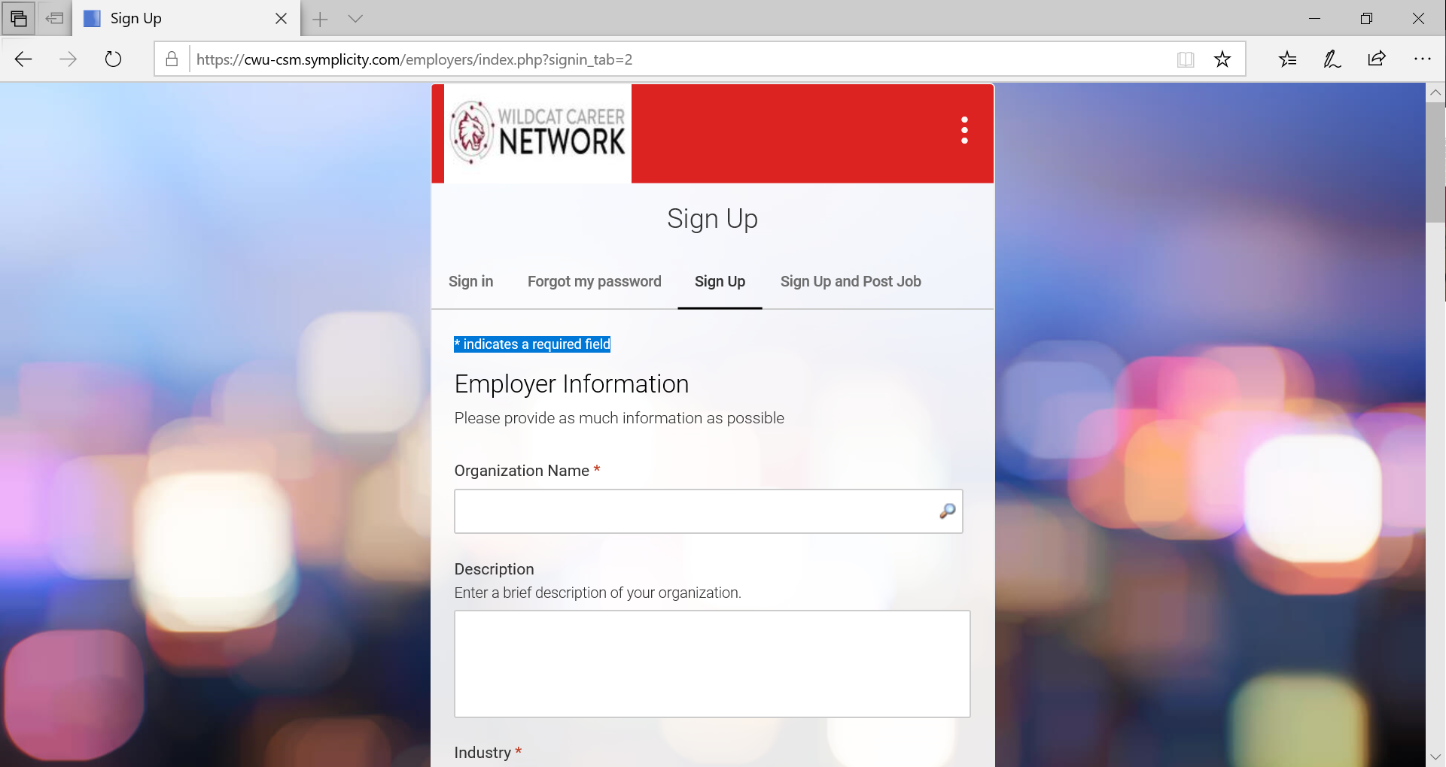
- Fill out the necessary fields. Note: * indicates a required field:
  - In “Organization Name”, you can enter part of your organization and then search the database for the official company name.
  - In the “Industry” field, you can select one or multiple entries by using the “Ctrl” button and making multiple selections.
  - Once you have filled all of the required fields and any of the other sections, click “Submit”. This will bring up a confirmation of the account creation shown below:
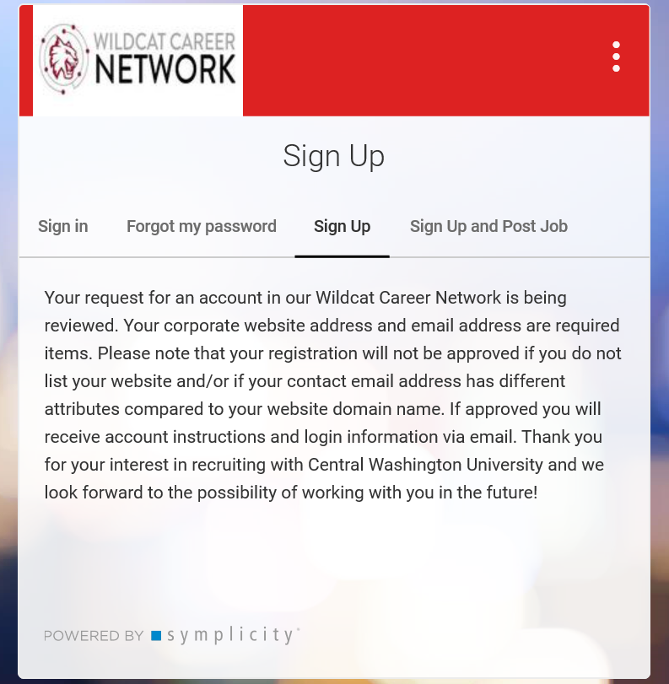
  - Your account will then be reviewed by the CWU Career Services Administrators for approval. You will receive an email once the account application is approved.
- Once the account application is reviewed and approved by CWU Career Services you will get an email alerting you to the approval. There is also a link on how to create a password for your new account. Below is what this email looks like:

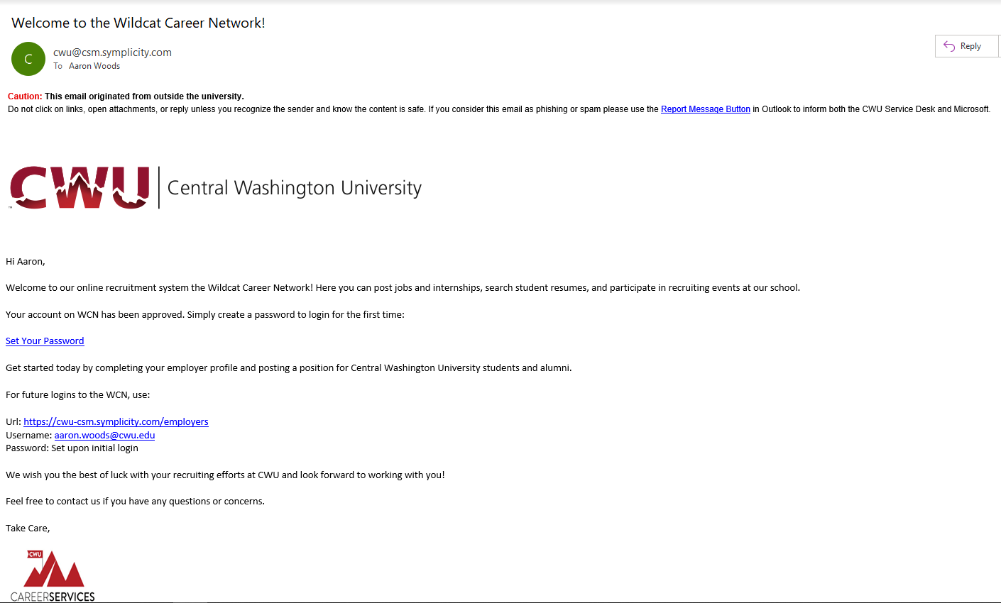
- Click the “Set Your Password” link and follow the instructions to setup a password.
- Your CWU Employer Account is now ready to use.

