Wildcat Career Network User Guide:
Mock Interview Tools - Student Guide

Step 1) Login to the WCN: Login to your Wildcat Career Network account (hint: You already have one.) via the link in the Applications box of your MyCWU dashboard. If you’ve never logged in before, you may have to answer a few questions first.

Step 2) Navigate to Mock Interview Tool: Select “Resources” from the left menu tab, then select “Mock Interview” from the menu sub-tab that appears below it.

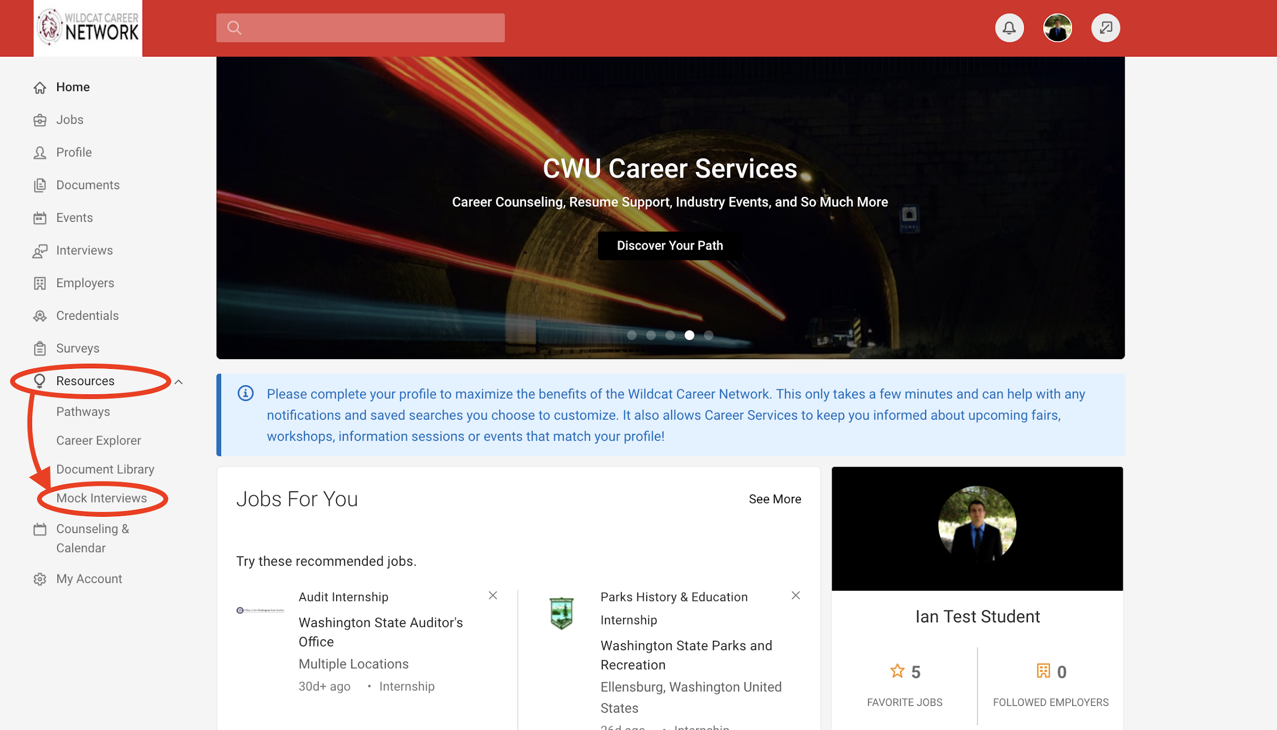

Step 3) Select an interview option: Once inside of the Mock Interview module, there will be a list of possible mock interview templates in the center of the page. You may scroll through the list or use the search bar to locate an interview that aligns with your career path or interests.

*Note: For this assignment select CWU Career Services General Undergrad (Top 5 Questions)

Step 4) Begin interview attempt: Once you have located the interview from the list, you may select “Record New Attempt” to begin the mock interview. IF you have previously completed an interview, there will also be “Review”, “Share”, and “Download” options available on this screen.

Continued….

Step 5) IF prompted, allow the web application to run: Click on the “Get ADOBE FLASH PLAYER” box and then select “allow”.
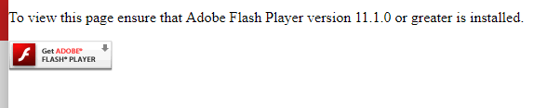

________________________________________________________
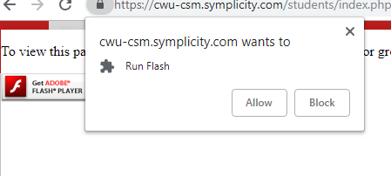

________________________________________________________
Please also ensure your pop-up blocker is not preventing the application window from opening. If the pop-up is being blocked, an error message or icon will generally appear on the screen or in the top right of the URL address bar of your browser. Depending on your browser, you can right-click this icon to allow.

Step 5) Complete your Interview: Once the interview tool window has opened, you will have the option to complete a practice question or to begin the interview. Once an interview option is started, you will have two screens, one should show a pre-recorded video of an interview question. The other will show whatever your webcam sees (ideally your face). Once the question is asked by the interviewer, you will be able to select “begin my response” to record your response to that question. Once a response is completed, you can review; re-record; or submit your responses as needed. Answer all questions to the best of your ability.

Step 6) Share your Interview: After you’ve completed your mock interview, it will give you the options “Review Your Interview” or “Exit the Interview”. Either way, in order to share your interview with someone to solicit feedback, you will have to locate the interview that you originally selected from the main Mock Interview page. As shown below, you will have a few options. Select “Share Interview” or “Download”. Share Interview will give you a shareable link. Download will give you an MP4 video.
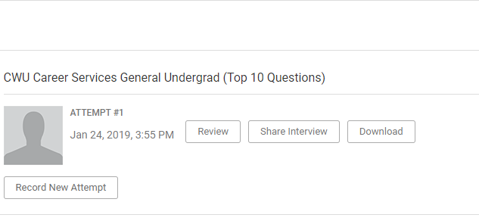
If you have any technological problems with the system, contact the WCN Coordinator Ian Morris at 509-963-1921.

