Tips to Prepare for Virtual Networking Events

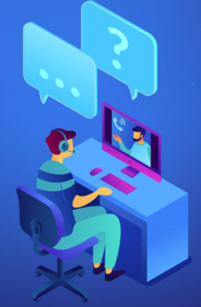
Just because this is virtual networking event doesn’t mean you can be lazy about it. Approach it as if you are preparing for an actual job interview. Here are some tips to help you present yourself in a professional manner.

Dress to impress. Avoid wearing casual clothes. No hoodies or baggy sweatshirts. You should dress as you would for an in-person interview. Doing so will not only make you appear more professional and excited about the opportunity, but it will also make you feel more prepared and confident.

Test your tech. Cut down on technical difficulties by testing your setup ahead of time. Video chat with a friend to make sure you can hear and be heard. Know how to mute and unmute your microphone. Using headphones can prevent weird echoes, and if it has a microphone it can make it easier to hear you, but be careful your microphone does not rub on your shirt, or bump against things like jewelry. Additionally, if you will be using a virtual platform you are unfamiliar with, download the platform as soon as it is available and carefully read any instructions or tips for using it before your event.

Set up your shot. To create a good impression, choose a quiet area and set up in front of a neutral background without a lot of distracting colors or contrasts. Avoid an unmade bed, a cluttered closet, or a bright window behind you. Make sure you are well lit (natural light is best) with the light source in front of you and behind your computer, not coming from behind you. Fluorescent and tungsten lighting can be unflattering. Check for glare from eyeglasses, a watch or jewelry. Again, test this via videoconferencing with a friend. You don’t want to be so brightly lit that it washes you out, or to have the light coming at an angle so that one side of your face is in shadow. If you will be using your phone, prop it up securely to avoid a shaky handheld effect.

Frame yourself squarely in the camera. This may require you to raise your computer so that the camera is not angled up toward the ceiling. Position it about eye level in front of you and sit so that there is about 10-20 percent of screen space above your head and your upper chest is visible. This will enable you to look straight ahead rather than down.

Prep for optimal eye contact. If you’ve framed yourself properly, you still want to appear to be making eye contact with your interviewer. If your camera is at the top of your computer screen, position the window with the interviewer near the camera. This will prevent you from appearing to look down. A good trick to remind you is to place a sticky note just above the camera that says “Look Here!” or to tape a photo of someone there to draw you eye back to the camera when engaging with someone. Avoid leaning forward or back too much, or slouching. Sit up straight, smile and nod to show you are engaged with the interviewer.

