REGULAR MEETING
Wednesday, May 7, 2025, 3:10 p.m.
AGENDA

- CHANGES TO AND APPROVAL OF AGENDA
- MOTION NO. 24-48: APPROVAL OF MINUTES of April 7, 2025
- SENATE CHAIR REPORT
- FACULTY ISSUES
- STUDENT REPORT

REPORTS/ACTION ITEMS

Executive Committee
Motion No. 24-36: Deactivate the antiracism, diversity, and inclusivity (ADI) graduation requirement for all current and incoming CWU students. See Exhibit A for additional information.

Removal of 184s (Padstones) from General Education feedback. See Exhibit B for additional information.

Academic Affairs Committee
Motion No. 24-49: Amend CWUP 5-90-040(25), Academic Dishonesty, to add a section on AI use as outlined in Exhibit C.

Motion No. 24-50: Amend CWUP 5-90-040(39), Class Attendance, to clarify policies regarding missed work and make-up work as outlined in Exhibit D.

Bylaw and Faculty Code Committee
Motion No. 24-08 (third reading of three): Revise Faculty Code section IV to allow four NTT senators as outlined in Exhibit E.

Motion No. 24-39 (second reading of three): Revise Faculty Code section IV.E to eliminate Executive Committee summer workload as outlined in Exhibit F.

Motion No. 24-42 (second reading of two): Modify Senate Bylaws section I.C to change the number of senators allocated to departments as outlined in Exhibit G.
Curriculum Committee
Motion No. 24-51: Approve the new Actuarial Science Minor: Financial Mathematics as outlined in Exhibit H.

Motion No. 24-52: Approve the new MBA Cybersecurity Management Specialization as outlined in Exhibit I.

Motion No. 24-53: Approve the new Professional Studies BAS as outlined in Exhibit J.

Motion No. 24-54: Approve the new Sport Coaching Certificate (type A) as outlined in Exhibit K.

Motion No. 24-55: Approve the new Wine Industry Management, BS as outlined in Exhibit L.

Faculty Legislative Representative Report

- PRESIDENT
- PROVOST

- CHAIR-ELECT

- NEW BUSINESS

- ADJOURNMENT

***NEXT REGULAR SENATE MEETING: June 4, 2025
Exhibit A

Clarifications about the ADI Graduation Requirement

Over the past several weeks, the Faculty Senate Executive Committee has received numerous questions about the ADI graduation requirement, the vote to remove it, and federal/state laws. In order to support more informed department and senate discussion, the Executive Committee has created this document to provide context and clarity around the most common faculty questions.

Q: Why is Senate voting on possibly deactivating the ADI graduation requirement now? Why can’t this vote be postponed?
The U.S. Department of Education (DoE) released a Dear Colleague Letter along with a follow-up Dear Colleague FAQ stating that the mandating of racially-focused classes would be considered a violation of Title VI which could result in loss of federal funding.

The Dear Colleague Letter, published on February 14th, stated that the DoE “intends to take appropriate measures to assess compliance... beginning no later than 14 days from today’s date.” An April 3rd letter from the DoE instructed states to comply within ten days or risk losing federal funding. On April 15th, the DoE agreed to delay enforcement until April 24th. Unless this situation changes, beginning April 24th, the ADI graduation requirement places CWU at legal risk of losing federal funding. Update: On April 24th, a federal judge issued an injunction pausing the new enforcement of Title VI once more. It is currently unknown how long this pause will last or what the eventual legal outcome will be.

Q: Are the Dear Colleague and Dear Colleague FAQ letters law?
The Dear Colleague and Dear Colleague FAQ letters are not laws but rather explain how existing law (Title VI) will be interpreted and enforced by the DoE. Title VI of the 1964 Civil Rights Act prohibits discrimination on the basis of race, color, and national origin in programs and activities receiving federal financial assistance.

Q: How likely is CWU to be subject to a federal investigation?
The DoE has created an online reporting form where anyone—whether part of the university community or not—can submit a complaint. A complaint can then trigger a federal investigation. The Faculty Senate Executive Committee believes that if CWU’s ADI graduation requirement remains, it is only a matter of time before a complaint is submitted.

Q: What happens if CWU is investigated?
An investigation will likely require CWU to remove its ADI graduation requirement or lose federal funding, possibly including Pell Grants and federal student loans. It is unknown if federal funding would be paused at the beginning of the investigation or if CWU would be given adequate time to respond to federal demands before any funding is paused.

Q: What would happen if CWU lost federal funding?
The results of lost—or even paused—federal funding would be catastrophic for CWU. 43% of CWU students rely on federal Pell Grants to be able to attend. 60% of CWU students rely on federal student loans to be able to attend. If funding were paused, these students would immediately lose access to their Pell Grants and federal loans and would likely drop out of CWU due to financial constraints. The abrupt drop in students would create a financial exigency that would have severe repercussions for the university.

Q: What about Washington state law mandating DEI/ADI?
WA SB 5227, passed during the 2021-2022 state legislative session, requires that higher-education institutions must develop and establish professional development programs focused on diversity, equity, inclusion, and antiracism for faculty, staff, and students. The bill contains a clause at the end (section 6) specifying that the bill must be implemented in a manner that does not conflict with federal law, and that in the case of any conflicts, federal law takes precedence.

Q: What would happen to the ADI graduation requirement if Senate votes to remove it?
The graduation requirement would immediately be removed for all current and incoming students. The requirement itself would still exist in a deactivated state within the Peoplesoft system and would not be deleted or purged. It could be potentially reactivated in the future if circumstances changed.

Q: What would happen to the ADI graduation requirement if Senate votes to keep it?
Senate’s decision would be communicated to CWU’s Board of Trustees. The Board of Trustees has final authority over the entire university, including curricular matters. If the Board of Trustees deemed the ADI graduation requirement to be an unacceptable risk to the institution, they could override Faculty Senate’s decision and remove the ADI graduation requirement. Otherwise, the graduation requirement would remain in effect.

Q: Could the ADI graduation requirement be modified or renamed instead of removed?
The DoE guidance interprets any racially-focused mandatory requirements as a violation of Title VI, regardless of how such requirements are labeled. This means that even a modified or relabeled version of the graduation requirement would still pose a legal risk.

Q: Could Senate develop curricular alternatives that would support ADI goals?
Senate can consider alternate curricular structures (e.g. badges, certificates, different forms of graduation requirements) in future curriculum discussions. These discussions would be more fruitful when Senate has time to consider the changes carefully.

Q: Is it now illegal to teach courses with ADI content?
No. The Dear Colleague FAQ specifies that the DOE is targeting mandated race-focused requirements, differential treatment of students based on race, racial stereotyping, and hostile racial environments. Questions 8 and 9 of the Dear Colleague FAQ provide more detail about these terms. Provided they do not violate these conditions, courses with ADI-related content can and will continue to be taught.

Q: What would happen to the Senate ADI Committee if the ADI graduation requirement is removed?
The Executive Committee is still investigating whether the ADI Committee could have a viable role going forward without the ADI requirement in effect. If there appears to be a viable role for the committee, then the Executive Committee supports the continued work of a reenvisioned committee. If there is not a viable role, then the Executive Committee would support disbanding the committee. This decision does not have to be made at the May Senate meeting and can be postponed.

Q: What are other Faculty Senates in Washington state doing?
Other state four-year universities have required diversity components as part of their general education programs. However, all of them define “diversity” in a broad manner encompassing many different dimensions that do not necessarily require students to take a racially-focused course.

- UW’s Gen Ed diversity component includes the “sociocultural, political, and/or economic diversity of the human experience at local, regional, or global levels.”
- WSU’s Gen Ed includes a Global Cultural Diversity and an Equity and Justice component.
  - The Global Cultural Diversity component investigates “differences, similarities, and connections among cultures… in global comparative context.”
  - The Equity and Justice component investigates “how inequalities and/or stereotypes, discrimination, systemic inequities, and violence along lines of race, ethnicity, class, gender, religion, national origin, sexuality, ability, or intersections thereof.”
- EWU’s gen ed has a Diversity component that “examine[s] movements that shape or challenge systems of power, privilege, oppression, or colonization” and “evaluate[s] constructions of identities of underrepresented or marginalized groups.”
- WWU’s gen ed has a Comparative, Gender, and Multicultural Studies component.

Because the other four-year universities have defined diversity more broadly, they do not perceive their diversity requirements to pose a legal risk under new Title VI enforcement and consequently, none of their Faculty Senates are planning to change any curricular requirements. Earlier this academic year, the UW Faculty Senate investigated expanding their diversity component to add a new race-focused requirement. They have since paused this initiative and do not plan to resume it for the immediate future. CWU is the only state university that added a race-focused requirement. That decision now creates a curricular risk for CWU that other state universities do not face.

Based on both Pell Grants and operating cash available, CWU is also arguably the most vulnerable university in the state to a pause in federal funding.

Institution | % Pell
CWU | 35%
EWU | 39%
UW | 22%
WSU | 27%
WWU | 21%
Statewide | 26%

2023-24 PELL GRANT PERCENTAGES
Source: Education Research & Data Center (ERDC) Statewide Public Four-Year Dashboard - Annual Enrollment. Last Updated January 14, 2025

Exhibit B

In early April, it was brought to the Executive Committee’s attention that a lack of Padstone (184) seats for this current academic year has created a bottleneck for roughly 500 freshmen. This bottleneck is projected to grow significantly for the coming academic year, with 1400 incoming freshmen and only 600 seats being offered. Query reports also indicate that roughly 350 current sophomores, juniors, and seniors have not completed their Padstone requirement. If no action is taken, CWU will have over 1,500 bottlenecked students by the end of next year.
~500 seat shortfall
Academic Year | # freshman entering in fall | # Padstone Seats offered that year
2023 - 2024 | 1,475 | 1,368  ~100 seat shortfall
2024 - 2025 | 1,447 | 956
2025 - 2026 | ~1,400 | ~600  ~800 seat projected shortfall

Department chairs indicate that they are scheduling less Padstone courses for several reasons:
- Major courses must be prioritized and offered. Padstones are not major courses.
- Gen Ed courses that serve as pre-reqs for other courses must be prioritized. Padstones are not pre-reqs for any courses.
- Larger courses will increase their college’s SCH generation, which has a positive budgetary impact for subsequent academic years. Padstones are the smallest gen ed classes and have low SCH generation.
- No one department “owns” Padstones and feels a sense of responsibility for them.

Padstone class sizes would need to rise well into the 40s next academic year to adequately handle all incoming freshmen and begin addressing the bottlenecked returning students. However, both GEC and other Padstone instructors have strongly emphasized that Padstone classes larger than 30 students will create an unreasonable burden for instructors. GEC does not support raising the class size beyond 30 students.

The EC has discussed different possibilities to address the bottlenecking issue. All of these possibilities (e.g. offering more summer Padstones, one-time waiver of Padstone requirement) do not address the underlying problem that given current budget and personnel constraints, departments have little incentive to offer Padstones. Some possibilities (e.g. creating alternatives ways to satisfy the Padstone requirement) add complexity to the gen ed program and would create additional work for faculty.

The EC is also concerned that Padstones are not fulfilling their original vision of creating cohorts and increasing retention. Analysis of all Padstones taught in calendar year 2024 found that only 44% were taught fully in person. The remaining 56% were either taught online or hybrid. Additionally, analysis by IERP found that taking a Padstone class in fall 2024 had no effect on fall-to-winter retention.

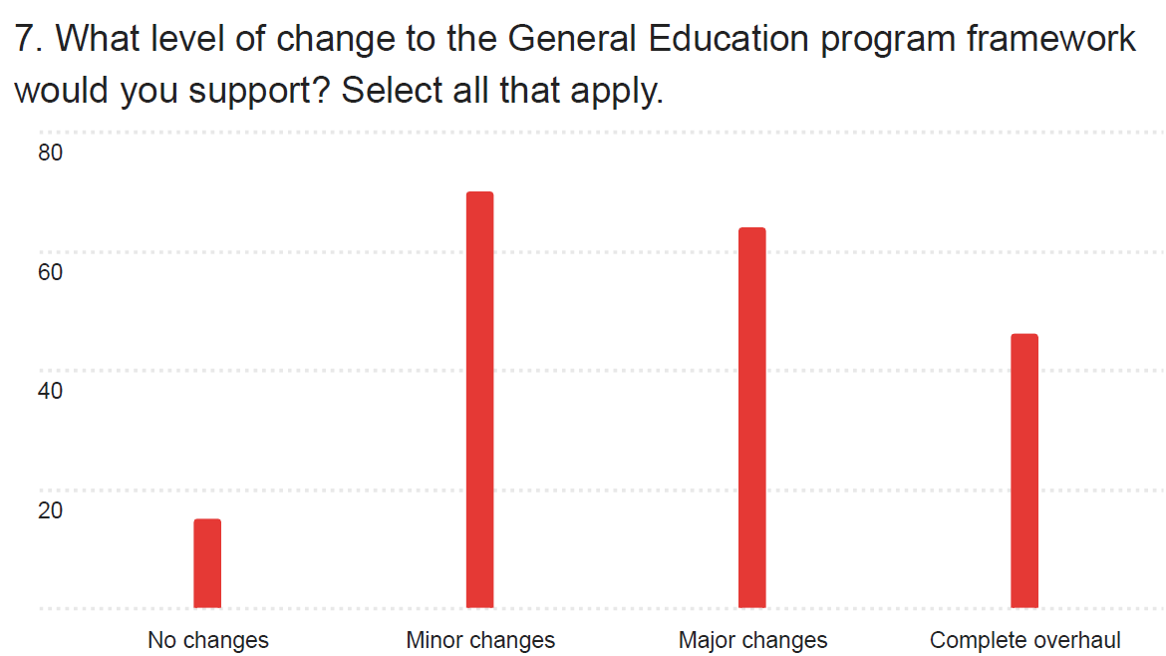
Quantitative Results from Gen Ed Survey during fall 2024
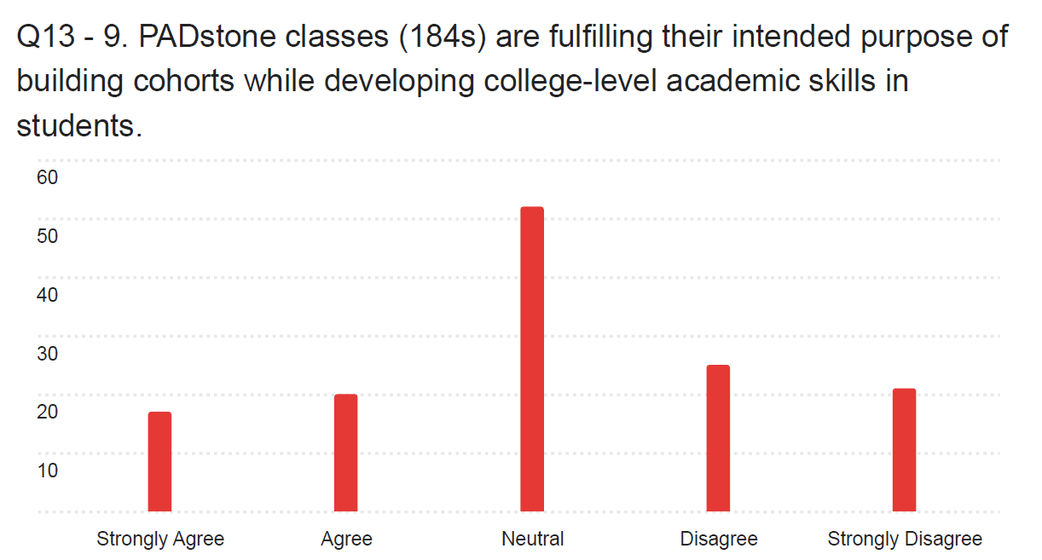
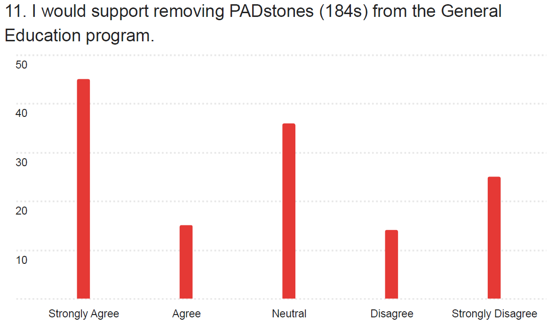
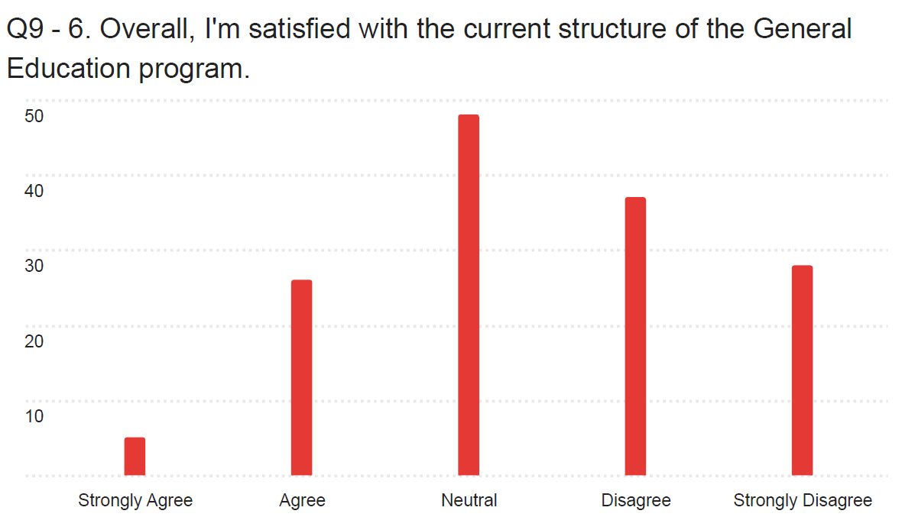
n = 155 faculty

Exhibit C

Section: CWUP 5-90-040(25)

Title of Section: Academic Dishonesty

New Removal Revision

Summary of changes:

This motion modifies the language previously presented to Faculty Senate, and approved (Motion No. 24-28), to clarify how unauthorized use of AI tools by students constitutes Academic Dishonesty.

Rationale for changes:

By explicitly referring to "violation of an instructor's written policy", the present language addresses concerns brought by Dean's Council that the original language effectively created a default policy of "no AI use", which could encourage instructors to avoid creating a written policy, thereby putting the onus on students to know and understand details of University Academic Policy.

Rationale for original motion:
The goal of this policy revision is to unambiguously include the unauthorized use of generative AI as an instance of Academic Dishonesty, since it is not currently mentioned in WAC 106-125-20. At such time that the WAC is revised to include generative AI, it may be appropriate to revisit this section of policy.

AAC recognizes that some uses of generative AI tools may have pedagogical value, but that it is up to each instructor to communicate to students the ground rules for appropriate usage of AI in completing assigned work for a particular class. It should be noted that AAC is considering a separate charge for requiring a statement in the course syllabus about generative AI use.

Given the rapid development of artificial intelligence, we decided against mentioning specific examples of Generative AI tools or how they might be used by students in a way that constitutes academic dishonesty. Better to have a simple and concise policy that leaves to faculty the burden of specifying appropriate usage of AI in their classes.

Proposed Policy and Procedure Revisions:

CWUP 5-90-040 Academic and General Regulations

(25) Academic Dishonesty

(A) Academic dishonesty is defined in the Washington Administrative Code (WAC) 106-125-20 Prohibited Student Conduct.

(B) Absent a clear written statement from a course instructor granting permission, the use of Generative AI tools to complete any assigned work is prohibited. The unauthorized use of AI shall be considered an instance of academic dishonesty.

(B) Violation of an instructor's written policy on the use of artificial intelligence (AI) tools for coursework shall be considered an instance of academic dishonesty.

(B) (C) Faculty who suspect students of academic dishonesty must follow the procedure outlined in CWUR 2-90-040(25).

(C) (D) Students found responsible of academic dishonesty violations in a course will be prohibited from completing an SEOI for the course.

(D) (E) Withdrawing from a course does not excuse academic dishonesty. In circumstances when academic dishonesty is confirmed, a W can be replaced by a letter grade (see CWUP 5-90-040(13)).

Exhibit D

Section: CWUP 5-90-040(39)

Title of Section: Class Attendance

New Removal Revision

Summary of changes:

This motion proposes revisions to Academic Policy regarding class attendance and missed assignments during the Change of Class Schedule Period (first week of the quarter).

Rationale for changes:

This motion has two objectives:
- Clarify and simplify the policy regarding make-up work related to student absence for reasons of religious observance or obligation.
- Address an inconsistency in policy regarding missed work during the Change of Class Schedule Period.

Proposed Policy Revisions:

CWUP 5-90-040 Academic and General Regulations

(39) Academic Dishonesty

(…)

(E) In compliance with RCW 28B.137.010, educational institutions must accommodate student absences to allow students to take holidays for reasons of faith or conscience or for organized activities conducted under the auspices of a religious denomination, church, or religious organization, so the students' grades are not adversely affected by the absences.

- Faculty members must reasonably accommodate students who, due to the observance of religious holidays, expect to be absent or endure a significant hardship during certain days of the course or program.

- "Reasonably accommodate" means coordinating with the student on scheduling examinations or other activities necessary for completion of the course or program and includes rescheduling examinations or activities or offering different times for examinations or activities. Students seeking reasonable accommodations under this policy must provide written notice to the faculty, within the first two weeks of the beginning of the course, of the specific dates the student requests accommodations regarding examination or other activities.

- RCW 28B.137.010 requires course or program syllabi to include either this policy or a link to the policy.

- Students may not be required to pay any fees for seeking reasonable accommodations under this policy.

- Students who feel that this policy has not been fairly implemented may appeal to the Dean of Student Success in the Office of the Provost.

- Instructors are not required to offer makeup work for missed classes, including those missed during the Change of Class Schedule period or university-approved activities, regardless of student course enrollment status in the absence of a prior arrangement.

(F) If a student enrolls in a class during the Change of Class Schedule Period, but after an assignment is due, the instructor shall either offer a reasonable opportunity to make up the assignment without penalty or excuse the student from completing the assignment.

(F G) In cases where an absence meets the guidelines below, instructors are strongly encouraged to work with the student to make arrangements to avoid academic penalties due to absences. The student is responsible for obtaining written documentation that will serve as verification of the agreement. Sponsors of university-approved activities requiring absence from campus will prepare and sign an official list of the names of those students who plan to be absent. It is each student's responsibility to present a copy of the official list to the appropriate instructors and make arrangements prior to the absence. Members of the university community directing or arranging such activities must adhere to the following guidelines:
- Scheduling of such activities shall not overlap with official final examination periods;
- Scheduling of such activities shall not require an absence of more than three (3) consecutive class days;
- Scheduling of such activities shall be announced to the students far enough in advance for them to plan to fulfill course requirements;
- Responsibility for seeking an exception to these guidelines lies with the sponsor and not with the student(s).

Exhibit E

Section: Faculty Code IV

Title of Section: Faculty Code IV. Faculty Senate, B. Membership,1. a. iii and iv
Faculty Code IV. Faculty Senate, B. Membership, 2. Terms of Service, b.

New Removal Revision

Summary of changes:

Section removed: Section IV. Faculty Senate, B. Membership, 1. iii. concerns CWU center senators.

Sections revised: Section IV. Faculty Senate, B. Membership, 1. iv. concerns NTT senators. New language regarding the designation of NTT senators for CAH, CEPS, COTS, and one senator-at-large elected to represent all colleges and entities not from CAH, CEPS, or COTS (CB, Library, etc.).

Section revised: Section IV. Faculty Senate, B. Membership, 2. Terms of Service, b. concerns the NTT senator terms.

Rationale for changes:
As of October 15th, 2024, CEPS has 141 NTT faculty (73.55 FTE), CAH has 71 NTT (55.95 FTE), COTS has 58 NTT faculty (42.84 FTE), and CB has 21 NTT faculty (14.42 FTE). Additionally, there are NTT 20 faculty in Library and other areas (23.96 FTE) - not CAH, CB, CEPS, and COTS.
Removal of iii. CWU centers no longer have senators representing the individual centers. Departments and programs at the centers are represented by their respective department senators. NTT senators at the CWU centers will be represented by their respective CAH, CEPS, COTS and NTT senator-at-large. The NTT senator at large will be elected by those NTT faculty who are not in the CAH, CEPS, and COTS colleges.
Revision of iv. NTT senators will now be elected to represent CAH, CEPS, and COTS. An additional senator-at-large will be elected to represent divisions outside of CAH, CEPS, and COTS such as the Library and other areas. Senator representation is based on the NTT FTE for each area with CAH, CEPS, and COTS having the most NTT FTE, and other divisions lower have FTE.
Revision of terms of service. NTT senator terms of service will be for one year with maximum of three terms. Currently the Faculty Code does not identify a term limit for NTT senators. This term limit provides more opportunities for NTT faculty to serve as Faculty Senate.

Proposed Code revision:

Faculty Code Section IV. Faculty Senate

B. Membership
- The Senate shall include:
- Voting members
The following voting members are selected from faculty who hold no concurrent exempt appointment.
- One senator and an alternate are elected by and from TT/T faculty from each academic department and the library.
- Additional senators, elected as directed in paragraph I i above, allocated to departments as specified in the Senate Bylaws (Bylaws).
- One senator-at-large and an alternate from each of the CWU centers that have at least five full-time faculty. Also one senator-at-large and an alternate for the remaining centers with fewer than five full-time faculty. Senators-at-large and alternates may be full-time NTT, and are elected by the faculty at the respective center(s).
  - CAH, CEPS, AND COTS will each have two (2) one (1) NTT senator and two (2) one (1) NTT alternates, elected by and from the NTT faculty in those colleges. Additionally, one (1) NTT senator-at-large and one (1) NTT alternate will be elected by and from NTT faculty who are not in CAH, CEPS, or COTS. NTT senators and alternates will be elected during in the spring quarter for the following year by those NTT faculty under contract in the preceding winter quarter. Eligible NTT faculty will have a minimum of twelve (12) WLUs for the year they serve. The senators and alternates shall serve for one academic year contingent on continued employment as NTT faculty at CWU. The EC shall oversee the election.
- If the elected senator’s workload drops below the 12 minimum WLUs, the alternate will serve as senator. If the alternate’s workload drops below 12 WLUs or they are unable to serve, the unit will hold an election as soon as is practical.
- NTT faculty who work in two or more units are eligible to vote and be nominated for senator or alternate in the unit in which they work the most WLUs during the winter quarter of the election year. If faculty work an equal number of WLUs in two or more units, they may vote and be nominated for only one senate position.
b. Nonvoting members There shall also be the following ex officio, nonvoting members:
- the President;
- the Provost;
- three student representatives selected by the Associated Students of CWU (ASCWU) – Board of Directors.

- Terms of service for voting senators:
- Term appointments for TT/T senators and alternates shall run three (3) academic years. No TT/T senator shall serve more than three (3) consecutive terms. A partial term of two (2) academic years or more shall be treated as a full term, while a partial term of less than two (2) academic years shall not be counted.
- Term appointments for NTT senators and alternates shall run one (1) term academic year. A partial term shall be treated as a full term. No NTT senator shall serve more than three (3) consecutive terms. A partial term shall be treated as a full term of two (2) or more academic quarters shall be treated as a full term, while a partial term of less than two (2) quarters shall not be counted.
- All terms begin June 16th.

Exhibit F

Sections: Code IV.E.3.b
Code IV.E.5.b

Title of Sections:
Assigned Time and WLU for Senate Offices and Activities, Faculty Senate Chair-Elect
Assigned Time and WLU for Senate Offices and Activities, EC Member

New Removal Revision

Summary of revision:
Removal of summer workload for Faculty Senate Chair-Elect and EC members.

Rationale for revision:
In an effort to reduce cost, the Senate Executive Committee (EC) will eliminate the summer workload for EC members and the Chair-Elect. The EC Chair and Past-Chair will maintain their summer workload.

Proposed revision/addition:

SECTION IV. FACULTY SENATE

E. Assigned Time and WLU for Senate Offices and Activities
- WLU associated with Senate offices and activities are based on thirty (30) hours of time spent in meetings and in preparation for meetings - one (1) WLU. It is acknowledged that units assigned reflect an annual average that faculty may reasonably expect over a three-year term.
- Faculty Senate Chair
- The Faculty Senate Chair shall be relieved of thirty-six (36) WLU of teaching for the academic year to perform their duties. The department in which the chair teaches shall receive compensatory funds from the Senate.
- The chair assumes certain duties and responsibilities in the summer, for which 8-14 WLU (based on need and budget considerations) are negotiated with the President.
- Faculty Senate Chair-Elect
- The Faculty Senate chair-elect shall be relieved of eighteen (18) WLU of teaching for the academic year to perform their duties. The department in which the chair-elect teaches shall receive compensatory funds from the Senate.
- The chair-elect assumes certain duties and responsibilities in the summer, for which the Faculty Senate Chair assigns 1 WLU. If asked to assume any Senate-related duties or responsibilities during the summer, the Faculty Senate Chair-Elect must be given WLU based on the anticipated time requirement of the tasks.
- Faculty Senate Past Chair
- The Senate past chair shall be relieved of eighteen (18) WLU of teaching for the academic year to perform their duties. The department in which the past chair teaches shall receive compensatory funds from the Senate.
- The past chair assumes certain duties and responsibilities in the summer, for which 4-7 WLU (based on need and budget considerations) will be negotiated with the President.
- EC Member
- EC members who are not the chair, chair-elect or past chair shall receive six (6) service WLU, three (3) of which shall be reimbursed by the Senate.
- Members of the EC assumes certain duties and responsibilities in the summer, for which the Faculty Senate Chair assigns 1 WLU. If asked to assume any Senate-related duties or responsibilities during the summer, members of the EC must be given WLU based on the anticipated time requirement of the tasks.

- FLR
- The FLR shall receive release time from teaching as well as a travel allowance, negotiated each year with the President.
- In the event that the FLR is also elected chair of the Washington Council of Faculty (FLRs of Washington universities), more release time, a higher travel allowance, and a summer stipend shall also be negotiated.
- Past allocations for these items shall be available from the Senate Office.

- Senator
- WLUs for senators from academic departments, the library, and university centers (Code Section IV.B.1.a.i-iii) are estimated at one (1) per academic year.
- WLUs for NTT senators (Code Section IV.B.1.a.iv) shall be allocated each year in consultation with the Provost. Information on past allocations for these positions shall be available from the Senate office.

- Senate Committee Chair
WLUs for the position of chair of a Senate committee are estimated at two to four (2-4) per academic year. When elected committee chairs configure their workload plans, they should contact the Faculty Senate Office to determine a specific estimate for the upcoming year.

- Senate Committee Member (Non-Chair)
WLUs for the positions of non-chair members of Senate committees are estimated at one to two (1-2) per academic year. When ratified committee members configure their workload plans, they should contact the Faculty Senate Office to determine a specific estimate for the upcoming year.

Exhibit G

Section: Senate Bylaws 1.C.1

Title of Section: Membership and Procedures for Election, Senate representation for departments/library

New Removal Revision

Summary of revision:
Department/unit FTE will be altered to reflect new requirements for senator representation.

Rationale for revision:
The change to the minimum FTEs for senator representation is being proposed due to the loss of approximately 60 FTE Tenure Track/Tenured (TT/T) faculty since 2019, as well as the increasing service demands placed on TT/T faculty across the university.

Proposed Bylaws revision:

  - Senate representation for departments/library
      - Each academic department/library shall have Senate representation according to the following full-time equivalent (FTE) faculty:
1 – 14 FTE 1 senator
15 – 29 FTE 2 senators
30 – 44 FTE 3 senators
45 or more FTE 4 senators
1 – 19 FTE 1 senator
20 – 39 FTE 2 senators
40 – 59 FTE 3 senators
60 or more FTE 4 senators

      - In the event that a department/library falls below 15/30/4520/40/60 FTE, senators will serve out the remainder of their terms. At the first regularly scheduled election of senators, the department/library which experienced a decrease of faculty below the prescribed FTE will elect the appropriate number of senators for the subsequent term, unless, by the time of the election, the department/library has returned to the prescribed FTE or more.

Current Department FTE at end of Winter Quarter 2024-25 Academic Year

Highlighted departments would drop one senator position under new cutoffs. Note that several other departments (CSEL, EDTL) would also be very close to dropping a senator position as well.

Department | Dept FTE | # Senators
Accounting | 8.29825 | 1
Anthropology | 9.14825 | 1
Art and Design | 15.9772 | 2
Aviation | 9.267 | 1
Biological Sciences | 16.92 | 2
Chemistry | 9.0625 | 1
Communication | 9.71135 | 1
Computer Science | 8.88025 | 1
Curriculum , Supervision and Educational Leadership | 20.10125 | 1
Economics | 7.8555 | 1
Education, Development, Teaching & Learning | 20.7985 | 2
Engineering Technologies, Safety & Construction | 14.8565 | 2
English | 27.69125 | 2
Family & Consumer Sciences | 17.19075 | 2
Finance & Supply Chain Management | 13.13 | 1
Geography | 7.73 | 1
Geological Sciences | 10.20325 | 1
Health Sciences | 22.891 | 2
History | 12.6665 | 1
Information Tech & Administrative Mgt | 26.46125 | 2
Law and Justice | 10.6 | 1
Library | 5.7665 | 1
Management | 18.984 | 2
Mathematics | 22.20675 | 2
Music | 31.42745 | 3
Philosophy & Comparative Religion | 6.75 | 1
Physics | 7.77675 | 1
Political Science | 4 | 1
Psychology | 22.32175 | 2
Science & Mathematics Education | 3.73 | 1
Sociology | 7.58 | 1
Sport and Movement Studies | 12.40775 | 1
Theatre & Film | 13.62875 | 1
World Languages | 11.30325 | 1
 | TOTAL | 48

Exhibit H

Actuarial Science Minor: Financial Mathematics

Required Courses - Credits 27
  - ECON 201 Principles of Economics Micro
  - FIN 370 Introductory Financial Management
  - MATH 172 Calculus I
  - MATH 173 Calculus II
  - MATH 418A Financial Mathematics I
  - MATH 418B Financial Mathematics II

Select one of the following accounting courses - Credits: 5
  - ACCT 251 Financial Accounting
  - ACCT 301 Accounting Skills for Non-Accounting Majors

Select one of the following statistics courses - Credits: 5
  - BUS 221 Introductory Business Statistics
  - MATH 211 Statistical Concepts and Methods
  - MATH 314 Probability and Statistics

Total Credits: 37

Exhibit I

MBA Cybersecurity Management Specialization

Replace with MBA Shared Core (37 credits)

Cybersecurity Management Specialization Credits: 16
  - IT 647 Cybersecurity Fundamentals
  - IT 657 Strategic IT Security
  - IT 667 Cybersecurity Risk Management
  - IT 677 Operations and Physical Security

Total Credits: 53

Exhibit J

Professional Studies BAS – Core

Professional Studies Core

Foundation Courses Credits: 23
    - ADMG 285 Sustainable Decision-Making
    - COM 250 Introduction to Public Speaking
    - ECON 130 Foundations for Business Analytics
    - ETSC 101 Modern Technology and Energy
    - IT 305 Artificial Intelligence Tools for IT Managers

Business Courses Credits: 30
Select six courses from the following:
    - ACCT 301 Accounting Skills for Non-Accounting Majors
    - BUS 241 Legal Environment of Business
    - ECON 201 Principles of Economics Micro
    - HRM 381 Management of Human Resources
    - MGT 380 Organizational Management
    - MKT 360 Principles of Marketing
    - PFP 310 Introduction to Financial Planning
    - SCM 310 Supply Chain Management

Cooperative Education (Internship) Credits: 4
    - ETSC 490 Cooperative Education OR SHM 490 Cooperative Education OR Department Approved Elective(s)

Total Core Credits: 57

Professional Studies BAS – General Specialization

Replace with Professional Studies Core - 57 Credits

General Specialization Credits: 29-45
Complete any two of the following certificates.
The specialization credit range reflects that individual courses may be used in multiple certificates, but can only be counted once towards the overall degree. The requirements for each certificate, including credits, are listed in full.

Administrative Management Certificate Credits: 21
    - ADMG 371 IT Administrative Management
    - ADMG 372 Leadership and Supervision
    - ADMG 374 Project Management
    - ADMG 385 IT Tools for Professional Communications
    - ADMG 471 Leading Change

Innovation through AI Certificate Credits: 24
    - IT 165 Seeing Through the Data
    - IT 202 Change Ready: Technology Skills for Civic and Community Leaders
    - IT 248 Foundations of Digital Environments
    - IT 301 Information Technology Security, Privacy, and Ethics
    - IT 305 Artificial Intelligence Tools for IT Managers
    - IT 486 Critical Issues in Information Technology

Insurance Management Certificate Credits: 20
    - SHM 102 Occupational Health
    - SHM 353 Risk and Insurance
    - SHM 450 Commercial Property Risk Management and Insurance
    - SHM 451 Commercial Liability Risk Management and Insurance
    - SHM 454 Risk Management Principles and Practices
    - SHM 482 Evolving Issues in Risk Management

Project Management Certificate Credits: 21
    - ADMG 372 Leadership and Supervision
    - ADMG 374 Project Management
    - ADMG 385 IT Tools for Professional Communications
    - ADMG 474 Executing Project Management I
    - ADMG 475 Executing Project Management II

Public Health and Risk Management Certificate Credits: 20
    - PUBH 230 Foundations of Public and Community Health
    - PUBH 380 Epidemiology
    - PUBH 411 Public Health Emergency Preparedness and Management OR SHM 371 Emergency Planning and Preparedness
    - SHM 454 Risk Management Principles and Practices
    - SHM 455 Risk Assessment and Treatment

Total Credits: 86-102

Professional Studies BAS – Leadership Specialization

Replace with Professional Studies Core - 57 credits

Leadership Specialization Requirements Credits: 32-41
Choose two of the course groupings below. Please note the Management Certificate and Project Management Certificate options are certificates, and the Change Management & Assurance courses are not an certificate but count as an optional core.
The specialization credit range reflects that individual courses may be used towards completion of multiple program component areas, but can only be counted once towards the overall degree. The requirements for each certificate, including credits, are listed in full.

Change Management and Quality Assurance Courses Credits: 22
    - ADMG 372 Leadership and Supervision
    - BUS 320 Business Project Management
    - ETSC 380 Quality Control
    - ETSC 455 Engineering Project Management
    - MGT 200 Tactical Skills for Professionals

Management Certificate Credits: 20

Required Courses
      - MGT 380 Organizational Management OR MGT 382 Principles of Management
      - MGT 386 Principles of Organizational Behavior
      - MGT 395 Leadership in Business Organizations

Department Approved Electives
      - BUS 411 Emotional Intelligence for Professionals
      - HRM 381 Management of Human Resources
      - MGT 200 Tactical Skills for Professionals
      - MGT 389 Business and Society

Project Management Certificate Credits: 21
    - ADMG 372 Leadership and Supervision
    - ADMG 374 Project Management
    - ADMG 385 IT Tools for Professional Communications
    - ADMG 474 Executing Project Management I
    - ADMG 475 Executing Project Management II

Total Credits: 89-98

Professional Studies BAS – Project Management Specialization

Professional Studies Core - 57 Credits

Project Management Specialization Credits: 41
Complete the Management Certificate and either the Administrative Management Certificate or the Project Management Certificate
Please note: students in this specialization may not select MGT 380 for the Business component of the Professional Studies Core; and HRM 381 can be used either in the Professional Studies Core, or as a Management Certificate elective, but not both.

Management Certificate Credits: 20

Required Courses
      - MGT 380 Organizational Management OR MGT 382 Principles of Management
      - MGT 386 Principles of Organizational Behavior
      - MGT 395 Leadership in Business Organizations

Department-Approved Electives
Select 1 course from the following:
      - BUS 411 Emotional Intelligence for Professionals
      - HRM 381 Management of Human Resources
      - MGT 200 Tactical Skills for Professionals
      - MGT 389 Business and Society

Select either the Administrative Management Certificate or the Project Management Certificate

Administrative Management Certificate Credits: 21
      - ADMG 371 IT Administrative Management
      - ADMG 372 Leadership and Supervision
      - ADMG 374 Project Management
      - ADMG 385 IT Tools for Professional Communications
      - ADMG 471 Leading Change

Project Management Certificate Credits: 21
      - ADMG 372 Leadership and Supervision
      - ADMG 374 Project Management
      - ADMG 385 IT Tools for Professional Communications
      - ADMG 474 Executing Project Management I
      - ADMG 475 Executing Project Management II

Total Credits: 98

Professional Studies BAS – Safety and Health Management Specialization

Replace with Professional Studies Core - 57 Credits

Safety and Health Management Specialization Credits: 39-43*
Complete both of the following certificates:
* The specialization credit range represents that SHM 371 may be used towards completion of the requirements of either or both certificates, but credits will only be counted once for the degree.

Public Health and Risk Management Certificate Credits: 20
    - PUBH 230 Foundations of Public and Community Health
    - PUBH 380 Epidemiology
    - PUBH 411 Public Health Emergency Preparedness and Management OR SHM 371 Emergency Planning and Preparedness
    - SHM 454 Risk Management Principles and Practices
    - SHM 455 Risk Assessment and Treatment

Safety and Health Management Certificate Credits: 23
    - SHM 102 Occupational Health
    - SHM 323 Construction Safety and Health OR SHM 325 General Industry Safety and Health
    - SHM 351 Incident Analysis
    - SHM 353 Risk and Insurance
    - SHM 371 Emergency Planning and Preparedness OR SHM 473 Crisis Management and Continuity of Operations
    - SHM 474 Safety and Health Management Systems

Total Credits: 96-100

Exhibit K

Sport Coaching Certificate (type A)

Required Courses Credits: 9
  - PE 365 Foundations of Coaching
  - PE 448 Leadership and Ethics in Sport
  - PE 453 Diversity in Sport

Elective Courses Credits: 3
Select one course from the list below.
  - PE 321 Football Coaching
  - PE 323 Basketball Coaching
  - PE 325 Baseball and Softball Coaching
  - PE 326 Soccer Coaching
  - PE 330 Volleyball Coach

Total Credits: 12

Exhibit L

Wine Industry Management, BS

Required Courses Credits: 74
  - WINE 201 Wine Service and Food Pairing
  - WINE 202 Introduction to Wine, Beer, and Spirits
  - WINE 301 Wine Distribution Management
  - WINE 302 Fundamentals of Viticulture and Enology
  - WINE 303 Major Wine Regions of the World
  - WINE 304 Wine Marketing and Branding
  - WINE 315 Survey of Washington Wines
  - WINE 325 Winery Administration and Budgeting
  - WINE 332 Social Media Theory and Practice in the Wine Industry
  - WINE 353 Tasting Room and Wine Club Management
  - WINE 402 Sustainability in Viticulture and Enology
  - WINE 403 Advanced Topics in Wine Marketing and Branding
  - WINE 404 Wine Law and Winery Compliance
  - WINE 406 Professional Wine Analysis
  - WINE 412 Advanced Wine Regions
  - WINE 452 Regional Wine Tourism
  - WINE 489 Wine Studies Capstone
  - WINE 492 Field Experience
  - WINE 493 Practicum (Must be taken for a total of 6 credits)

Department-Approved Electives Credits: 6-10
Select two courses from the following:
  - AGB 361 Food and Agribusiness Marketing
  - AGB 380 Human Resource Management in Food and Agribusiness
  - CRBW 420 Farm to Glass: Beer, Wine, Cider
  - HTE 310 Customer Service Operations
  - HTE 331 Sustainable Events: Best Practices
  - HTE 374 Festivals and Event Planning
  - HTE 393N Destination Marketing
  - WINE 396 Individual Study
  - MGT 380 Organizational Management

Total Credits: 80-84

