Guide to Learning Outcomes
Spring 2023

Guide to Learning Outcomes 1
Why Learning Outcomes Matter 2
Use Learning Outcomes to Improve Student Critical Thinking 2
Popular Model of Bloom’s Taxonomy 3
Realistic Model of Bloom’s Taxonomy 3
Writing Effective Outcomes 3
Bloom’s Verbs 4
Learner Outcome Form for Curriculum 5
Anatomy of a Learning Outcome 6
What to Avoid When Writing Outcomes 6
How to Build an Effective Knowledge Outcome 6
How to Build a Skill Outcome 7
How to Build a Mindset Outcome 7
Final Considerations 8
References 8

Why Learning Outcomes Matter
Effective learning experiences begin with what you want students to accomplish by the end of your course. Learning outcomes serve as targets for what you want students to know and be able to do after completing your course. They are the most specific aspects of measuring student learning and may also align with, or map to, program outcomes. Regardless at what level they exist, student learning outcomes should be clear, observable, measurable, and reflect the range of cognitive and other accomplishments you anticipate. Typically, courses and programs each include 3-7 learning outcomes.
Here are some practices for writing learning outcomes:
- Begin the learning outcome with a verb (e.g., apply, use, design, create, etc.). Exclude unnecessary introductory text such as the phrase “Students will…”, as this is assumed).
- Keep your learning outcome concise and measurable. Minimize special formatting (e.g., bullets, dashes, numbering, etc.).

Use Learning Outcomes to Improve Student Critical Thinking
Whether your outcomes target low- or high-level thinking, that is what your students will achieve. Low-level thinking focuses primarily on remembering facts or repeating information back without much mental processing. High-level or critical thinking requires students to apply knowledge in new contexts, dissect complex problems and situations, and weigh and judge the relative merits of one option vs. another. Critical thinking-based learning outcomes prompt greater intellectual growth and achievement. Learning outcomes that require such intellectual rigor help maximize learning for all students, including those who are historically disadvantaged (Hammond, 2015).
Unless otherwise identified by the proposer, the standard used by the committee to characterize student thinking is Bloom’s Taxonomy (Bloom et al., 1956). However, there are other ways to conceptualize student thinking (e.g., Depth of Knowledge TTL, UbD Six Facets, Marzano and Kendall, Significant Learning, Webb's, SOLO). Faculty new to writing learner outcomes may find Bloom’s Taxonomy useful. In some cases, Bloom’s may not work in your specific context. What ultimately matters is to ensure your students have high cognitive learning targets.
Bloom’s original taxonomy included Knowledge, Comprehension, Application, Analysis, Synthesis, and Evaluation levels of thinking. Recent revisions clarified those levels to be Remember, Understand, Apply, Analyze, Evaluate and Create. Historically and online, Bloom’s Taxonomy is organized and represented as a pyramid-shaped hierarchy. However, this model assumes that one higher-level thinking skill (e.g., analyze) depends on or is a prerequisite for another higher-level skill (e.g., apply), which is less supported by research data than the more realistic model below. The more realistic version of Bloom’s Taxonomy indicates that lower-level thinking skills of Remember and Understand are needed first (i.e., you can’t critically think about nothing), but then one can use any of the high-level cognitive skills in a non-hierarchical manner.

Popular Model of Bloom’s Taxonomy | Realistic Model of Bloom’s Taxonomy
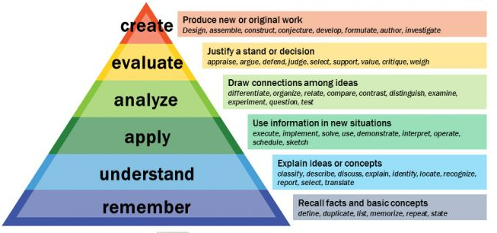 | 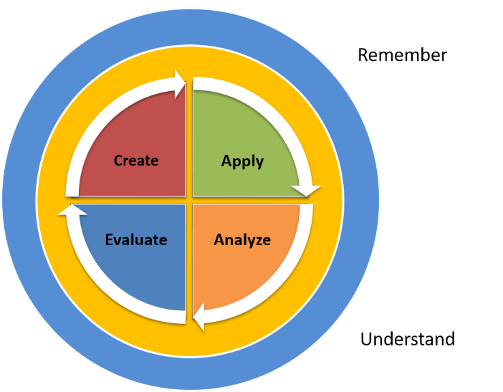
Armstrong, P. (2010). Bloom’s Taxonomy. Vanderbilt University Center for Teaching. Retrieved October 7, 2022 from https://cft.vanderbilt.edu/guides-sub-pages/blooms-taxonomy/. | Orlich, D. (1991). A New Analogue for the Cognitive Taxonomy. In The Clearing House (Vol. 64, Issue 3, pp. 159–161).

Writing Effective Outcomes
As you design your course, focus on creating clear learning objectives that rely on action verbs. Then you’ll be able to align these higher-quality outcomes to your key assignments, exams, and other course assessments.
- Start with a measurable and observable verb
- Ensure an appropriate range of early learning outcomes and more complex learning expectations for upper division courses
- Use verbs that match the expected level of learning based on course level
- Avoid language of “students will” at the beginning of an outcome
- Ensure congruence between what students are expected to learn and how students will be assessed
- If using a taxonomy other than Bloom’s, identify it in the justification
- When required by external accreditors to include specific verbiage in outcomes, identify the accrediting agency and applicable standard next to the related outcome
- Any approved learner outcomes older than 5 years are subject to review and revision (or if no approval date is listed)

Bloom’s Verbs
Here are some action verbs for each level of Bloom’s Taxonomy that you can use to create effective student learning outcomes and assessments.
Remember | Comprehend | Apply | Analyze | Evaluate | Create
Recalling previously learned information, facts, terms, basic concepts, and answers. | Restating or interpreting information in one’s own words. | Using learned material in a new scenario or in a different way. | Unpacking problems or scenarios, examining information, making inferences, and breaking information into parts. | Weighing and judging relative merits of multiple options, defending opinions using contextual about information. | Compiling previously distinct information together in a novel way to create something new.
Choose  Describe  Define  Label  List  Locate  Memorize  Name  Omit  Recite  Select  State  Count  Draw  Outline  Point  Quote  Recall  Recognize  Repeat  Reproduce | Associate  Classify  Compute  Convert  Defend  Demonstrate  Discuss  Distinguish  Estimate  Extrapolate  Explain  Express  Extend  Generalize  Give Examples  Illustrate  Indicate  Interrelate  Interpret  Match  Paraphrase  Predict  Represent  Restate  Rewrite  Select  Show  Summarize  Tell  Translate | Add  Calculate  Change  Choose  Classify  Complete  Compute  Discover  Divide  Dramatize  Examine  Generalize  Graph  Interpolate  Judge  Manipulate  Modify  Operate  Organize  Paint  Prepare  Produce  Select  Show  Sketch  Solve  Subtract  Use | Arrange  Breakdown  Categorize  Classify  Combine  Compare  Detect  Diagram  Differentiate  Distinguish  Discriminate  Identify  Infer  Outline  Point Out  Select  Separate Subdivide  Survey | Appraise  Judge  Criticize  Defend  Compare  Assess  Conclude  Contrast  Critique  Determine  Grade  Justify  Measure  Rank  Rate  Support  Test | Combine  Compose  Construct  Design  Develop  Formulate  Hypothesize  Invent  Make  Originate  Organize  Plan  Produce  Role Play  Drive  Devise  Generate  Integrate  Prescribe  Propose  Reconstruct  Revise  Rewrite  Transform

Learner Outcome Form for Curriculum
Course Prefix and Number: Date:
Please do not begin Learner Outcomes with “Student will be able to . . .” Learner Outcomes should begin with a measurable verb.
Learner Outcome | Activity (optional) | Assessment
Faculty Senate Rev 2/23

Anatomy of a Learning Outcome
Learning outcomes generally address knowledge (what students know), skills (what students can do), and mindsets (student attitudes or disposition about the concept). Knowledge, skills, and mindsets aren’t the only ways to frame an outcome, but they are a good place to start. Remember, effective learning outcomes are specific and measurable.
Anatomically speaking, learning outcomes are typically comprised of 3 pieces:
- a single action verb,
- a subject, and
- context.
Sometimes it helps to see examples, especially if you don’t have much prior training or experience writing effective learning outcomes. As an exercise to learn how to identify anatomical components of learning outcomes, let’s consider a topic: bicycles. So, in the anatomy of a learning outcome, the subject is bicycles.

What to Avoid When Writing Outcomes
Not trying to lead with the negative here, but it sometimes helps to know what NOT to do before you put in the work writing outcomes. Nobody wants to write learning outcomes repeatedly. As with any other academic endeavor, writing effective learning outcomes takes practice. Here’s an example of an ineffective outcome that faculty inexperienced with this sort of thing would think is perfectly fine:
- Students will understand how to ride a bicycle.
What’s the problem with this outcome? First, it uses the verb ‘understand’, which is neither directly observable nor measurable. In reality, we have no way of knowing if a student understands something. It’s much clearer and more effective if we use a verb we can directly observe and that specifically describes a student action. Second, the outcome is vague and provides no clear context.
As an aside, since outcomes refer to students by default, there’s no need to add ‘Students will…’ or ‘Students will be able to…’ to the beginning of a learning outcome as it is self-evident.
How can we write an outcome that remains focused on our subject (bicycles) but gets more specifically at what we want our students to know and be able to do?

How to Build an Effective Knowledge Outcome
First, let’s consider a knowledge outcome that has low cognitive demand (meaning students aren’t very intellectually taxed by what you’re asking):
- Describe the major components of a 12-speed bicycle.
Notice that this outcome is more specific than the previous example, focuses more clearly on student knowledge, and that the action verb ‘describe’ is easily observable in class or on an assessment. The outcome has an action verb (describe) and a subject (bicycle), but what about context? In this case, context is (major components).
Note also that it would be straightforward for students to accomplish this outcome. Therefore, the cognitive demand is low. That isn’t to say this learning outcome is bad – it is noticeably better than the previous example – only that it isn’t very intellectually demanding.
How can we increase cognitive demand so that students build their intellect in ways that serve them more usefully after graduation? Let’s reframe the same learning outcome so that it has high cognitive demand (meaning students must intellectually work harder based on what you’re asking):
- Evaluate which major component(s) of a 12-speed bicycle most contribute to mechanical advantage.
You should first notice that the action verb of this outcome (evaluate) is much harder for a student to accomplish than the action verb of the previous outcome version (describe) but is still focused on what you want students to know (knowledge about bicycles). The verb ‘evaluate’ requires a student to weigh and judge the merits of one bicycle component relative to another based on the criteria of mechanical advantage. This is a much more intellectually complex task, but the tradeoff for the increased rigor is that students build more of the thinking abilities they’ll need in the professional world.

How to Build a Skill Outcome
Ok, so what about a skill outcome for the same subject (bicycles)?
- Investigate which bicycle gears provide the best tradeoff of speed and mechanical advantage.
This outcome implies that some type of action is required or for students to do something, and therefore this outcome is focused on student skill. This outcome prompts students to come up with a method to determine which bicycle gear is the best balance of mechanical advantage (torque) and speed (ability to move the bicycle most quickly). To achieve this outcome, students would need some way of evaluating the relative advantage of each gear (mathematics and/or physics would help with this) and then comparing them or evaluating each relative to another. As you probably surmise, this is a skill outcome with high cognitive demand.

How to Build a Mindset Outcome
Mindset outcomes tend to be the most difficult to write, because they deal with student attitudes, dispositions, or personality traits. Some faculty might wonder why we should include mindset outcomes in our courses and curricula? Aside from the fact that we teach whole students and not just the intellectual pieces of them, students are generally not taught how to build a productive mindset.
From both psychological and biological perspectives, mindset influences reality. What do we mean by that? A positive mindset is associated with less depression, greater satisfaction, lower production of stress hormones, less inflammation, and greater health and well-being (Park et al., 2014). Considering the stressors students experience, it is well worth helping them build a positive mindset.
What does a mindset outcome for the same subject (bicycles) look like?
- Consider multiple perspectives when determining which bicycle gears provide the best tradeoff of speed and mechanical advantage.
This outcome asks for students to become open-minded, a personality trait or mindset that is useful in every life circumstance – not just for figuring out which gears are the best tradeoff.
Keep in mind that human mindsets tend to not change quickly, whereas knowledge and skills can change in a short amount of time. Regardless, if we don’t intentionally build mindset development into our courses and curricula, they are much less likely to happen at all.

Final Considerations
When you include knowledge, skill, and mindset learning outcomes in a course, students are much more likely to achieve the levels of intellectual and other growth they will require after graduation. Remember that writing effective learning outcomes is a skill that takes practice. Take the time to do it right, not just for your students, but for yourself. CWU faculty are constantly revising courses and trying to provide the best possible experience for our students. Learning to create effective learning outcomes will not only prompt students to learn more effectively, but it will also make your teaching practice more effective, consistent, and enjoyable.

References
Armstrong, P. (2010). Bloom’s Taxonomy. Vanderbilt University Center for Teaching. Retrieved October 7, 2022 from https://cft.vanderbilt.edu/guides-sub-pages/blooms-taxonomy/.
Hammond, Z. (2015). Culturally responsive teaching and the brain: Promoting authentic engagement and rigor among culturally and linguistically diverse students. Corwin, a SAGE company.
Orlich, D. (1991). A New Analogue for the Cognitive Taxonomy. In The Clearing House (Vol. 64, Issue 3, pp. 159–161).
Park, N., Peterson, C., Szvarca, D., Vander Molen, R. J., Kim, E. S., & Collon, K. (2014). Positive psychology and physical health. American Journal of Lifestyle Medicine, 10(3), 200–206.

