Enterprise Information Systems
Financial Management Human Resources Student Administration

Maintain Department Milestone Certificates
Business Process Guide

Update Log

Date | Action | Page(s)
01/29/2024 | Creation | ALL

Table of Contents

Introduction 4
Overview 5
Before You Begin 5
Prerequisites and Assumptions 5
Other Materials Needed 5
A. Adding a Milestone (First Time) 6
B. Updating a CWU Certificate Milestone 10

Introduction

Visio Diagram

Overview

Milestones are used for two reasons, track certificate completions and test placements in English and Math. This guide is intended to give instructions on how to manage milestones for department certificates.
Certificate programs
- Milestones are used to record a student’s achievement of College Supported, Collaborative and Continuing Education Certificates.
- Milestones are assigned, managed, and maintained manually by the departments responsible for the certificate program.
- Milestones used for certificates are set up to appear on the student’s official transcript.
  - Only curriculum-approved certificates in the catalog are approved to show on the official transcript.

Before You Begin

Prerequisites and Assumptions
Before you can successfully create a milestone for a certificate program, it is assumed that each of the following conditions has been met:
- The certificate has gone through the curriculum, has been approved, and is in the catalog.
- The milestone for the certificate program has been requested and created by IS.
- The student for the program is active in a career and program.
- The department has requested access to assign and manage milestones from IS.

Other Materials Needed
None

A. Adding a Milestone (First Time)
Navigation: Main Menu > Campus Solutions > Records and Enrollment > Enroll Students > Student Milestones

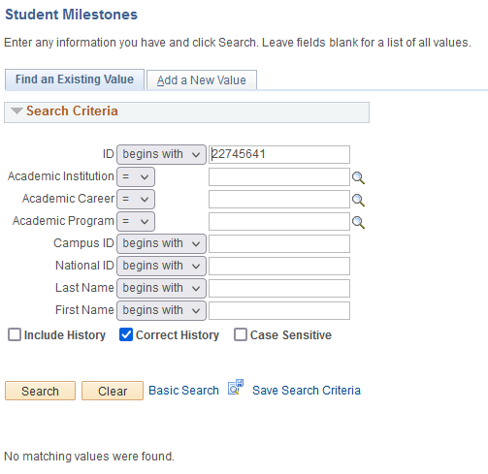

Steps to search for student
Step | Field | Note
1. | ID | Enter the student ID number  NOTE: If you don’t have an ID number enter last name and part of first name
 | Academic Institution | Leave Blank
 | Academic Career | Leave Blank
 | Academic Program | Leave Blank
 | Campus ID | Leave Blank
 | National ID | Leave Blank
 | Last Name | Enter if you do not have an EMPLID
 | First Name | Enter in combination with Last Name if you do not have an EMPLID
2. | Search | Click Search  NOTE: If no matching values click the tab called Add a New Value
If the student has a milestone record already the page will open up. Go to Steps for entering a CWU Certificate Milestone for next steps.
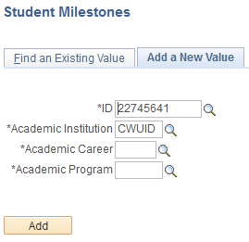 #1 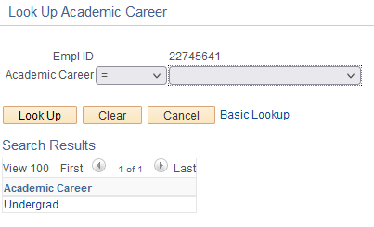 #3
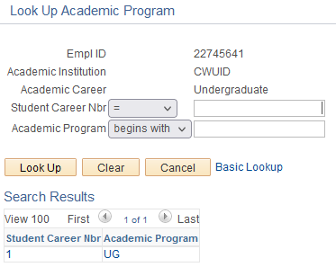#4
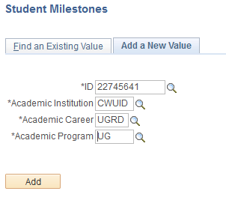#5

Steps to Add a New Value
Step | Field | Note
1. | ID | Enter the student ID number
2. | Academic Institution | CWUID
3. | Academic Career | Use the search icon and find the active Academic Career
4. | Academic Program | Use the search icon and find the active Academic Program
5. | Add | Click the Add Button
When the page opens. Go to Steps for entering a CWU Certificate Milestone for next steps.
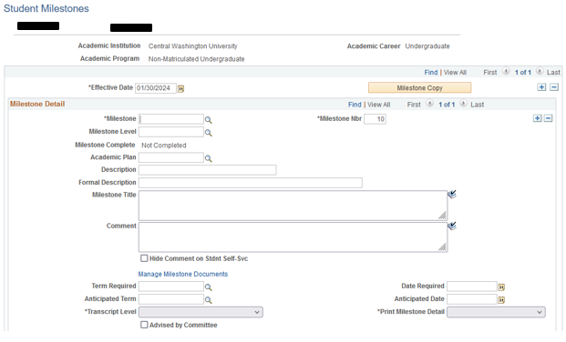

Steps for entering a CWU Certificate Milestone
Step | Field | Note
The student EMPLID (student ID) and first and last name appear in the upper left side of the page
 | Academic Institution | Populates based on information found in the search criteria
 | Academic Career | Populates based on information found in the search criteria
1. | Effective Date | Populates with current date or the date of the last entry.  NOTE: If another milestone already exists you must click the + symbol to the right and add a row.  Caution: be sure to click the + symbol next to Milestone Copy and not the + symbol below it.
Milestone Detail
2. | Milestone | Click the search icon to find the certificate milestone you want to assign to the student
3. | Milestone Level | Click the search icon to find the certificate milestone level you want to associate with the Milestone
 | Milestone Complete | This starts are “Not Completed”
4. | Academic Plan | Click the search icon to find the appropriate Academic Plan
 | Description | Automatically populates with the information provided for the set up of the certificate milestone  DO NOT CHANGE
 | Formal Description | Automatically populates with the information provided for the set up of the certificate milestone  DO NOT CHANGE

Steps for entering a CWU Certificate Milestone (Part 2)
Step | Field | Note
 | Milestone Title | Leave Blank
 | Comment | Leave Blank
 | Hide Comment | Leave unchecked. Milestones are not displayed in self-service
 | Manage Milestone Doc | Leave Blank
5. | Term Required | Enter the students Admit Term  NOTE: Correctly enter the term (quarter) the student starts the certificate program. This may or may not match their admit term.
6. | Date Required | This auto populates based on the admit term you enter and is the start of the specified term
 | Anticipated Term | Leave blank until the student completes their certificate program.
 | Transcript Level | DO NOT CHANGE  This will automatically populate based on the certificate milestone set up
 | Print Milestone Detail | DO NOT CHANGE  This will automatically populate based on the certificate milestone set up
 | Advised by Committee | Leave unchecked
STOP The remaining information will be populated when the student completes their certificate program

B. Updating a CWU Certificate Milestone
Navigation: Main Menu > Campus Solutions > Records and Enrollment > Enroll Students > Student Milestones

Search for student using Steps to search for student
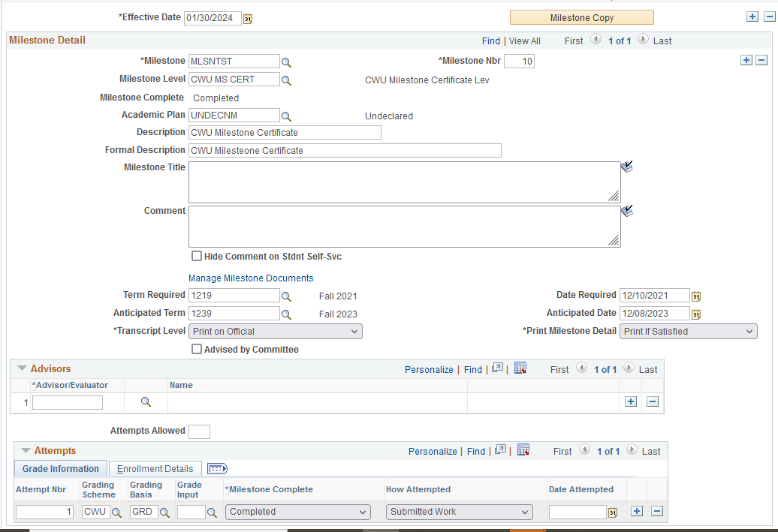

Steps to set Certificate Milestone as Completed
Step | Field | Note
 |  | If the milestone you are looking for isn’t present, click the fist and last arrows to find your certificate milestone
1. | Effective Date | Click the + symbol; the current date will auto populate
2. | Anticipated Term | Add the term (quarter) the student completed the certificate milestone
 | Anticipated Date | DO NOT CHANGE  This auto-populates based on the term entered
 | Advisors | Leave Blank
 | Attempts Allowed | Leave Blank
Attempts
 | Attempt Nbr | Auto populates DO NOT CHANGE
1. | Grading Scheme | CWU  If populated leave alone
2. | Grading Basis | GRD  If populated leave alone
3. | Grade Input | Leave Blank
4. | Milestone Complete | Set to “Completed”
5. | How Attempted | Set to “Submitted Work”
 | Date Attempted | Leave Blank

