Introduction
Computer technology is changing the nature of the workplace. About seventy percent of the American workforce now sits on the job. This increasingly sedentary workstyle can result in a variety of adverse health effects. Common complaints include excessive muscle fatigue, musculoskeletal disorders (MSD), eye strain, stress, and headaches. Research has shown that these symptoms can result from problems with the equipment, workstations, office environment or job design, or from a combination of these factors along with various lifestyle causes outlined below:

Lifestyle Causes
- Dehydration: Healthy muscles are comprised of at least 70% water. Dehydration causes muscle fatigue, strain, tendonitis, and other disorders of the movement system. Soda pop is not water, it’s liquid junk.
- Poor Nutrition: Eating too many “empty” calories that don’t contain the nutrients our body needs is a primary cause of injuries and disorders of the movement system. Tobacco contains toxins that increase inflammation.
- Inflammation: Inflammation causes many lifestyle-related disorders, including heart disease and movement system disorders. Too much sugar and fat within our diet can contribute to inflammation.
- Fatigue: Adequate amounts of rest and sleep are very important ingredients for our health.
- Poor Fitness: Poor levels of physical fitness increases the risk of disease and injury.

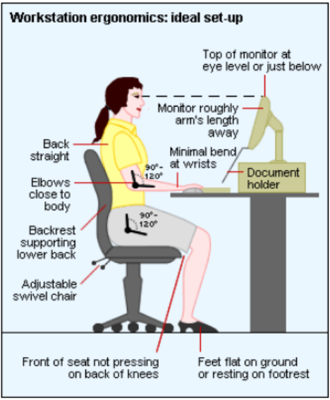
Seating
- Chair should be vertically adjustable and on a five-point base.
- Chair should have an adjustable lumbar (low back) support with a backrest that provides adequate support for your back.
- Chair seat pan should have adequate width and depth to provide for good fit, and the cushion should provide adequate comfort.
- Chair seat pan forward tilt and depth (forward and backward) adjustability is a plus.
- Chair seat pan should have a rounded front that does not pressure the back of your knees and legs.
- Chair should allow for proper body positioning with knees at or below the level of your hips, and feet resting flat on floor or supported by footrest.
- Chair armrests (if any) should support your forearms and not interfere with swivel or movement of the chair.

Monitor
- The screen should be located directly in front of you so there is no twisting of your head or neck).
- The top line of screen should at or slightly (0-30 degrees) below eye level and located at least arm’s length away from you.
- You should be able to clearly read the screen without bending your head, neck, or trunk forward/backward.
- The monitor should be in a location that eliminates glare on the screen which might cause you to assume an awkward posture to read screen.
- The monitor should be placed at a right angle and/or away from windows and task lights to avoid glare and bright light directly behind the screen.
Keyboard and Mouse
- The keyboard and mouse locations should allow you to keep your upper arms and elbows close to body.
- There should be weight bearing support for your arms (chair arms, desktop, or wrist rest) when you are using your keyboard and mouse.
- The keyboard position and angle should allow for a neutral wrist posture, so hands are in a straight line with forearms (not bent up/down or sideways toward little finger).
- Your arms and wrists should rest upon surface areas (chair arms, desktop, or wrist rests) that are absent any sharp or hard edges.
Other Ergonomic Considerations
- There should be adequate desktop space available to perform job tasks without twisting, side bending, or reaching.
- There should be adequate clearance for your feet, knees, and legs, and enough space to allow you to swivel your chair (without leg obstruction) to perform work tasks.
- A headset should be provided if your job requires frequent telephone use and phone communication is combined with hand tasks such as typing or writing.
- A document holder to position hard paper copies in a vertical orientation should be provided if your job requires frequent viewing of documents while entering data into computer. The document holder (if provided) should be placed at about the same height and distance as monitor screen.

CWU Ergonomic Resources
If you suffer from discomfort or pain while you are working, please consider visiting the EH&S Ergonomic webpage at; https://www.cwu.edu/ehs/ergonomics-0 for more resources. If you need further assistance with ways that you can better suit your workstation to your needs, you can request an ergonomic assessment from our Certified Office Ergonomic Evaluator in the CWU EH&S Department. This can be performed by visiting http://www.cwu.edu/ehs/request-ergonomic-assessment. The evaluator will then decide if an in-person assessment is warranted.

