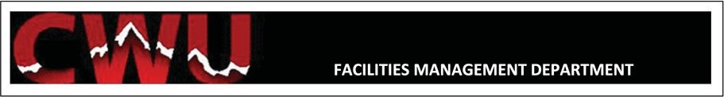

2026 Summer Fire Alarm Device Inspections & Testing (page 1)
(Sounding of Horns is required and will last between 5 and 20 minutes depending on size of
building. Individual room entry is required.)

MONDAY- August 17th
- Dugmore Hall
- Northside Commons Dining
- Bledsoe State Archives

TUESDAY- August 18th
- Wendell Hill Hall B (East)
- Button Hall
- Laundry and Duplicating

WEDNESDAY- August 19th
- Alford-Montgomery
- Carmody-Munro
- Student Village Multi-Purpose Room

THURSDAY- August 20th
- Wendell Hill Hall A (West)
- Kennedy Hall
- Green Hall/North Village Café

FRIDAY- August 21st
- Barto Hall
- Dining Warehouse
---------------------------------------------------------------------------------------------------------------------------------------------------------------------------

2026 Summer Fire Alarm Device Inspections & Testing (page 2)
(Sounding of Horns is required and will last between 5 and 20 minutes depending on size of
building. Individual room entry is required.)

MONDAY- August 24th
- Anderson Hall
- Moore Hall
- Beck Hall

TUESDAY- August 25th
- Kamola Hall
- Munson Hall

WEDNESDAY- August 26th
- Stephens-Whitney
- North Hall
- Wilson Hall
- Short-Getz Mechanical
- Sue Lombard Hall
- Tunstall Commons try to perform earlier in the day, in case of event*

THURSDAY- August 27th
- Early Childhood Learning Center try to sound horns around 1030am*
- Hitchcock Hall
- Sparks Hall

FRIDAY- August 28th
- Meisner Hall
- Davies Hall
--------------------------------------------------------------------------------------------------------------------------------------------------------------------------

* Ensure we notify all staff of any schedule changes. Contact List can be found in the folder below.
J:\SHOPS\EMCS\FIRE\Fire Inspection Documents\Faculty Notification

