Construction Management Program  Detail of Work Experience Form  Include all relevant experience after high school graduation.  Year of graduation from high school: __________________ |  |  |  | 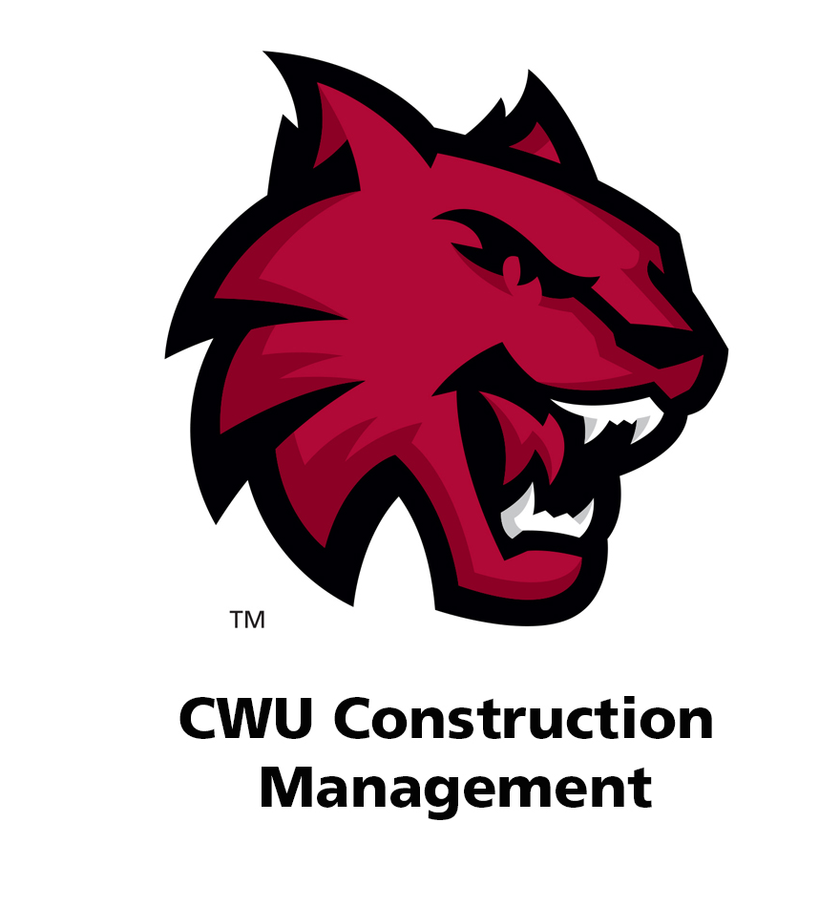
Dates (include month and year). List most recent first | Company, location, and type of work | Full-time or part time?  Hours/week? | - Duties and Responsibilities  - Supervised any employees?

