How to Find Holds on your MyCWU

1. Log in to MyCWU through the icon at the top of cwu.edu:

2. Click on the Student Tab:
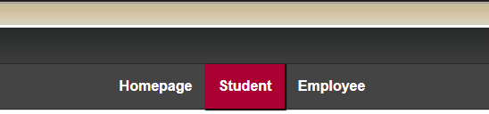

3. Your holds will be listed in the Holds widget in the center of the screen:

4. Click on the hold for information on the reason, contact information, and instructions on how to remove the hold:

