How to waitlist courses in your Shopping Cart:
- Navigate to your Shopping Cart through the following pathway: MyCWU>Student Tab>Enrollment>Add Classes
- Once there, click on the class name
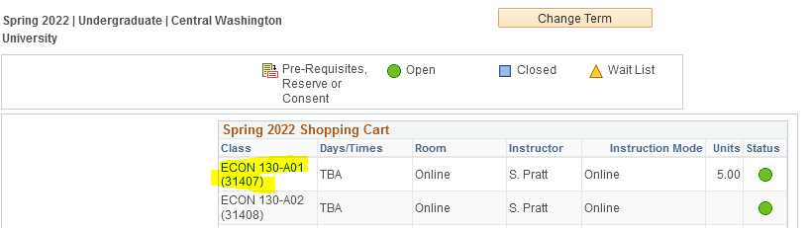

- This will bring up info about each course. Then click the “Waitlist if Class is full” box.
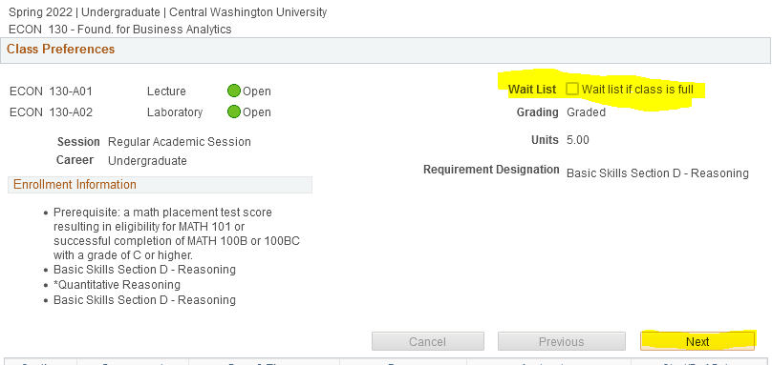
- Press “Next” and then enroll into the course!

To check where you are on a waitlist, this can be found on your class schedule: MyCWU>Student Tab>Schedule>My Class Schedule

