Finding Your Enrollment Date and Time Instructions

1. Log in to MyCWU through the icon at the top of cwu.edu:

2. Click on the Student Tab:
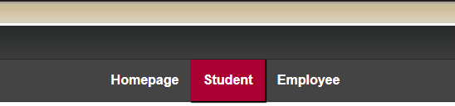

3. Click on Enrollment in the Navigation bar on the left-hand side of the screen:
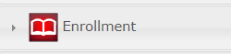

4. Click on Enrollment Dates
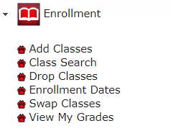
5. Select Winter 2021
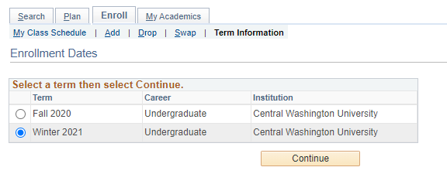

6. Look for Winter 2021 and your enrollment date will be listed below.
