Graduate Student Handbook
2023-2024

Central Washington University
Department of Biological Sciences

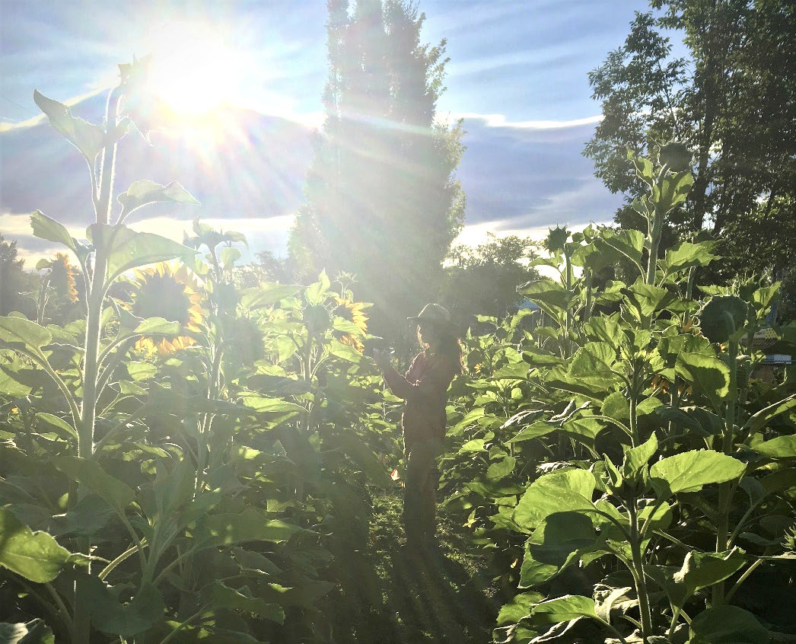
Lauren Segarra in sunflower field, 2019.

Table of Contents

Welcome to Graduate School, 3
Timeline, 4
Important Milestones Checklist, 5
Campus Resources, 6
Cultivating Professional Behavior, 6
Graduate Assistantships, 7
Graduate (Thesis) Committee, 8
Biology Faculty, 9
Coursework, 10
Oral Exam, 10
Planning Your Research, 11
Thesis Research Proposal, 11
Special permits for research on humans and other vertebrates, 12
Funding Your Research: Grants, 12
Conducting Your Research, 12
Writing Your Thesis, 13
Getting Ready to Graduate, 14
Final Folder Check, 14
Thesis Defense, 14
Publishing Your Thesis, 14
Moving On, 15

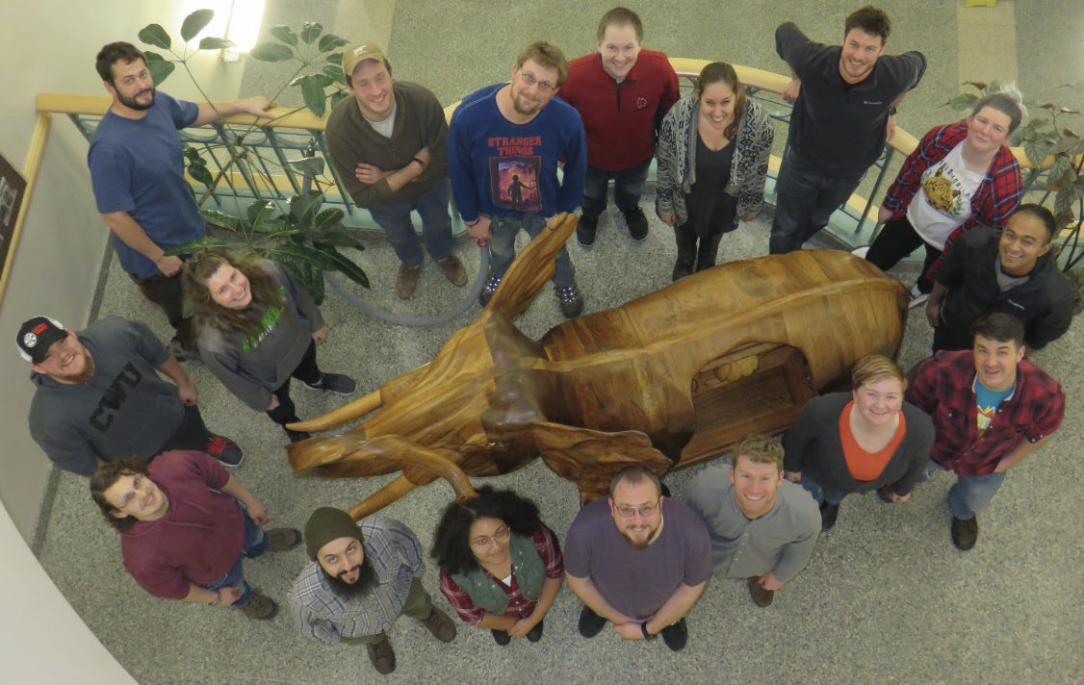
CWU Biology Graduate Students, 2017-2018

Welcome to Graduate School
You are embarking on one of the most exciting times of your career. Unlike undergraduate study where you had less freedom to determine your curriculum, in graduate school you design most of your own course of study and especially your research. You are becoming an authentic scientist, learning how to design and conduct scientific studies and disseminate your work.

Graduate school is fun and exciting; it can also be stressful and difficult. We have compiled this handbook to help make your progress smooth and less stressful. You’ll find some “nuts-and-bolts” information to guide you through the hurdles of graduate school, and some advice that comes from our experience as former graduate students and current graduate advisors. This guide is not intended to be comprehensive, but rather to complement the guidelines set forth by the School of Graduate Studies & Research (SGSR). Consult the SGSR webpage for additional details about graduate school at CWU.

While many universities discourage students from seeking a master’s degree and prefer them to concentrate their efforts on pursuit of a Ph.D., CWU has developed a strong program at the master’s level. Why do we believe so strongly in master’s degrees? Our master’s program provides training and expertise for those needing a terminal degree for entry-level positions in government, industry, and education. We serve other students by preparing them for the Ph.D. degree and careers in biological research. Obtaining a master’s degree before a Ph.D. broadens your perspective by diversifying your exposure to new ideas, provides experience in research and writing, and provides what may be your first opportunity to publish a paper.

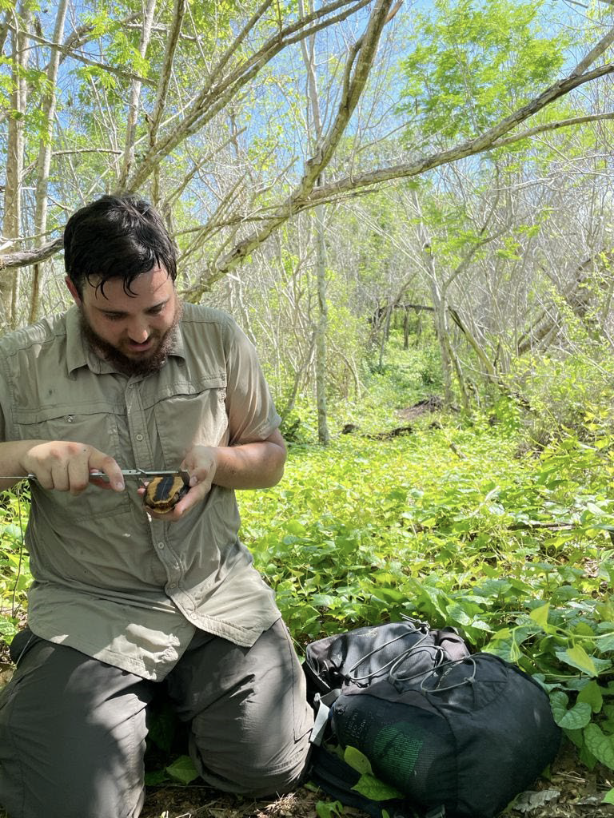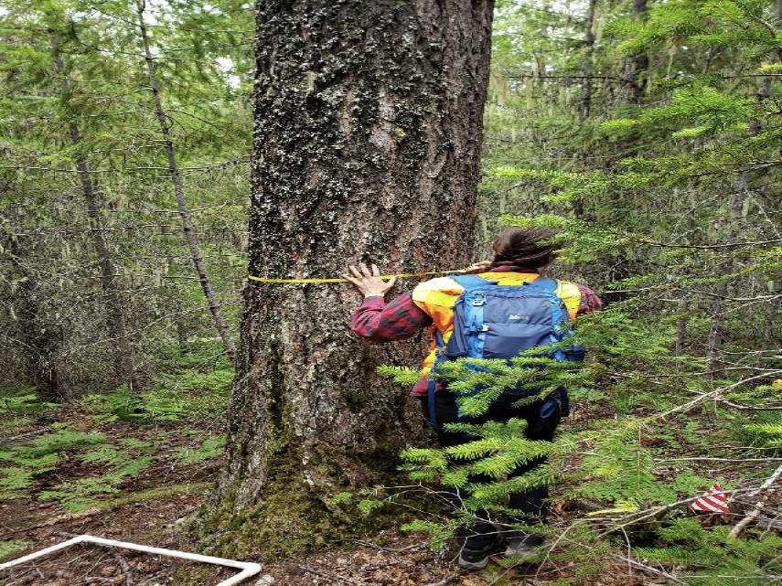
Jose Garrido measures a turtle in Chamela Forest. Jordan Ryckman measuring for habitat studies of shrews.

Timeline
Our goal is for you to complete your master’s degree within two years. The timetable outlined below suggests steps to take each quarter to achieve this. Schedules and sequences of events will vary depending on the student and the nature of their graduate program, so please consult with your advisor. Please be aware that completing all the requirements for a master’s degree in two years can be challenging and will require long hours, likely including nights and weekends.

Year One
Fall: BIOL 501, establish thesis committee, define research topic and questions.
Winter: BIOL 502, develop research proposal and present to department, Grad Committee and Option approval, Course of Study.
Spring: Collect (preliminary) data
Summer: Collect data, conduct preliminary analyses

Year Two
Fall: Finish data collection, analyze data, begin writing thesis
Winter: BIOL 602, Specialty (oral) exam, complete data analysis, continue writing thesis
Spring: Final folder check, permit to schedule oral exam (defense), final thesis draft, prepare for oral defense
Summer: Final thesis revisions, submit for publication

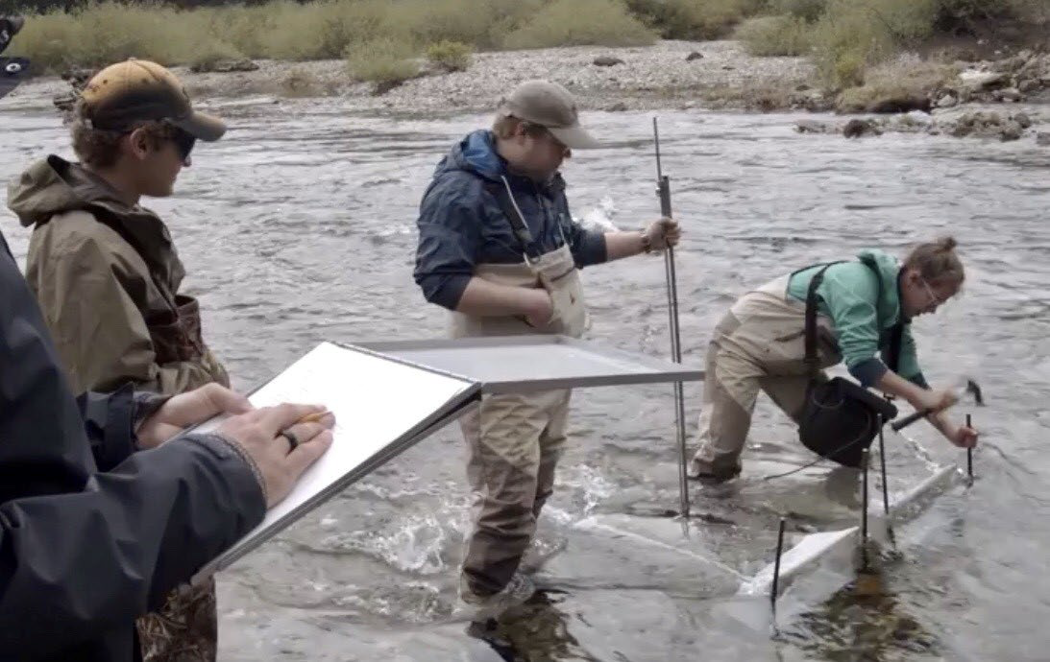
Graduate student Alex McCarrel hammers down sampling nets in Gold Creek to capture Kokanee salmon (Oncorhynchus nerka). She is assisted by CWU undergraduates.

Important Milestones Checklist
This checklist will help you meet deadlines for submitting required forms. You are responsible for meeting deadlines. Confirm deadlines on the Graduate Studies web page and find forms and additional information on the Graduate School Onboarding Canvas Course.

Task: Course of Study
Deadline: Prior to enrolling for 25 credits
Requirements: Meet with your advisor to form a committee that will review your transcripts and test scores to identify weaknesses and choose appropriate coursework. IMPORTANT: failure to meet this deadline may result in dismissal from the program.

Task: Graduate Committee and Option Approval
Deadline: End of 2nd quarter
Requirements: Meet with your committee and decide upon a topic and title of your proposed thesis research project. The graduate committee and option approval form can be found on the Graduate School Onboarding Canvas Course. Once your form is submitted you will be given access to the Thesis Canvas Course which will help guide you through the requirements for completion of your graduate degree.

Task: Research Proposal
Deadline: End of 2nd quarter
Requirements: Oral presentation of research proposal as final requirement of BIOL 502. Submit written thesis research proposal to your committee (confirm due date and exact requirements with your advisor).

Task: Specialty Exam (oral)
Deadline: Quarter prior to graduation
Requirements: Exam will cover topics in your area of study and will be administered by your committee and other interested faculty.

Task: Final Folder Check
Deadline: 1st week of anticipated final quarter
Requirements: Candidacy requirements, grade point average, course of study completion, and final examination (public oral defense + committee oral exam) scheduling will be processed by the School of Graduate Studies and Research.

Task: Penultimate thesis draft
Deadline: Three weeks before defense
Requirements: Provide your committee with a complete, penultimate thesis draft. You will still need to incorporate their comments before submitting a final thesis to the Graduate School.

Task: Permit to Schedule Final Exam
Deadline: Two weeks before defense
Requirements: Find a day and time that works for you and all committee members. Work with Biology Office to find an available room. Get signatures from all committee members and Program Director (= Biol. Grad. Coordinator); submit form to Graduate School and a copy to the Grad Coordinator. The approval form will be emailed from GSR after final folder check.

Task: Defense announcement
Deadline: One full week (7 days) before defense
Requirements: Email your announcement (with your name, thesis title, date, time, and room) to the Biology Office (Stacey Ferris) and Biology Graduate Coordinator (Gabrielle Stryker). Post printed copies around the building (the Biology Office may be able to help with this).

Campus Resources
Biology Department
Office: Science 338
Biology Graduate Program

Staff: Department Chair: Dr. Holly Pinkart
Fiscal Specialist Supervisor: Kari Linnell (budgets, travel)
Secretary: Stacey Ferris (forms, keys)
Fiscal Specialist I: Mari Knirck (ordering)
Stockroom: Emma Nelson (Safety)
Media Prep: Elaina Martinez
Engineering Technicians: Emil Babik
Graduate Coordinator: Dr. Gabrielle Stryker

(Biology) Graduate Committee: The Biology Dept. has a Graduate Committee whose responsibilities include policies and procedures for the graduate program, graduate curriculum, review of applicants, and other issues related to graduate students within the department. The committee typically has 3-5 faculty members, one of whom serves as chair of the committee and Graduate Coordinator, and one student representative selected by the graduate students each fall.

Graduate Studies and Research: A wealth of information and guidance, including potential funding sources. www.cwu.edu/masters/
Office: Barge 214
Contacts:
Grants and fellowships:
Christy Gilchrist 509-963-3111 Christina.Gilchrist@cwu.edu
(Director of Research & Sponsored Programs)
Kelley Quirk, 509-963-2118 Kelley.Quirk@cwu.edu
(Grants and Contracts Coordinator)
Diane Houser, 509-963-2102 Diane.Houser@cwu.edu
(GSR related fellowships)

Final degree requirements:
Dawn Anderson, 509-963-3108 Dawn.Anderson@cwu.edu
Lynn Niemi, 509-963-2243 Lynn.Niemi@cwu.edu
Victoria Clapper, 509-963-3104 Victoria.Clapper@cwu.edu

Thesis formatting and final edits:
Lila Harper, harperl@cwu.edu (or set up a video call through Graduate Hub on Canvas)

Cultivating Professional Behavior
Keep yourself engaged, motivated, and on-task. Psychological issues, not intellectual deficiencies, are the most common stumbling block in graduate school. Take advantage of this opportunity to develop colleagues – your fellow graduate students, faculty, and professional biologists in your area of interest. They will help keep you excited about scientific research.

Always follow through on commitments, however small, that you make with your committee members and other colleagues. Schedule regular meetings with your advisor and keep her/him up to date with your progress, concerns, and any difficulties you are having. Keep in mind that your advisor (and your committee) is here to help you. They want to see you succeed almost as much as you do. If you are having problems, let your advisor know early on; he/she will appreciate your candor and likely have some good suggestions for helping solve your difficulties.

Take every opportunity to interact with faculty and students in some of the other excellent departments on campus. Attend the Natural Science Seminars and seminars in Chemistry, Geology, Geography, Physics, Psychology, Anthropology, and other departments. Take a GIS or Anthropology course. Go on a Geology fieldtrip. One of the benefits of a university the size of CWU is that it is easy to develop interactions with other departments in the sciences. Such interactions can broaden your perspective and make you a better scientist.

All graduate students are expected to attend department-sponsored seminars and defense seminars of other graduate students. These opportunities will broaden and deepen your scientific background, and help you become part of the scientific community. Be sure to check the schedule for the Science Seminar Series each quarter and plan to attend these.

Graduate Assistantships
Assistantships generally take two forms: teaching assistantships (TA’s) and research assistantships (RA’s). The biology department typically offers a limited number of TA’s to biology graduate students. Research Assistantships may be available to work with a faculty member on a project funded through a grant or contract.

Teaching Assistantships
TAs are the more common means by which graduate students keep themselves afloat financially at CWU. While your main purpose in graduate school is to gain experience in research, your acceptance of a TA requires that you become a competent and responsible teacher as well. Some graduate students will relish this opportunity, as they have chosen teaching as their career goal. But even for those who do not foresee teaching in the future, being a TA can be very rewarding as you help undergraduate students learn more about biology and inspire them to become scientifically literate. Teaching also greatly improves your understanding of biology (thus CWU’s motto, Docendo Discimus - By Teaching We Learn) and your ability to think and speak on your feet (benefits for your oral exam and thesis defense).

Your responsibilities as a TA include:
- being available to the instructor from the beginning of the quarter through final exams.
- attending TA meetings throughout the quarter.
- asking the instructor what your responsibilities are for the course you are TA’ing.
- having a thorough understanding of the material students are expected to learn in the course.
- posting your name and office hours on your office door, and keeping your office hours (or posting a note in the rare instances when you cannot be there).
- promptly grading and returning assignments to students.
- - keeping accurate records of student grades (check with your instructor); and
- - treating students in a professional and courteous manner.

The School of Graduate Studies & Research and the Department of Biological Sciences periodically hold workshops for teaching assistants (usually in the fall). Be sure that you stay informed as to when these workshops are offered and that you attend them as required.

Graduate (Thesis) Committee
One of the first items of business is to select your committee. The committee helps you design a course of study, provides feedback on your thesis research design, administers the specialty oral exam, and provides guidance on and approves your written thesis. The committee consists of a committee chair (your advisor or major professor) and at least two other members.

You and your advisor should work together to select the other committee members. While these often are Biology faculty (see list below), faculty members from other departments may also serve on committees. Adjunct faculty (including researchers outside of CWU) may also serve on committees (but not as committee chairs) if approved by the Dean of Graduate Studies & Research. Please check with your advisor or the Graduate Coordinator to confirm the eligibility of potential committee members.

Choose committee members whose expertise complements one another. Breadth is important for maximizing feedback on your research. Perhaps more importantly, pick faculty who will be interested in your work. Your committee is integral to your success in graduate school; it is very important that you feel comfortable with each member to seek advice. Make a concerted effort during your first quarter to get to know the faculty, keeping in mind their suitability as potential committee members. Stop by and chat about research and teaching interests. Ask them for copies of their publications, and about important books and papers that have influenced them.

To gain the respect of your committee, keep them informed of what you are doing and progress you are making. Stay in touch but work toward developing independence. Anticipate personality conflicts. If you find that you don’t get along with your major professor or other committee member, try to discuss concerns with them early on; you may need to change committee members if issues are not resolved.

Act professionally in the scheduling of and participation in committee meetings. Never underestimate how difficult it can be to get three or four busy people together at one time for an hour. Set meetings up in advance, giving each committee member sufficient notice so you can find a mutually agreeable time. Reserve a room. Shortly before the meeting, remind each member of the time, date, and room of the meeting. Committee meetings are for you. Know ahead of time exactly what you want to get out of the meeting and get feedback from your advisor. Write an agenda and lead the meeting. Take notes on decisions and recommendations made during each meeting.

Biology Faculty Members | Research Interests
Clay Arango* | Stream ecology; how humans modify the uptake and transformation of stream nutrients; forest-stream ecological connectivity
April Binder* | Molecular biology, reproductive and developmental biology, gene expression in mouse ovaries
Lucinda Carnell* | Regulation of behavior in the nematode, C. elegans
Celine Cortes | Ecology, cranial morphology, and hybridization of North American wolf-like canids.
Blaise Dondji* | Cellular immune responses to hookworm and Leishmania infections
Kristina Ernest* | Population and community ecology, biology of small mammals, ecological connectivity, road ecology, conservation biology
Fabiola Serra Fuertes | Animal biology, physiology
Jason Irwin* | Physiological ecology of cold tolerance and seasonal patterns of energy use in insects, amphibians, and other ectotherms
Paul James* | Fish ecology, stream ecology
James Johnson* | Mycology, molecular systematics, molecular ecology and amphibian disease
Sarah Oppelt* | Aspects of metabolism and how it influences cell fate
Holly Pinkart* | Microbial ecology and physiology, microbes of saline alkaline lakes
Mary Poulson* | Plant Physiology, photosynthesis, and photosynthetic responses to the environment
Ian Quitadamo* | Neuro-cognitive basis of critical thinking, assessment of science learning
Linda Raubeson* | Conifer phylogeny, chloroplast genome evolution, conservation, and ecological genetics of local plants
Alison Scoville* | Ecological and evolutionary genomics, rapid evolution, and conservation biology
Gabrielle Stryker* | Protozoan parasites, paraflagellar rod proteins in kinetoplastids, cell motility, immunology
Lixing Sun* | Ecology and evolution of animal behavior (especially communication systems); primate behavior, cognition, behavioral economics

*Graduate Faculty status; others may serve on committee but not direct it.

Coursework
As you plan your course of study, be sure to refer to the following general policy on required and allowable credits. Keep in mind that, in addition to courses offered in the Biology Department, other departments and programs on campus (e.g., Anthropology, Chemistry, Cultural and Environmental Resource Management, Geography, Geology, Primate Behavior, Psychology) may offer courses relevant to your study.

45 credits beyond the B.S./B.A. degree are required for the M.S. Required courses include:
• BIOL 501 -- Research Methods and Techniques, 2 credits
• BIOL 502 -- Research Proposal Presentations, 2 credits
• BIOL 505 -- Current Topics in Biology, 6 credits (2 credits each; take 3 times)
• BIOL 595 -- Graduate Research, 10 credits. (A maximum of 10 can be counted toward the 45 credits required; you can take more as your advisor/committee approves, but only 10 will count on the course of study form).

• BIOL 602 -- Research Presentations, 2 credits
• BIOL 700 -- Master’s Thesis, 6 credits
• Electives selected by advisement, 17 credits

In addition, please note:
• Any courses below the 400 level that you take (either by choice or required by the committee) cannot be counted toward the required 45 credits.
• Courses at the 400-level may be accepted for credit toward your degree if they are taken after you are admitted to the master’s program and are approved as part of your official course of study. Graduate students are expected to perform at a high level, while completing requirements additional to those expected of undergraduates in the course.
• No more than 9 graduate credits can be transferred from another school.
• Students with assistantships must take at least 10 credits each quarter (BIOL 595 credits can be used to keep fulfill this requirement).
• You must be enrolled for at least 2 credits during the quarter in which you graduate.
• Credit toward the graduate degree will not be accepted for courses in which a grade lower than C is earned.
• Grades for all courses included on the Course of Study must average at least 3.0, where the cumulative grade point average is calculated on all courses taken after admittance into a graduate program, whether part or the approved Course of Study or not. A graduate student whose cumulative grade point average falls below 3.0 at the end of any quarter will be placed on academic probation for the next academic quarter. A student on probation may not hold a graduate assistantship. If the cumulative grade point average remains below 3.0 after a second consecutive quarter, the student will not be eligible to continue in the master’s program.

Oral Exam
The oral exam, administered by your graduate committee, is usually taken during your 4th or 5th quarter. Its purpose is to assess your grasp of topics in your area of study, and your understanding of how your specialty fits into a larger biological context. Specifics of the oral exam may vary from committee to committee, and different faculty members may stress different points (e.g., one may be interested in your understanding of the historical underpinnings of your specialty, while another may want to see how well you can “think on your feet”). In any case, remember that your committee is on your side during the oral exam – they truly want you to succeed. Talk to them well ahead of time about how you might prepare.
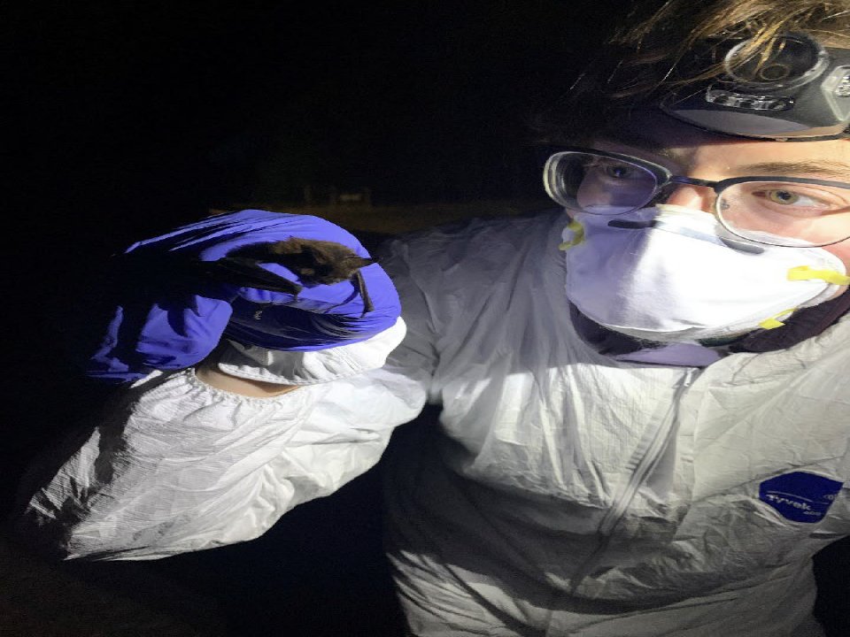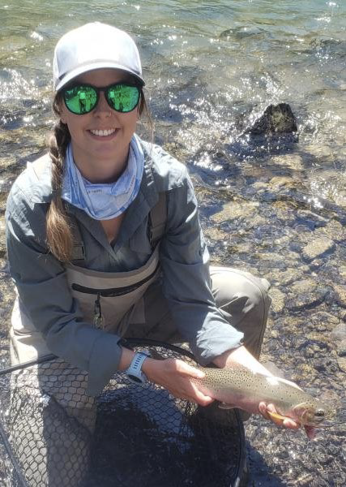
Jenna Chapman safely holding a local bat. Aimee Taylor researching Bull trout movement and migration patterns in Lake Kachess.

Planning Your Research

Thesis Research Proposal
A major part of graduate school is to conceive, design, implement, and summarize in written form original, independent research. Your proposal is the first step in this process. Focusing on an exciting research question is the primary goal of your first quarter, so plan your time accordingly. Realize that your research will shape you as a scientist; therefore, it is essential that you choose a topic in which you are very interested. The stronger your interest and passion for your research topic, the easier it will be to press forward through any difficulties which may arise.
You will begin the process of developing your proposal during BIOL 501, then write and present your proposal orally in BIOL 502. When preparing your proposal, discuss your ideas with other graduate students. Ask them (or your faculty advisor) if you can look at their proposals. Critical elements of a research proposal include:

•Title page: thesis title, your name, advisor’s name, date
•Introduction (what you propose to do)
-why it is important
-how it fits into the broad scheme of knowledge
-a literature review that substantiates #3
-a clear statement of your questions/hypotheses
•Methods (description of experiments or observations you’ll conduct that will permit you to test your hypotheses)
-how you will analyze your data
•Potential pitfalls and what you’ll do if things go awry
•Timeline of anticipated completion: Include preliminary observations/experiments, main data collection periods, data analysis, writing, defense
• Budget (optional, but recommended; will be helpful in planning and when seeking funding)

Special Permits for Research on Humans and Other Vertebrates
No human or animal research of any kind may be conducted without obtaining prior approval from the relevant department and university review committees. In the case of research with human subjects, the review is conducted by the Human Subjects Review Program, which serves as CWU’s Institutional Review Board (IRB). Research on (non-human) vertebrates is regulated by CWU’s Institutional Animal Care and Use Committee (IACUC), and in some cases also by state and federal permitting agencies such as Washington State Department of Fish & Wildlife and US Fish & Wildlife Service.

Funding your Research: Grants
Learning how to find funding sources and write successful proposals is an important skill for graduate students to develop.

Graduate students may apply for internal (CWU) grants:

Biology Department: check the Biology website for application information and deadlines
- CWU Distinguished Fellowship in Biology
- The Botanical & Mycological Research Fun
- Kittitas Audubon Research & Tuition Scholarship

School of Graduate Studies and Research: Look for information and verify deadlines Graduate School Onboarding Canvas Course.
- Graduate Student Research/Creative Activity Support Award (applications due in Nov. or April), up to $1000 for research expenses.

Graduate Student Summer Fellowship (application due in April), $3500 stipend for conducting research.

Travel Award, up to $750 for travel expenses to present your research at a conference; no specific deadline but submit application before travel.

Many funding sources outside the university are also available. Check with members of your committee, the Biology graduate program website, and on-line searches.

Most funding sources will require research proposals. Be sure to work with your faculty advisor to develop and edit your proposal. Your advisor will need some time, likely at least two weeks, to read the proposal before you submit it, so stay on top of deadlines and plan ahead of time. You may also need prior approval from the Institutional Animal Care and Use Committee (IACUC) and/or the Human Subjects Review Council (HSRC) to submit your proposal. Note that these committees may require submission of your proposal 1-2 months before their monthly meeting to review proposals. If you are awarded a fellowship or grant, you must acknowledge this support on posters, presentations, and publications that result from your research. Also, many funding sources (including CWU’s School of Graduate Studies & Research) require a final report summarizing the work you did. Failure to submit final reports may disqualify you from additional funding.

Conducting Your Research
Plan a schedule and stay on track. You are engaging in an exciting, creative endeavor of your own design—make it fun. Consult frequently with your major professor during this stage; encourage him or her to accompany you into the field or laboratory. Keep reading the literature as much as you can during this stage; it will help keep you excited and motivated. Go to regional meetings; present your preliminary data if possible. Posters are great for showing early results and getting feedback; they are also less stressful than oral presentations.
As you carry out your research, it is essential to keep good records of your data. Keep a detailed lab or field notebook, recording all your methods and results as well as your objectives and interpretations. Don’t run the risk of losing data: make electronic copies of your notes periodically, and store these in a separate location from your notebook. There are horror stories of students having all their notes in a backpack that got stolen (from an office, from a vehicle, etc.) – and having to start from scratch. The same goes for computer files – keep backup documents in separate locations (e.g., pin drives, network server, cloud).

Writing the Thesis
This stage of your degree can be just as exciting as planning your research and collecting the data. It is a time for more intensive reading, organizing your thoughts, and putting your study into the context of what is known about your specialty area. As you enter this phase, be careful not to underestimate how much time it takes to write well! A typical thesis goes through four to six drafts from start to finish: a published paper, several more. Two options are available for the general format of the thesis: traditional master’s thesis and journal-ready format. Please consult with your advisor when deciding which option best suits your needs.

Follow these general steps:
- Refer to the School of Graduate Studies & Research (SGSR) guidelines for the thesis on the Thesis Canvas Course. SGSR has very exacting expectations of what the final copy of your thesis should look like. Consult with SGSR early in writing your thesis and review its guidelines frequently as you write. Attend the thesis writing workshop offered by the SGSR. This will make your life much easier as you enter the final stretch between your defense and getting that final copy approved by the Graduate Office. All theses at CWU are submitted electronically.

- Make an outline of key points and follow it carefully.

- Write your Methods section as you proceed through your research.

- Make your figures and tables and write your thesis around them. This often means you will work on the Results first, then Introduction and Discussion later.

- Track references carefully to give proper credit and avoid plagiarism. The SGSR performs a Turnitin audit on all theses.

- Consult writing resources. Read “The Elements of Style” by E.B. White or a similar text before you begin writing and consult it frequently as you write your thesis. Follow the Council of Science Editors (CSE) style manual (Scientific Style and Format: The CSE Manual for Authors, Editors and Publishers); copies are available for checkout from the Biology Stockroom. Write with economy, clarity, and precision: clear writing leads to clear thinking.

- Work with your advisor to get feedback on early drafts. Your other committee members will typically read only the final drafts (confer with your committee on their preferences).

Getting Ready to Graduate
Please review the Thesis Regulations on the Thesis Canvas Course and confer with the Graduate Studies website for current requirements, deadlines, and fees.

Final Folder Check
All students wishing to graduate must apply online for a final folder check (application to graduate) no later than the first week of the student’s final quarter. At this evaluation, candidacy requirements, grade point average, and Course of Study completion are processed. Students must register for a minimum of two (2) credits at the university during the quarter in which the degree will be conferred. Enrollment for this purpose should be completed during the usual pre-registration or registration periods to insure degree conferral. A student who has been approved for the degree list for a particular quarter and does not complete the requirements for degree conferral by the published deadline (two weeks prior to the last day of finals) will not finish that quarter and will have to register for 2 credits the following quarter.

Thesis Defense (Final Examination)
Plan Ahead! The Permit to Schedule Orals/Portfolio Review/Final Exam is due two weeks prior to the final exam (defense) during the quarter of graduation. This form will be sent to you after your final folder check is complete and must be completed by you and your committee members, signed by the Biology Graduate Coordinator, and filed in the School of Graduate Studies & Research Office.
Your committee should get your “penultimate” thesis draft at least three weeks before your defense. This gives your committee members 10-14 days to review it and provide you with feedback and gives you a week or so to incorporate their comments and provide them a “final” copy of your thesis three to four days before your defense. How long it takes for committee members to return the draft and the quality of their feedback depend greatly on how well you have prepared your thesis (as well as how many other graduate students are submitting drafts at the same time!). If submitting a journal-ready thesis, be sure to provide your committee with the name of the journal (the journal’s instructions for authors are also helpful).

Plan to present your oral defense seminar no sooner than 10 days after you get comments back from your committee (this, of course, depends on how many changes are needed). Practice multiple times – as a rule, run through five practice presentations before your final defense. Practice by yourself, ask your advisor to watch a practice, and invite your peers (fellow graduate students) to give you constructive feedback.

Logistics: In advance, reserve a room for your defense (ask the department secretary for assistance). Prepare an announcement for your defense (with your name, thesis title, date, time, and location of defense). At least 1 full week before your defense, email this to the department secretary to distribute, and post photocopies around the department and Science Building. Invite your friends and family!

Publishing Your Thesis
Publishing a paper is not as brutal as many people think and can be fun! This accomplishment may be crucial for obtaining certain jobs and for acceptance to a Ph.D. program. Dissemination is also one of the responsibilities of being a scientist – it makes your research accessible and useful to others. Because your degree is indirectly (and perhaps directly) subsidized by the public, you should make your findings available to the public and to other scientists. The thesis alone (considered an unpublished document) does not reach a broad audience and may be difficult for many people to access. A publication in a journal receives wider attention and is more readily accessible. Work with your committee chair to discuss possible journals for submitting your thesis research for publication. Discuss authorship early on, and revisit as needed.
Moving On
While we hate to see you go, we know you have great things ahead of you! Leave in good standing by providing your advisor and committee the final version of your thesis (ask if they prefer pdf or printed). Be sure to return all equipment and leave laboratory and office space clean. Provide the Biology office with your new contact information. And please keep in touch – we love to hear what our former graduate students are doing.

Naomi Bryant, M.S. Biology, Spring 2019. CWU Photo.

