Services & Activities Fee Annual Program Review
Program Name: | Diversity and Equity Center
Program Manager: | Malbert Stewman
Fiscal Year: | FY2024

- In what way(s) does your program support CWU students? Please be specific and concise.

The Diversity and Equity Center (DEC) actively supports students across campus by championing advocacy, engaging in social justice peer-education, and orchestrating identity and cultural programming. Focusing on the unique needs of students with marginalized identities, the DEC establishes various identity affinity spaces (such as THRIVE and Q*Fam) to foster a sense of community based on shared identities and diverse experiences.
Collaborating with student organizations, clubs, and campus departments, the DEC spearheads campus-wide cultural programming aimed at validating the experiences and cultural backgrounds of marginalized students. Social justice workshops, co-facilitated by DEC student and professional staff, are also provided to the campus community. Through this comprehensive range of programs, the DEC consistently facilitates community building initiatives throughout the year, fostering strong peer relationships, mutual learning, and a profound sense of belonging at Central.
One of our Program Managers serves as an Advisor to the Equity & Services Council (ESC), offering guidance and support to the ASCWU’s Director for Equity & Multicultural Affairs in leading the ESC Executive Board. This includes supporting ESC student organizations in planning their cultural and educational events.
Furthermore, we maintain a team of 12 student initiatives coordinators at the DEC year-round. These coordinators are mentored to take on leadership roles in DEC programs, and they receive professional development and learning opportunities to nurture their personal growth and leadership skills.

- What are your specific program goals or learning/operational objectives? How are you assessing the effectiveness of your program in achieving those targets?

The overall goal of the Diversity and Equity Center is to provide programs, opportunities, and space for students to explore their identities and communities. It is through the DEC Core Values that enable our students to provide resources and values to others and build a cohesive and respectful community.

- Identity-Affinity Programs
Our yearlong identity-affinity programs include THRIVE: a women of color empowerment program, Q*Fam: a 2LGBTQIA+ student support program and Find Your People series – where we partner with various student orgs and clubs to bring students together.

Our identity-affinity program goals are to:
- Build community and create a sense of belonging to increase retention of students from marginalized and targeted identities.
- Give time, place, and space to individuals with like identities to dialogue about lived experiences and the impacts on their lives.
- Provide opportunities for networking, discussion, and connection in a supportive and affirming environment.
After each event, we provide reflection cards with prompts on a Likert scale of Strongly Agree to Strongly Disagree to collect attendees' attitudes and opinions as well as feedback on the event. Prompts include:
- “I feel confident claiming space as a woman of color.” [THRIVE]
- "I learned 2 new things about women of color self-care & solidarity." [THRIVE]
- “I feel connected to the 2LGBTQIA+ Community here on campus.” [Q*Fam]
- "My interactions at Q*Fam today made me feel loved, appreciated, and supported."

For the Find Your People Series, the primary program goal is for students to build community and create sense of belonging. Depending on the student club or organization we partnered with (e.g., First Gen Student Organization, African Student Association, etc.), we integrated their goals into our assessment process. For instance, certain orgs wished to facilitate educational programming, and our reflection card included qualitative data collection: “What did you learn? How will you apply what you learned to the classroom and/or real life?”

- Campus-Wide Cultural Events
To facilitate a space for students with marginalized identities to highlight their cultures and unapologetically take up space.

We collected general event evaluation cards, inviting attendees to share what they learned from the event and how they might apply what they’ve learned in real life. One attendee shared: It is apparent through the reflection cards that attendees were able to engage meaningfully with the student performers and student organizations and clubs that were tabling.

For our social justice workshops, we have specific learning outcomes based on the topic of the workshops. You can view a sample of our evaluation for “Safer Spaces” a work centering on supporting 2LGBTQ+ students.
At the end of each quarter, we produce assessment reports for each of these areas listed above.
- Educational Opportunities

DEC Student Staff
For DEC Student Staff, we conduct a student staff pre and post evaluation to assess their personal and professional growth over the course of the year. The pre-evaluation takes place in the Fall Quarter and the post-evaluation takes place at the end of the academic year. The goals are to see growth in the following areas:
- An appreciation for others/feeling, opinions, and perspectives when working with a team.
- Diffuse difficult situations while upholding policies and values of the DEC.
- Know where to direct students for various resources available to them on campus (academically, support, advocacy)
- Model event management best practices
- Develop effective collaborative relationships with a variety of campus partners.
- Create programs/services related to intercultural development on campus.

We added a professional development to our weekly staff meeting to cultivate learning and increased understanding of DEI and self-awareness concepts.

Additionally, we conduct a mid-year self-assessment that student staff complete to reflect on their performance and professional skills related to customer service, knowledge of the DEC, communication, and initiative.

Overall
At the end of each quarter, we conduct a SWOT analysis during a staff retreat with student staff and professional staff. We review the assessment writeups for each program area and create goals and revisions for the upcoming quarter. We continuously reflect on our program alignment with the DEC’s mission, mission, values.

- What is the overall purpose of your program and what service(s) does your program provide?
  - Are there overlaps or intersections with other university programs that have similar purposes or services?

Here is an example of the programs and services the DEC provides.

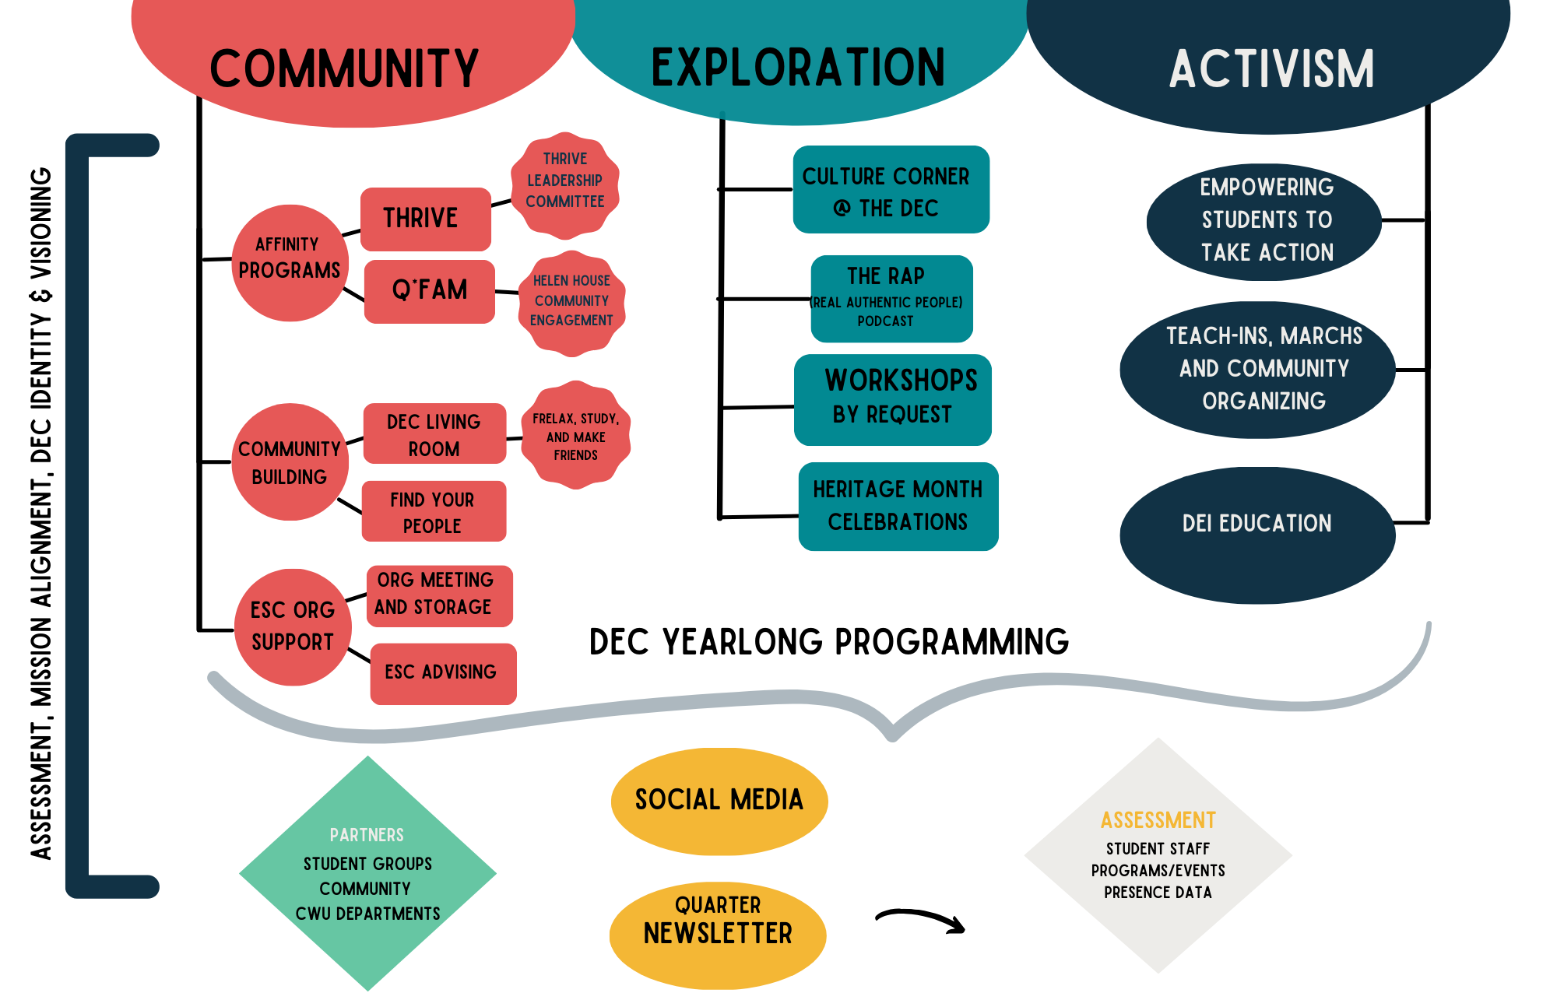
I am not aware of any overlaps with other programs other than the established vision to create equity and belonging that we all share.

- How does your program align with the purpose of S&A funding? “Supporting cocurricular and extracurricular activities and programs participated in by students in the furtherance of their education.”

We believe that fostering student identity development, sense of belonging, and community building are integral parts of students’ education. Our activities and programs seek to uplift, affirm, and support students to unapologetically show up and learn with their peers as their whole selves, both inside and outside the classroom. Our programs are informed by social justice practices, including Harro’s cycles of socialization and liberation.

We work collaboratively with various faculty and staff across campus to bring educational programming to students in a range of formats, from bringing in guest speakers to panelists to teach-ins and workshops. We also work closely with student staff to co-develop our social justice workshops – In the past year, we have built a new Disability 101 workshop in partnership with Disability Services and are currently crafting an Antiracism Workshop. We aim to be a transformative anti-oppressive center that inspires and cultivates students to be agents of social change in our communities.

Inspired by Harro’s cycle of liberation, the lifecycle of a student who comes through the DEC is captured below:
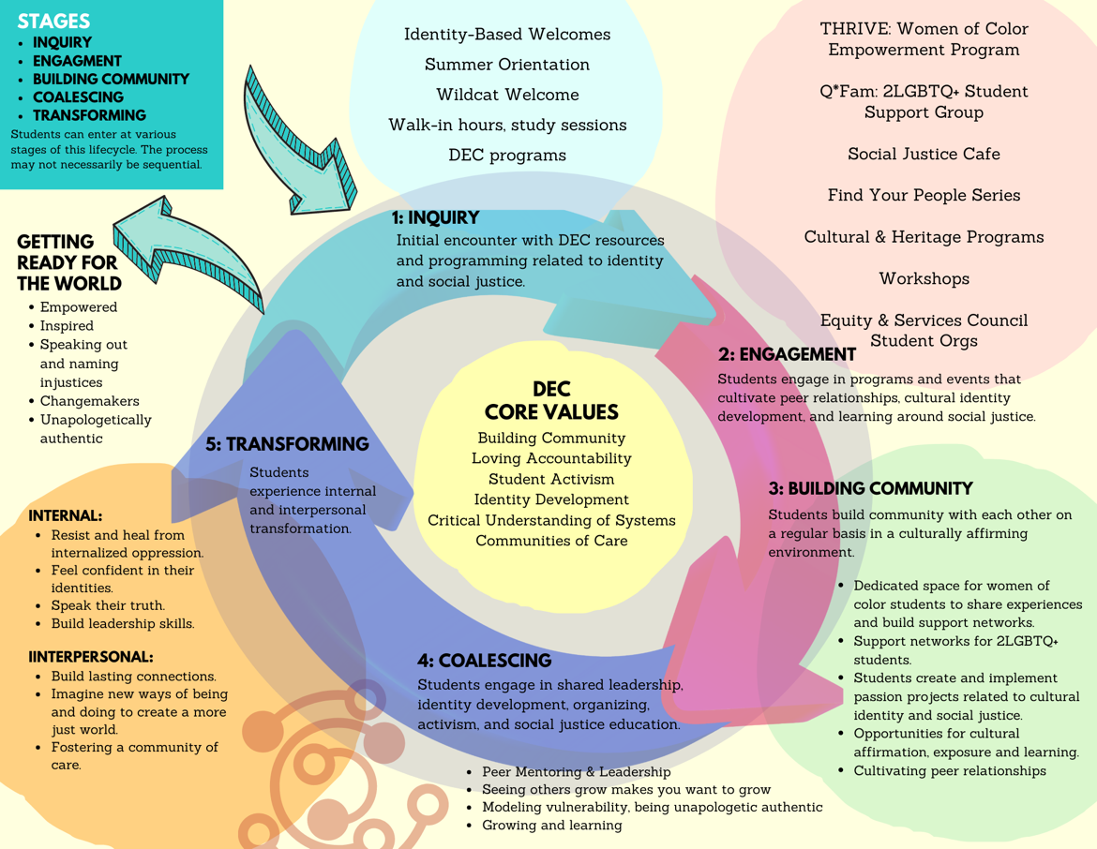

- Please provide specifics on how your program supports and aligns with CWU’s strategic plan (https://www.cwu.edu/about/mission-vision/_documents/cwu-vision-mission-values-strat-plan-bot-approved.pdf)?

DEC programming strongly aligns with CWU's strategic plan, specifically Goal 3, which aims to cultivate an inclusive and welcoming campus culture that embraces diversity, fosters a sense of belonging, and nurtures pride in the university. In accordance with Initiative 3.1 of the strategic plan, we contribute to the development and implementation of diversity, equity, and inclusion (DEI) training programs.
Our commitment to Inclusiveness and Diversity is evident in our support for these programs, ensuring that faculty, staff, and students receive training to raise awareness, build understanding, and promote inclusive practices across the university.
Initiative 3.2 emphasizes the establishment, maintenance, and resourcing of affinity groups for historically excluded students, faculty, and staff. Our identity-affinity programs, THRIVE and QFam, play a pivotal role in achieving this initiative's objectives. These programs regularly bring together faculty, staff, and students who identify with specific communities, such as racial/ethnic, LGBTQ+, and others. For instance, QFam hosts events that connect 2LGBTQ+ students with staff and faculty who share similar identities, fostering a safe and supportive environment in alignment with the strategic plan.
Furthermore, Initiative 3.3 underscores the importance of building mechanisms to nurture a strong sense of affiliation with and pride in Central Washington University. Our programs actively contribute to this initiative by celebrating students' diverse cultural identities, organizing events that affirm their experiences, heritages, and identities, and creating opportunities for deeper connections between students, faculty, and staff. Through these efforts, we contribute to the university's goal of creating a campus culture that embraces diversity, fosters belonging, and instills pride in being part of Central Washington University.

- Please provide detailed information regarding who utilizes your program? (Students, faculty, staff, community? Specific demographic information? Class standing, gender, ethnicity, transfer, campus location, etc.)

Both students, faculty, staff, and community members utilize our programs. The following information is from Presence, and please note that the program is limited when it comes to the demographic of “Race”. This information is taken from 2022-2023, as well as some preliminary data from Fall 2023 as results are still being analyzed from the evaluations done this quarter. Additionally, at the time of this report, Presence has no discernable code for Hispanic/LatinX to include within the overall data for the category of “Race”. Note, (2023-2024) signifies Fall 2023 data.

Specific Metric information collected via Presence:
Attendance 2022-2023:
- Attended Events: 203
- Total Attendees: 3971
- Unique Attendees: 813
- Average Attendees: 19.56
Attendance 2023-2024:
- Attended Events: 77
- Total Attendees: 1922
- Unique Attendees: 673
- Average Attendees: 24.96

Demographics:
Class Standing 2022-2023:
- Senior: 991
- Junior: 1072
- Sophomore: 720
- First-Year: 781
- Graduate: 206
- Post-Baccalaureate: 26
Class Standing 2023-2024:
- Senior: 326
- Junior: 428
- Sophomore: 347
- First-Year: 639
- Graduate: 112
- Post-Baccalaureate: 14

Race (As seen on Presence)
Race 2022-2023:
- Black: 1492
- White: 1392
- Asian: 191
- Pacific Is: 61
- PILNDR: 44
- American I: 12
- AMIND: 9
Race 2023-2024:
- Black: 471
- White: 911
- Asian: 157
- Pacific Is: 75
- American I: 11

Gender:
Gender 2022-2023:
- F: 2291
- M: 1658
- X: 15
Gender 2023-2024:
- F: 1170
- M: 702
- U: 31
- X: 13

Ethnicity
Ethnicity 2022-2023:
- Yes: 748
- No: 2851
Ethnicity 2023-2024:
- Yes: 687
- No: 1202

- How many unique CWU students utilize your program or services?
  - How do you gather these metrics?
  - If you do not, what is preventing you from getting that data and how are you determining usage by CWU students?

Unique Students using the DEC space, attending programs, etc.: 813

These metrics are gathered via students or faculty providing CWU ID numbers to DEC staff, and the DEC staff check the student or faculty into Presence, the CWU program that tracks and analyzes vital information, such as demographic data. While this program can provide some information, however, Presence’s user interface program does not allow for cohesive and comprehensive data for some metrics, such as accuracy on ‘Race’ and ‘Ethnicity’ percentages of students who attend DEC events. Other metrics do provide accurate results, but those two categories are often incorrect and limit our data.

- Are there any current vacant positions in your program?

We currently have an Assistant Director Position vacant. This is because the previous DEC Assistant Director was holding an interim position in Career Services until recently.

- Given the budget reductions taking place, and continuing for the remainder of the funding cycle, please tell us what specific impacts those reductions have had on your program compared to what was originally planned and included in your initial base funding request.

We have limited some of our program offerings. For example, we were not able to offer Parade of Nations this year due to the staffing and funding limitation. We also were not able to provide support for Lunar New year celebration to level we had hoped. We also had a decrease in in our heritage month programming ( Hispanic heritage month, Native American Heritage Month, Asian Pacific Islander Month, and others.

- Are there any circumstances or challenges that are currently impacting your ability to use your base funding allocation this year?

We were asked to take a 10% cut from our base funding. This will limit our ability to do programs.

- What other funding does your program receive? What percentage of your program’s total funding is coming from S&A Fees?
Dec is currently receiving 100% of its funding from S&A.

- What growth or expense increases do you anticipate seeing in the future?

We would like to continue to build more consistent ongoing smaller scale programs to provide weekly touchpoints for students. These events include belonging specific activities that create spaces for student from underserved populations in the CWU campus community. We currently developing another affinity group for men of color. We will also be working to support the reestablishment of an organization for Native first nation folks.

Multicultural Cultural Center
The DEC will be working to create programming and support in anticipation of a Multicultural Center. This will include increased student staffing, extended hours of operation and more programming that cultivates belonging in our current space.

Latin X Programming
We are increasing our efforts to support of Latinx programs in direct connection to the University’s goal of becoming a Hispanic Serving institution. We will coordinate a Latinx programming/ planning group that brings together Latinx student organizations (MECHA, and LSO), El Centro, Equity and Services Council Organizations, staff, and faculty across various departments. We will also be using this model for all of the other heritage celebration events.

Heritage Month Awareness Partnerships
We intend to build more consistent Heritage month programming for and with our campus partners. In addition, we see an amazing opportunity to create programming and diverse displays that can be placed in other departments and building (i.e. Brooks Library, The Health Education/ Nicholson Building).

We hope to offer continued support for event planning for ESC orgs, and to build positive and clear partnerships with ESC.

